SECURITIES AND EXCHANGE COMMISSION

WASHINGTON, D.C. 20549

SCHEDULE 14A

(Rule 14a-101)

INFORMATION REQUIRED IN PROXY STATEMENT

SCHEDULE 14A INFORMATION

Proxy Statement Pursuant to Section 14(a) of the

Securities Exchange Act of 1934

Filed by the Registrant ☒ Filed by a Party other than the Registrant ☐

Check the appropriate box:

- Preliminary Proxy Statement

- Confidential, for Use of the Commission Only (as permitted by Rule 14a-6(e)(2))

- Definitive Proxy Statement

- Definitive Additional Materials

- Soliciting Material Pursuant to §240.14a-12

American Capital Agency Corp.

(Name of Registrant as Specified in its Charter)

Payment of Filing Fee (Check the appropriate box):

- No fee required

- Fee computed on table below per Exchange Act Rules 14a-6(i)(4) and 0-11.

  - Title of each class of securities to which transaction applies:

  - Aggregate number of securities to which transaction applies:

  - Per unit price or other underlying value of transaction computed pursuant to Exchange Act Rule 0-11 (set forth the amount on which the filing fee is calculated and state how it was determined):

  - Proposed maximum aggregate value of transaction:

  - Total fee paid:

- Fee paid previously with preliminary materials

- Check box if any part of the fee is offset as provided by Exchange Act Rule 0-11(a)(2) and identify the filing for which the offsetting fee was paid previously. Identify the previous filing by registration statement number, or the Form or Schedule and the date of its filing.

  - Amount Previously Paid:

  - Form, Schedule or Registration Statement No.:

  - Filing Party:

  - Date Filed:

Two Bethesda Metro Center
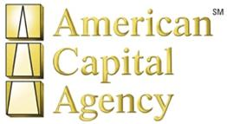
14th Floor

Bethesda, MD 20814

(301) 968-9300

(301) 968-9301 Fax

www.AGNC.com

FOR IMMEDIATE RELEASE

May 25, 2011

CONTACT:

Investors – (301) 968-9300

AMERICAN CAPITAL AGENCY CORP. RESCHEDULES

2011 ANNUAL MEETING OF STOCKHOLDERS

Bethesda, MD – May 25, 2011 – American Capital Agency Corp. (Nasdaq: AGNC) (“AGNC” or the “Company”) announced today that it has rescheduled its 2011 annual meeting of stockholders, originally scheduled for May 31, 2011. The new meeting date and time is Friday, June 10, 2011 at 9 a.m. (ET). The annual meeting will be held at AGNC, located at 2 Bethesda Metro Center, 14th Floor, Bethesda, Maryland 20814.

The Company also announced that it has supplemented its proxy statement for the 2011 annual meeting to amend the charter amendment proposal to eliminate the proposed increase in the Company’s authorized shares of preferred stock and to modify the requested increase in the Company’s authorized shares of common stock. The amended proposal now only requests an increase in the authorized number of shares of the Company’s common stock to 300,000,000 instead of 500,000,000. The Company rescheduled its annual meeting in order to provide its stockholders with additional time to consider and vote on the amended proposal.

The annual meeting will be held for the purposes set forth below.

- To elect the Board of Directors, with each director serving a one-year term and until his successor is elected and qualified;

- To approve an amendment to the Company’s Amended and Restated Certificate of Incorporation to increase the total authorized number of shares of common stock from 150,000,000 to 300,000,000;

- To ratify the selection of Ernst & Young LLP to serve as the Company’s independent public accountant for the year ending December 31, 2011; and

- To transact such other business as may properly come before the meeting or any adjournment thereof.

The Board of Directors of the Company has recommended a vote “FOR” all of the director nominees and “FOR” proposals 2 and 3 above.

Formal notice of the rescheduled meeting and the supplement to the Company’s proxy statement and revised proxy card are being mailed today to the Company’s stockholders. More information on the items to be discussed at the meeting can be found in the Company’s proxy statement, which is available at www.AGNC.com/2011proxymaterials.

Stockholders of record at the close of business on April 11, 2011 are entitled to notice of, and to vote at, the 2011 annual meeting and any adjournment of the meeting. If you wish to vote shares held in your name or attend the annual meeting in person, please register in advance by emailing Investor Relations at IR@AGNC.com or by phone at (301) 968-9300. Attendance at the 2011 annual meeting will be limited to persons presenting proof of stock ownership on the record date and picture identification. If you hold shares directly in your name as the stockholder of record, proof of ownership could include a copy of your account statement or a copy of your stock certificate(s). If you hold shares through an intermediary, such as a broker, bank or other nominee, proof of stock ownership could include a proxy from your broker, bank or other nominee or a copy of your brokerage or bank account statement. Additionally, if you intend to vote your shares at the meeting, you must request a “legal proxy” from your broker, bank or other nominee and bring this legal proxy to the meeting.

For further information or questions, please do not hesitate to call the Company’s Investor Relations Department at (301) 968-9300 or send an email to IR@AGNC.com.

ABOUT AMERICAN CAPITAL AGENCY CORP.

American Capital Agency Corp. is a REIT that invests in agency pass-through securities and collateralized mortgage obligations for which the principal and interest payments are guaranteed by a U.S. Government agency or a U.S. Government-sponsored entity. The Company is externally managed and advised by American Capital Agency Management, LLC, an affiliate of American Capital, Ltd. (“American Capital”). For further information, please refer to www.AGNC.com.

ABOUT AMERICAN CAPITAL

American Capital is a publicly traded private equity firm and global asset manager. American Capital, both directly and through its asset management business, originates, underwrites and manages investments in middle market private equity, leveraged finance, real estate and structured products. Founded in 1986, American Capital has $37 billion in assets under management and eight offices in the U.S., Europe and Asia. American Capital and its affiliates will consider investment opportunities from $10 million to $300 million. For further information, please refer to www.AmericanCapital.com.

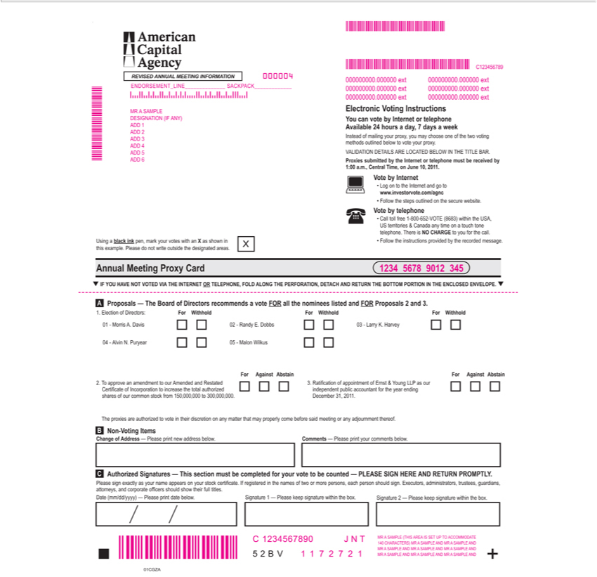

American Capital Agency
REVISED ANNUAL MEETING INFORMATION
Using |  | black ink pen, mark your votes with an X as shown in
this example. Please do not write outside the designated areas. X
01CGZA
5 2 B V +
nnual Meeting Proxy Card .
Authorized |  |  | Signatures — This section must be completed for your vote to be counted — PLEASE SIGN HERE AND C RETURN PROMPTLY.
Please sign exactly as your name appears on your stock certificate. If registered in the names of two or more persons, each person should sign. Executors, administrators, trustees, guardians,
attorneys, and corporate officers should show their full titles.
Date (mm/dd/yyyy) — Please print date below. Signature 1 — Please keep signature within the box. Signature 2 — Please keep signature within the box.
A
Change of Address — Please print new address below. Comments — Please print your comments below.
For Against Abstain
2. To approve an amendment to our Amended and Restated
Certificate of Incorporation to increase the total authorized
shares of our common stock from 150,000,000 to 300,000,000.
The proxies are authorized to vote in their discretion on any matter that may properly come before said meeting or any adjournment thereof.
Proposals — The Board of Directors recommends a vote FOR all the nominees listed and FOR Proposals 2 and 3.
B Non- |  | oting Items |  | MEETING INFORMATION
REVISED |  |  | . Davis
1 | Morris
4 | Alvin ANNUAL.Puryear
2 | Randy E. Dobbs
5 | Malon Wilkus
03—Larry K. Harvey
1. Election of Directors: For Withhold For Withhold For Withhold
For Against Abstain
3. Ratification of appointment of Ernst & Young LLP as our
independent public accountant for the year ending
December 31, 2011.
MMMMMMMMMMMMMMM
000000000.000000 ext
MMMMMM 1 1 7 2 7 2 1 |  |  |  |  | IS SET UP TO | TE
MR | SAMPLE (THIS
140 CHARACTERS) MRAREASAMPLE AND MRACCOMMODASAMPLEAND
MR A SAMPLE AND MR A SAMPLE AND MR A SAMPLE AND MMMMMMMMM
1234567890 J N T
C1234567899012 345
000004
MR | SAMPLE
DESIGNATION (IF ANY)
 | 1
 | 2
 | 3
 | 4
 | 5
ADD 6 |  |  |  |  | SACKPACK
NDORSEMENT_LINE
Electronic Voting Instructions
You can vote by Internet or telephone
Available 24 hours a day, 7 days a week
Ins ead of mailing your proxy, you may choose one of the two voting
methods outlined below to vote your proxy.
VALIDATION DETAILS ARE LOCATED BELOW IN THE TITLE BAR.
Proxies submitted by the Internet or telephone must be received by
1:00 a.m., Central Time, on June 10, 2011.
Vote by Internet
Log on |  | the Internet and go to
www.investorvote.com/agnc
Follow the steps outlined on the secure website.
Vote by telephone
CallUSterritoriestollfree1&-800Canada-652-VOTEanytime(8683)ona touchwithintonethe USA,
Followtelephone.the ThereinstructionsisNO providedCHARGEbytotheyourecordedforthe call.message.

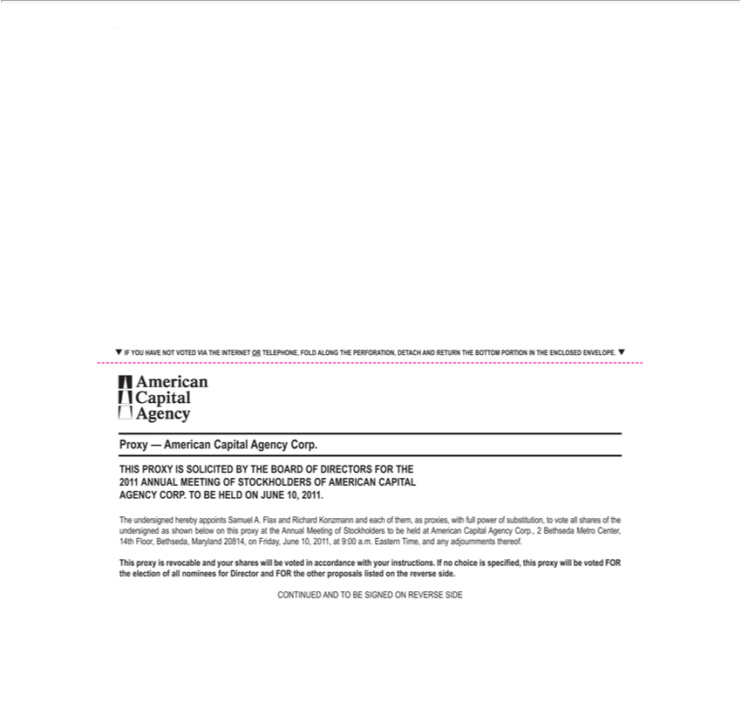

_IF YOU HAVE NOT VOTED VIA THE INTERNET OR TELEPHONE, FOLD ALONG THE PERFORATION, DETACH AND RETURN THE BOTTOM PORTION IN THE ENCLOSED ENVELOPE._
American Capital Agency
Proxy — American Capital Agency Corp
THIS PROXY IS SOLICITED BY THE BOARD OF DIRECTORS FOR THE
2011 ANNUAL | OF STOCKHOLDERS OF AMERICAN CAPITAL
AGENCY CORP.MEETINGOBEHELD ON JUNE 10, 2011. |  | to vote all shares of the
The undersigned hereby appoints Samuel A. Flax and Richard Konzmann and each of them, as proxies, with full power of
undersigned as shown below on this proxy at the Annual Meeting of Stockholders to be held at American Capital Agency Corp.substitution,2Bethseda Metro Center,
14th Fl or, Bethseda, | 20814, on Friday, June 10, 2011, at 9:00 a.m. Ea ern Time, and any adjournments thereof.
This proxy is revocableMarylandyour shares will be vo^{the}ed in accordance with your instructions. If no choice is specified, this proxy will be voted FOR the election of all nominees for Director and FOR other proposals listed on the reverse side.

