Table of Contents

SECURITIES AND EXCHANGE COMMISSION

WASHINGTON, D.C. 20549

SCHEDULE 14A

(Rule 14a-101)

INFORMATION REQUIRED IN PROXY STATEMENT

SCHEDULE 14A INFORMATION

Proxy Statement Pursuant to Section 14(a) of the

Securities Exchange Act of 1934

Filed by the Registrant ☒

Filed by a Party other than the Registrant

☐

Check the appropriate box:

- Preliminary Proxy Statement

- Confidential, for Use of the Commission Only (as permitted by Rule 14a-6(e)(2))

- Definitive Proxy Statement

- Definitive Additional Materials

- Soliciting Material Pursuant to §240.14a-12

AGNC Investment Corp.

(Name of Registrant as Specified in its Charter)

Payment of Filing Fee (Check the appropriate box):

- No fee required

  - Fee paid previously with preliminary materials

  - Fee computed on table in exhibit required by Item 25(b) per Exchange Act Rules 14a-6(i)(1) and 0-11

Table of Contents


AGNC INVESTMENT CORP.
NOTICE OF 2022 ANNUAL MEETING OF

STOCKHOLDERS TO BE HELD ON APRIL 21, 2022

DATE AND TIME:

Thursday, April 21, 2022, at 9:00 a.m., Eastern Time

WHERE:

Due to the ongoing Covid-19 pandemic, the Annual Meeting will be held only in a virtual format to support the health of our stockholders, employees, and community. The virtual meeting site is www.virtualshareholdermeeting.com/AGNC2022.

ITEMS OF BUSINESS:

1) To elect the Board of Directors, with each director serving a one-year term and until his or her successor is elected and qualified;

2) To approve an advisory resolution on executive compensation;

3) To consider and vote upon the ratification of the appointment of Ernst & Young LLP to serve as our independent public accountant for the year ending December 31, 2022;

4) To consider and vote upon amendments to our Amended and Restated Certificate of Incorporation (the "Certificate of Incorporation") eliminating supermajority voting requirements for stockholders to:

A. amend certain provisions of our Certificate of Incorporation;

B. amend our Fourth Amended and Restated Bylaws ("Bylaws"); and

C. remove directors; and

5) To transact such other business as may properly come before the meeting or any postponement or adjournment thereof.

Stockholders will have an opportunity to submit questions in advance of and during the meeting.

WHO CAN VOTE:

You are entitled to notice of, and to vote at, the Annual Meeting and any postponement or adjournment of the Annual Meeting if you were a common stockholder of record at the close of business on February 25, 2022.

MEETING DETAILS:

Attendance at the meeting is limited to holders of common stock as of the close of business on February 25, 2022. For details regarding our virtual annual meeting, including how to attend and how to submit questions, see Questions 14 and 15 of “Questions and Answers About the 2022 Annual Meeting and Voting” in this proxy statement.

DATE OF DISTRIBUTION:

This notice, the proxy statement, the accompanying proxy card, and our annual report to stockholders, which includes our annual report on Form 10-K with audited financial statements for the year ended December 31, 2021, are first being sent to our common stockholders on or about March , 2022.

BY ORDER OF THE BOARD OF
DIRECTORS,
Kenneth L. Pollack

Executive Vice President and Secretary

IMPORTANT NOTICE REGARDING THE AVAILABILITY OF PROXY MATERIALS FOR THE

ANNUAL MEETING OF STOCKHOLDERS TO BE HELD ON APRIL 21, 2022

This proxy statement and our annual report to stockholders, which includes our annual report on Form 10-K for the fiscal year ended December 31, 2021, are available free of charge on the internet at www.AGNC.com/2022proxymaterials.

Table of Contents

 | AGNC INVESTMENT CORP. AT A GLANCE
PROXY SUMMARY
Items to Be Voted
Proposal | Board | Page
 | Recommendation | Page
Proposal 1: Election of Directors | FOR | 11
Proposal 2: Advisory Resolution to Approve Executive Compensation | FOR | 16
Proposal 3: Ratification of Appointment of Independent Public Accountant | FOR | 17
Proposal 4: Amendments to our Certificate of Incorporation eliminating supermajority |  | 20
voting requirements | FOR | 20
A. Amendments to certain provisions of our Certificate of Incorporation | FOR | 20
B. Amendments to our Bylaws | FOR | 20
C. Removal of directors | FOR | 21

How to Vote Your Shares

Your vote is important, and we urge you to cast your vote as soon as possible. You may vote through the internet, by telephone, by mailing your completed proxy card (or voting instruction form, if you hold your shares through a broker, bank, or other nominee), or online during the virtual 2022 Annual Meeting (the “Annual Meeting”). See “Questions and Answers About the 2022 Annual Meeting and Voting” on page 54 of this proxy statement for additional information regarding voting.


How to Participate in the Meeting

Due to the ongoing COVID-19 pandemic (“Covid-19” or the "Pandemic”), our Annual Meeting will be held in a virtual format only to support the health of our stockholders, employees, and community. There will be no physical location for the Annual Meeting, and you will not be able to attend in person. As described in additional detail in this proxy summary and in the “Questions and Answers About the 2022 Annual Meeting and Voting” section beginning on page 54, we believe we are taking meaningful steps to facilitate the attendance and participation of our stockholders at the Annual Meeting, including by providing support for technical assistance during the meeting, allowing stockholders to submit questions in advance of and during the meeting, and addressing as many stockholder questions at the meeting as time allows. If you are an eligible stockholder, you may attend the meeting virtually by visiting www.virtualshareholdermeeting.com/AGNC2022 and logging in using the 16-digit control number printed on your notice, proxy card, voting instruction form, or in the email sending you the proxy statement.

AGNC INVESTMENT CORP. - Proxy Statement i

Table of Contents

AGNC INVESTMENT CORP. AT A GLANCE

AGNC INVESTMENT CORP. AT A GLANCE

AGNC Investment Corp. (“AGNC,” the “Company,” “we,” “our,” and “us”) is a leading provider of private capital to the U.S. housing market, enhancing liquidity in the residential real estate mortgage markets and, in turn, facilitating home ownership in the U.S.
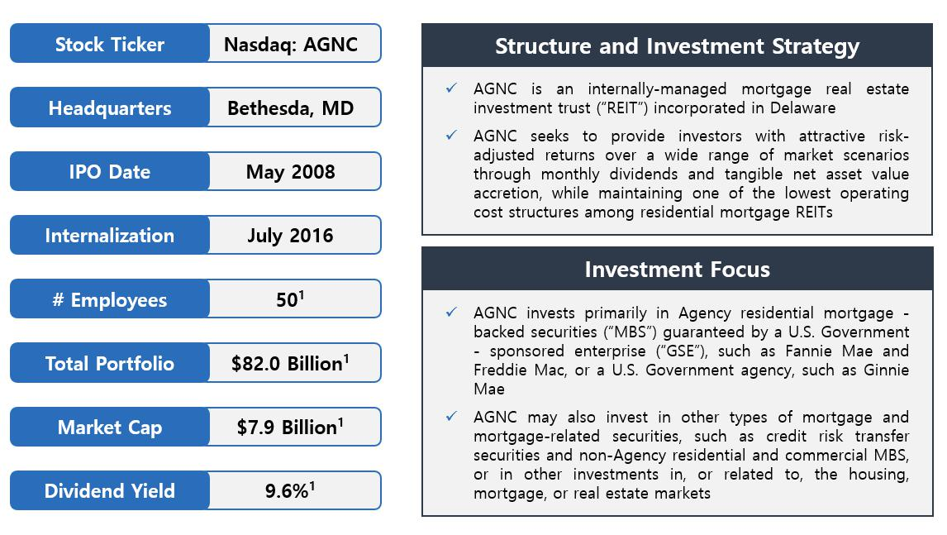

1. Data as of December 31, 2021.

Industry-Leading Performance

AGNC combines a track-record of strong financial performance with a significant yield component and the lowest operating cost structure in the residential mortgage REIT industry. Since our initial public offering (“IPO”), we have outperformed our residential mortgage REIT peer group and broader market indices through our active portfolio management strategy. This active portfolio management strategy has three critical components: prudent asset selection, dynamic funding and liability management, and disciplined risk management. In addition, our low-cost operating structure—the lowest among residential mortgage REITs as a percentage of stockholders’ equity—provides an inherent benefit to our performance relative to our higher cost peers.

From our May 2008 IPO through December 31, 2021, AGNC has declared $11.2 billion in common stock dividends, or $44.32 per common share, and has generated an annualized total stock return of 12.9%, compared to 5.9% for the Bloomberg Mortgage REIT Index, 6.7% for the S&P 500 Financials Index, and 11.6% for the S&P 500 Index.

ii AGNC INVESTMENT CORP. - Proxy Statement

Table of Contents

AGNC INVESTMENT CORP. AT A GLANCE
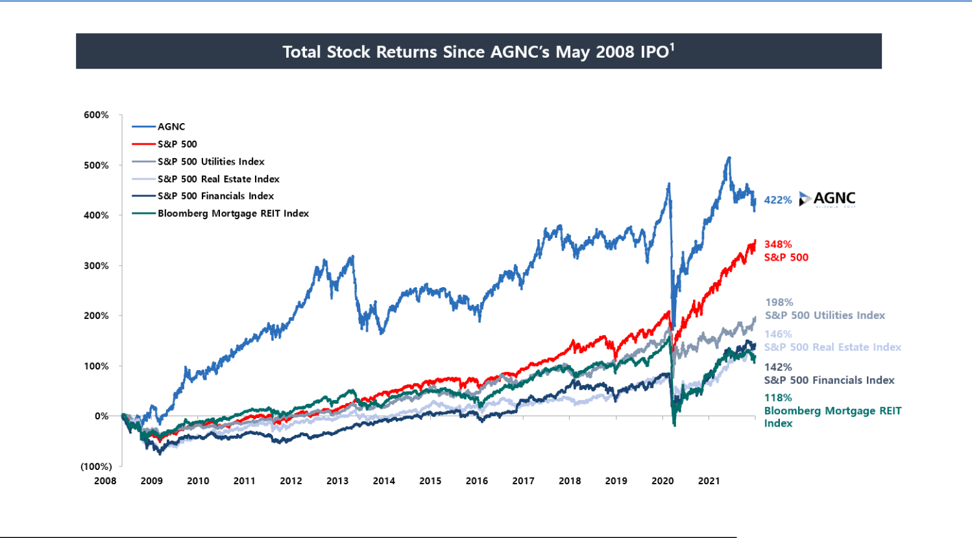

- Total stock return is measured from AGNC’s IPO through December 31, 2021. Total stock return over a period includes price appreciation and dividend reinvestment; dividends are assumed to be reinvested at the closing price of the security on the ex-dividend date. Source: S&P Global Market Intelligence and Bloomberg. Comparative data provided for informational purposes only. Historic performance is not indicative of future results. AGNC's investment strategy, business, and operations are different, and an investment in AGNC involves different risks and uncertainties, from companies included in the indices cited.

Successful Management Transition

The AGNC management team is led by Peter Federico, our President and Chief Executive Officer, following our successful leadership transition in July 2021. Consistent with our announcement in December 2020, Gary Kain, previously the Company’s Chief Executive Officer and Chief Investment Officer, transitioned to the role of Executive Chair of our Board effective July 1, 2021. As part of this transition, the Company appointed Christopher Kuehl to the role of Chief Investment Officer. The promotions of Mr. Federico, who previously served as AGNC’s President and Chief Operating Officer, and Mr. Kuehl, previously Executive Vice President, Agency Portfolio Investments, were consistent with our management succession plan.

As part of the July transition, Prue Larocca, previously Chair of the Board and Lead Independent Director, continued in her role as the Board’s Lead Independent Director and also became Vice Chair of the Board. The Company remains committed to strong independent leadership on the Board, and Ms. Larocca continues to work with Mr. Kain in leading the Board’s oversight of AGNC’s strategy and ongoing commitment to creating stockholder value. Further discussion of the responsibilities of Ms. Larocca and Mr. Kain are on page 1 under “Board Leadership Structure.”

Board of Directors

AGNC’s Board is currently comprised of nine members, including seven independent directors, whose diverse range of experience and backgrounds makes them highly qualified to oversee our strategy, operations, and risk management. We evaluate our Board’s backgrounds, skill sets, experience, and diversity on an ongoing basis, including as part of our annual evaluation process, to ensure they align with the Company’s go-forward strategy.

AGNC INVESTMENT CORP. - Proxy Statement iii

Table of Contents

AGNC INVESTMENT CORP. AT A GLANCE

Director Nominees

 |  |  |  | Committee
Name |  |  |  |  | Compensation &
Name | Director Since | Independent | Executive | Audit | Corporate Governance
Donna J. Blank | 2018 | ✓ | ✓ | Chair
Morris A. Davis | 2008 | ✓ |  |  | Chair
Peter J. Federico (Chief Executive Officer) | 2021
John D. Fisk | 2019 | ✓ |  |  | ✓
Andrew A. Johnson, Jr. | 2021 | ✓ |  | ✓
Gary D. Kain (Executive Chair) | 2016 |  | ✓
Prue B. Larocca (Lead Independent Director and Vice Chair) | 2013 | ✓ | Chair | ✓ | ✓
Paul E. Mullings | 2016 | ✓ |  |  | ✓
Frances R. Spark | 2019 | ✓ |  | ✓
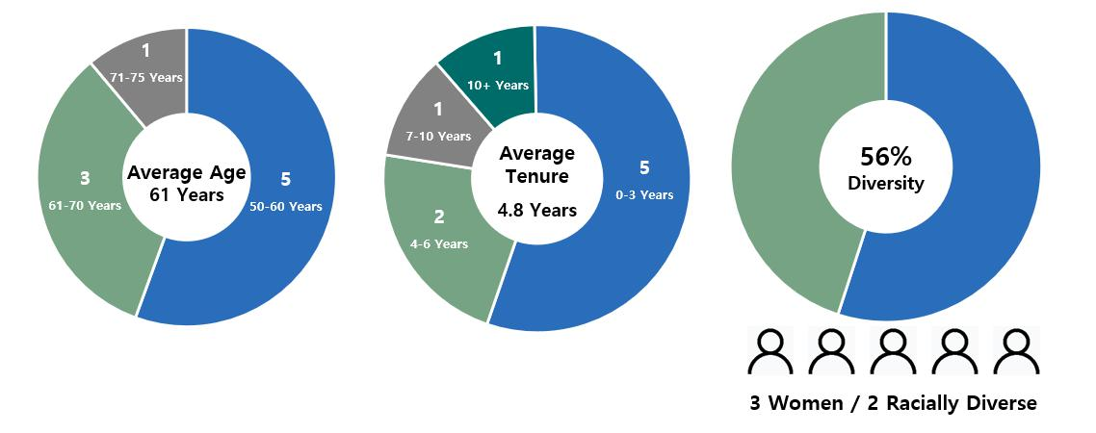

1. Metrics as of February 25, 2022.

iv AGNC INVESTMENT CORP. - Proxy Statement

Table of Contents

AGNC INVESTMENT CORP. AT A GLANCE
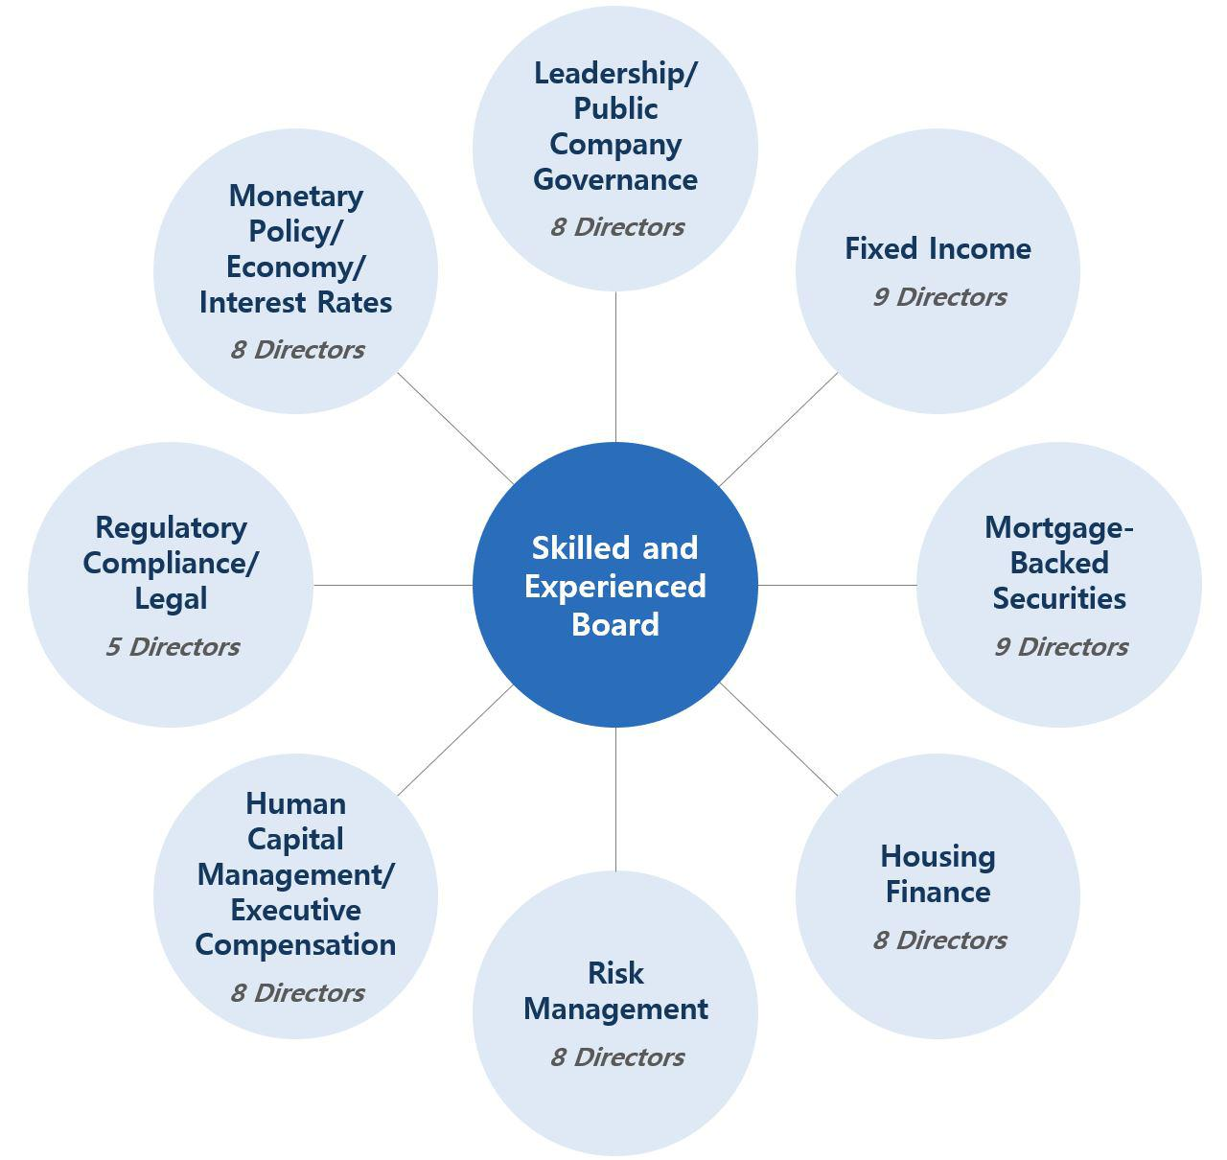

AGNC INVESTMENT CORP. - Proxy Statement v

Table of Contents

AGNC INVESTMENT CORP. AT A GLANCE

Strong Stockholder Focus

Our internal management structure provides us a differentiated platform that is closely aligned with stockholder interests. We stand out among mortgage REITs for our transparency, focus on financial disclosure, and our high-quality governance and compensation practices.
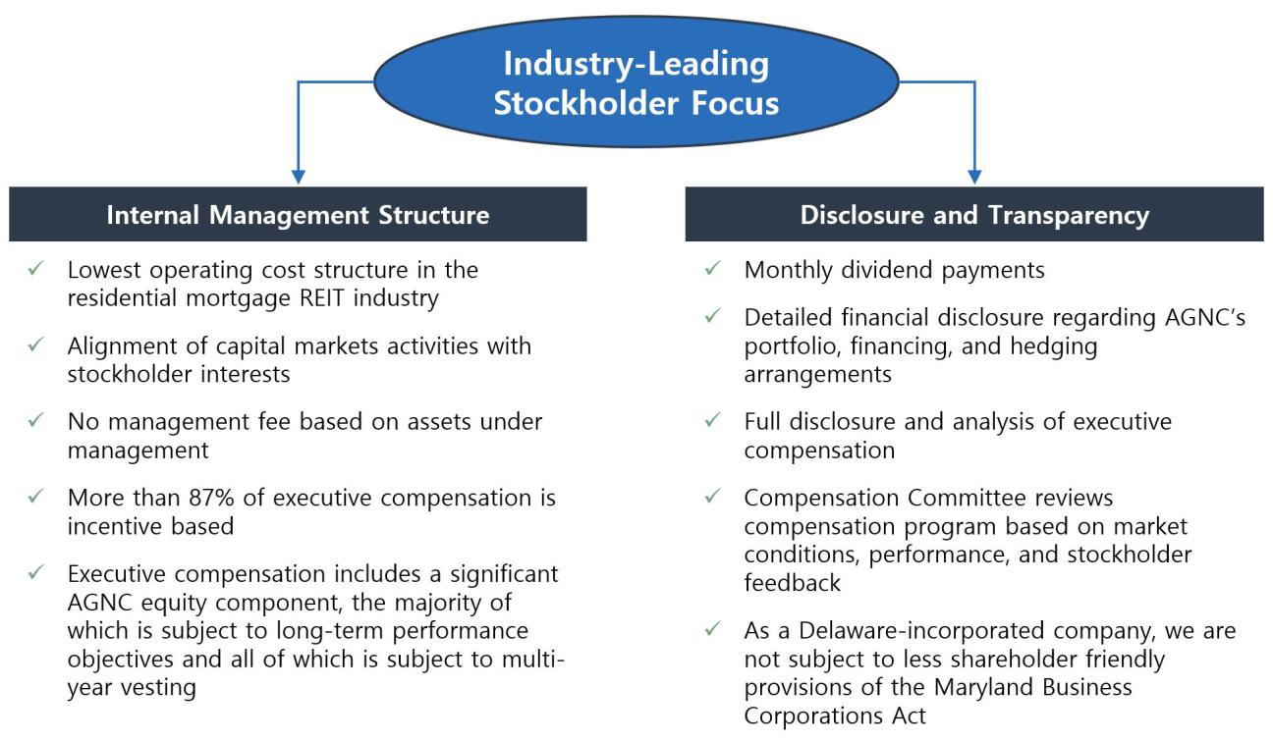

Stockholder Engagement

We actively engage with and value the opinions of our stockholders, which have influenced the evolution of our compensation program, corporate governance practices, and sustainability and human capital management efforts. We value regular engagement with our stockholders, including through our quarterly earnings calls, investor conferences, fall and spring engagement campaigns, and outreach through our Investor Relations department. We engaged in a robust outreach program in 2021, holding over 85 meetings and calls with institutional investors and responding to over 320 letters, emails, and calls from retail investors. We were awarded the 2021 Gold Investor CARE Award by Nareit, honoring our excellence in communicating effectively and efficiently with our investors.

Our discussions with investors in 2021 were generally focused on four key themes:

Executive Leadership Transitions

Board Composition

ESG Initiatives

COVID Response

Engagement Themes

ØGiven the ample lead time for market participants to digest the December 2020 announcement coupled with the detailed disclosure, investors noted that the transition occurred seamlessly

ØInvestors voiced an appreciation for our board refreshment efforts, particularly around enhanced diversity and the increased size

ØDiscussions with investors focused on our Board of Directors' oversight of ESG matters, and investors valued our enhanced ESG disclosure despite the ongoing limitations for reporting by Agency mortgage REITs
ØInvestors reacted favorably to our stated intentions to provide disclosure consistent with the Task Force on Climate-Related Financial Disclosures ("TCFD") framework

ØAGNC continues to prioritize the health and welfare of our employees and remains flexible regarding remote and hybrid work environments

ØTo facilitate our hybrid work environment, we continue to enhance AGNC's cybersecurity platform and information technology support

Taking into consideration the feedback from investors and other stakeholders, we expect to incorporate the TCFD framework into our second annual ESG Report, which we expect to publish during the second quarter of 2022.

vi AGNC INVESTMENT CORP. - Proxy Statement

Table of Contents

AGNC INVESTMENT CORP. AT A GLANCE

Executive Compensation Program Overview and Evolution

Philosophy and Structure

Our Compensation and Corporate Governance Committee (the “Compensation Committee”) has implemented a compensation program that links pay with performance, aligns executive objectives and incentives with our stockholders’ interests, and promotes operating efficiency. In addition, we believe our compensation program is competitive given AGNC’s size, scale, business, and management structure, promotes retention of our employees, and is well governed and transparent. All AGNC employees, including our named executive officers (“NEOs”), receive a combination of base salary, short-

term incentives in the form of an annual cash bonus opportunity, and long-term incentives (“LTI”) in the form of restricted stock units (“RSUs”). The long-term equity incentives awarded to our NEOs and other senior-level employees consist of a combination of performance-based RSUs and time-based RSUs.

As part of its ongoing evaluation of our compensation practices and in response to feedback we heard from stockholders during our prior outreach efforts, the Compensation Committee has made a number of meaningful changes to our compensation program and the corporate scorecard ("Corporate Scorecard") used to evaluate performance since the compensation program was first implemented in 2016. Those changes included increasing the portion of our NEOs' total compensation allocated to long-term equity awards, simplifying the annual Corporate Scorecard to increase reliance on financial performance and better align to our strategic objectives, and improving disclosure to provide greater context for our compensation programs. We have also taken steps that reduce the pay disparity between our CEO and other NEOs. Each of our NEOs now receive at least 40% of their target compensation in the form of LTI awards, and at least 50% and up to 67% of the target value of our NEOs' annual LTI awards vest based on performance over a three-year period.

AGNC INVESTMENT CORP. - Proxy Statement vii

Table of Contents

 |  |  |  |  |  |  |  |  |  |  |  |  |  |  |  |  |  |  |  |  |  |  |  |  |  |  |  | TABLE OF CONTENTS
 | Proxy Summary |  |  |  |  |  |  |  |  |  |  |  |  |  |  |  |  |  |  |  |  |  |  |  |  |  |  |  |  |  |  |  |  |  |  |  | i
 | Board and Governance Matters |  |  |  |  |  |  |  |  |  |  |  |  |  |  |  |  |  |  |  |  |  |  |  |  |  |  |  |  |  |  |  |  |  |  |  | 1
 |  |  |  | Board Leadership Structure |  |  |  |  |  |  |  |  |  |  |  |  |  |  |  |  |  |  |  |  |  |  |  |  |  |  |  |  |  |  |  |  | 1
 |  |  |  | Corporate Governance |  |  |  |  |  |  |  |  |  |  |  |  |  |  |  |  |  |  |  |  |  |  |  |  |  |  |  |  |  |  |  |  | 2
 |  |  |  | Committees of the Board of Directors |  |  |  |  |  |  |  |  |  |  |  |  |  |  |  |  |  |  |  |  |  |  |  |  |  |  |  |  |  |  |  |  | 4
 |  |  |  | Board and Committee Meetings |  |  |  |  |  |  |  |  |  |  |  |  |  |  |  |  |  |  |  |  |  |  |  |  |  |  |  |  |  |  |  |  | 4
 |  |  |  | Director Nomination Process |  |  |  |  |  |  |  |  |  |  |  |  |  |  |  |  |  |  |  |  |  |  |  |  |  |  |  |  |  |  |  |  | 4
 |  |  |  | Board Membership Criteria |  |  |  |  |  |  |  |  |  |  |  |  |  |  |  |  |  |  |  |  |  |  |  |  |  |  |  |  |  |  |  |  | 4
 |  |  |  | Oversight of Strategy and Key Risks |  |  |  |  |  |  |  |  |  |  |  |  |  |  |  |  |  |  |  |  |  |  |  |  |  |  |  |  |  |  |  |  | 5
 |  |  |  | ESG and Corporate Responsibility |  |  |  |  |  |  |  |  |  |  |  |  |  |  |  |  |  |  |  |  |  |  |  |  |  |  |  |  |  |  |  |  | 7
 |  |  |  | Director Compensation |  |  |  |  |  |  |  |  |  |  |  |  |  |  |  |  |  |  |  |  |  |  |  |  |  |  |  |  |  |  |  |  | 7
 |  |  |  | Stock Ownership Guidelines |  |  |  |  |  |  |  |  |  |  |  |  |  |  |  |  |  |  |  |  |  |  |  |  |  |  |  |  |  |  |  |  | 9
 |  |  |  | Director Resignation Policy |  |  |  |  |  |  |  |  |  |  |  |  |  |  |  |  |  |  |  |  |  |  |  |  |  |  |  |  |  |  |  |  | 9
 |  |  |  | Certain Transactions with Related Persons |  |  |  |  |  |  |  |  |  |  |  |  |  |  |  |  |  |  |  |  |  |  |  |  |  |  |  |  |  |  |  |  | 10
 |  |  |  | Compensation Committee Interlocks and Insider Participation |  |  |  |  |  |  |  |  |  |  |  |  |  |  |  |  |  |  |  |  |  |  |  |  |  |  |  |  |  |  |  |  | 10
 | Proposal 1: Election of Directors |  |  |  |  |  |  |  |  |  |  |  |  |  |  |  |  |  |  |  |  |  |  |  |  |  |  |  |  |  |  |  |  |  |  |  | 11
 |  |  |  | Summary of our Board’s Industry and Functional Expertise |  |  |  |  |  |  |  |  |  |  |  |  |  |  |  |  |  |  |  |  |  |  |  |  |  |  |  |  |  |  |  |  | 11
 |  |  |  | Director Nominee Biographies and Qualifications |  |  |  |  |  |  |  |  |  |  |  |  |  |  |  |  |  |  |  |  |  |  |  |  |  |  |  |  |  |  |  |  | 11
 |  |  |  | Conclusion and Recommendation; Vote Required |  |  |  |  |  |  |  |  |  |  |  |  |  |  |  |  |  |  |  |  |  |  |  |  |  |  |  |  |  |  |  |  | 15
 | Proposal 2: Advisory Resolution to Approve Executive Compensation |  |  |  |  |  |  |  |  |  |  |  |  |  |  |  |  |  |  |  |  |  |  |  |  |  |  |  |  |  |  |  |  |  |  |  | 16
 |  |  |  | General Information |  |  |  |  |  |  |  |  |  |  |  |  |  |  |  |  |  |  |  |  |  |  |  |  |  |  |  |  |  |  |  |  | 16
 |  |  |  | Conclusion and Recommendation; Vote Required |  |  |  |  |  |  |  |  |  |  |  |  |  |  |  |  |  |  |  |  |  |  |  |  |  |  |  |  |  |  |  |  | 16
 | Proposal 3: Ratification of Appointment of Independent Public Accountant |  |  |  |  |  |  |  |  |  |  |  |  |  |  |  |  |  |  |  |  |  |  |  |  |  |  |  |  |  |  |  |  |  |  |  | 17
 |  |  |  | Independent Public Accountant’s Fees |  |  |  |  |  |  |  |  |  |  |  |  |  |  |  |  |  |  |  |  |  |  |  |  |  |  |  |  |  |  |  |  | 17
 |  |  |  | Pre-Approval Policy |  |  |  |  |  |  |  |  |  |  |  |  |  |  |  |  |  |  |  |  |  |  |  |  |  |  |  |  |  |  |  |  | 17
 |  |  |  | Conclusion and Recommendation; Vote Required |  |  |  |  |  |  |  |  |  |  |  |  |  |  |  |  |  |  |  |  |  |  |  |  |  |  |  |  |  |  |  |  | 18
 | Report of the Audit Committee |  |  |  |  |  |  |  |  |  |  |  |  |  |  |  |  |  |  |  |  |  |  |  |  |  |  |  |  |  |  |  |  |  |  |  | 19
 | Proposal 4: Approval of Amendments to Our Amended and Restated Certificate of Incorporation Eliminating Supermajority Voting |  |  |  |  |  |  |  |  |  |  |  |  |  |  |  |  |  |  |  |  |  |  |  |  |  |  |  |  |  |  |  |  |  |  |  | 20
 |  | Requirements |  |  |  |  |  |  |  |  |  |  |  |  |  |  |  |  |  |  |  |  |  |  |  |  |  |  |  |  |  |  |  |  |  |  | 20
 |  | General Information |  |  |  |  |  |  |  |  |  |  |  |  |  |  |  |  |  |  |  |  |  |  |  |  |  |  |  |  |  |  |  |  |  |  | 20
 |  |  |  | Proposal 4A: Amendment to Eliminate the Supermajority Voting Standard for Certain Amendments to Our Certificate of |  |  |  |  |  |  |  |  |  |  |  |  |  |  |  |  |  |  |  |  |  |  |  |  |  |  |  |  |  |  |  |  | 20
 |  |  |  | Incorporation |  |  |  |  |  |  |  |  |  |  |  |  |  |  |  |  |  |  |  |  |  |  |  |  |  |  |  |  |  |  |  |  | 20
 |  |  |  | Proposal 4B: Amendment to Eliminate the Supermajority Voting Standard for Amendments to Our Bylaws |  |  |  |  |  |  |  |  |  |  |  |  |  |  |  |  |  |  |  |  |  |  |  |  |  |  |  |  |  |  |  |  | 20
 |  |  |  | Proposal 4C: Amendment to Eliminate the Supermajority Voting Standard for Removal of Directors |  |  |  |  |  |  |  |  |  |  |  |  |  |  |  |  |  |  |  |  |  |  |  |  |  |  |  |  |  |  |  |  | 21
 |  |  |  | Conclusion and Recommendation; Vote Required |  |  |  |  |  |  |  |  |  |  |  |  |  |  |  |  |  |  |  |  |  |  |  |  |  |  |  |  |  |  |  |  | 21
 | Executive Officers of Registrant |  |  |  |  |  |  |  |  |  |  |  |  |  |  |  |  |  |  |  |  |  |  |  |  |  |  |  |  |  |  |  |  |  |  |  | 22
 |  |  |  | Executive Officer Biographies |  |  |  |  |  |  |  |  |  |  |  |  |  |  |  |  |  |  |  |  |  |  |  |  |  |  |  |  |  |  |  |  | 22
 | Executive Compensation |  |  |  |  |  |  |  |  |  |  |  |  |  |  |  |  |  |  |  |  |  |  |  |  |  |  |  |  |  |  |  |  |  |  |  | 24

viii AGNC INVESTMENT CORP. - Proxy Statement

Table of Contents

 |  | Compensation Discussion and Analysis |  |  |  |  |  |  |  |  |  |  |  |  |  |  |  |  |  |  |  |  |  |  |  |  |  |  |  |  | 24
 |  |  | 2021 Named Executive Officers |  |  |  |  |  |  |  |  |  |  |  |  |  |  |  |  |  |  |  |  |  |  |  |  |  |  |  | 24
 |  |  | Executive Summary |  |  |  |  |  |  |  |  |  |  |  |  |  |  |  |  |  |  |  |  |  |  |  |  |  |  |  | 24
 |  |  |  | Business Overview |  |  |  |  |  |  |  |  |  |  |  |  |  |  |  |  |  |  |  |  |  |  |  |  |  |  | 24
 |  |  |  | Our Business in the Context of Our Broader Industry |  |  |  |  |  |  |  |  |  |  |  |  |  |  |  |  |  |  |  |  |  |  |  |  |  |  | 25
 |  |  |  | Recent Performance |  |  |  |  |  |  |  |  |  |  |  |  |  |  |  |  |  |  |  |  |  |  |  |  |  |  | 26
 |  |  |  | Compensation Philosophy and Objectives |  |  |  |  |  |  |  |  |  |  |  |  |  |  |  |  |  |  |  |  |  |  |  |  |  |  | 28
 |  |  |  | Stockholder Engagement |  |  |  |  |  |  |  |  |  |  |  |  |  |  |  |  |  |  |  |  |  |  |  |  |  |  | 30
 |  |  |  | Compensation Governance Practices |  |  |  |  |  |  |  |  |  |  |  |  |  |  |  |  |  |  |  |  |  |  |  |  |  |  | 32
 |  |  | Compensation Program In Detail |  |  |  |  |  |  |  |  |  |  |  |  |  |  |  |  |  |  |  |  |  |  |  |  |  |  |  | 32
 |  |  |  | Compensation Program Elements |  |  |  |  |  |  |  |  |  |  |  |  |  |  |  |  |  |  |  |  |  |  |  |  |  |  | 32
 |  |  |  | Corporate Scorecard for Calculating Annual Bonus |  |  |  |  |  |  |  |  |  |  |  |  |  |  |  |  |  |  |  |  |  |  |  |  |  |  | 33
 |  |  |  | Equity Incentive Compensation |  |  |  |  |  |  |  |  |  |  |  |  |  |  |  |  |  |  |  |  |  |  |  |  |  |  | 38
 |  |  |  | Compensation Decision Process |  |  |  |  |  |  |  |  |  |  |  |  |  |  |  |  |  |  |  |  |  |  |  |  |  |  | 40
 |  |  |  | Other Compensation Policies and Practices |  |  |  |  |  |  |  |  |  |  |  |  |  |  |  |  |  |  |  |  |  |  |  |  |  |  | 43
 |  | Report of the Compensation and Corporate Governance Committee |  |  |  |  |  |  |  |  |  |  |  |  |  |  |  |  |  |  |  |  |  |  |  |  |  |  |  |  | 44
 |  | 2021 Summary Compensation Table |  |  |  |  |  |  |  |  |  |  |  |  |  |  |  |  |  |  |  |  |  |  |  |  |  |  |  |  | 45
 |  | Grants of Plan-Based Awards in Fiscal Year 2021 |  |  |  |  |  |  |  |  |  |  |  |  |  |  |  |  |  |  |  |  |  |  |  |  |  |  |  |  | 46
 |  | Outstanding Equity Awards at 2021 Fiscal Year-End |  |  |  |  |  |  |  |  |  |  |  |  |  |  |  |  |  |  |  |  |  |  |  |  |  |  |  |  | 46
 |  | Option Exercises and Stock Vested for Fiscal Year 2021 |  |  |  |  |  |  |  |  |  |  |  |  |  |  |  |  |  |  |  |  |  |  |  |  |  |  |  |  | 48
 |  | Severance and Change of Control Payments |  |  |  |  |  |  |  |  |  |  |  |  |  |  |  |  |  |  |  |  |  |  |  |  |  |  |  |  | 48
 |  | CEO Compensation Pay Ratio |  |  |  |  |  |  |  |  |  |  |  |  |  |  |  |  |  |  |  |  |  |  |  |  |  |  |  |  | 51
 | Information Regarding Company Voting Securities |  |  |  |  |  |  |  |  |  |  |  |  |  |  |  |  |  |  |  |  |  |  |  |  |  |  |  |  |  | 52
 |  | Security Ownership of Management and Certain Beneficial Owners |  |  |  |  |  |  |  |  |  |  |  |  |  |  |  |  |  |  |  |  |  |  |  |  |  |  |  |  | 52
 | Questions and Answers About Stockholder Communications and Proposals |  |  |  |  |  |  |  |  |  |  |  |  |  |  |  |  |  |  |  |  |  |  |  |  |  |  |  |  |  | 53
 | Questions and Answers About the 2022 Annual Meeting and Voting |  |  |  |  |  |  |  |  |  |  |  |  |  |  |  |  |  |  |  |  |  |  |  |  |  |  |  |  |  | 54
 | Appendix I: Proposed Amended Provisions of Our Certificate of Incorporation |  |  |  |  |  |  |  |  |  |  |  |  |  |  |  |  |  |  |  |  |  |  |  |  |  |  |  |  |  | 1
 |  |  |  |  |  |  |  |  |  |  |  |  |  |  |  |  |  |  |  |  |  |  |  |  |  |  |  |  |  | AGNC INVESTMENT CORP. - Proxy Statement | ix

Table of Contents

BOARD AND GOVERNANCE MATTERS

BOARD AND GOVERNANCE MATTERS

Our Board is currently comprised of seven independent directors, our Executive Chair, and our CEO. The following table sets forth the current members of our Board and their committee membership:

Name |  |  |  | Compensation &
Name | Director Since | Executive | Audit 1 | Corporate Governance 2
Donna J. Blank* | 2018 | ✓ | Chair
Morris A. Davis* | 2008 |  |  | Chair
Peter J. Federico (Chief Executive Officer) | 2021
John D. Fisk* | 2019 |  |  | ✓
Andrew A. Johnson, Jr.* | 2021 |  | ✓
Gary D. Kain (Executive Officer) | 2016 | ✓
Prue B. Larocca* (Lead Independent Director and Vice Chair) | 2013 | Chair | ✓ | ✓
Paul E. Mullings* | 2016 |  |  | ✓
Frances R. Spark* | 2019 |  | ✓

* Director is “independent” as defined in Rule 5605(a)(2) of The Nasdaq Listing Rules (the “Nasdaq rules”).
- Each member of the Audit Committee is “independent” as defined in Rules 5605(a)(2) and 5605(c)(2) of the Nasdaq rules and Rule 10A-3 of the Securities Exchange Act of 1934 (the “Exchange Act”). The Board has determined that Mss. Blank and Spark are each an “audit committee financial expert” as defined in Item 407 of Regulation S-K under the Securities Act of 1933 (the “Securities Act”).
- Each member of the Compensation and Corporate Governance Committee is “independent” as defined in Rules 5605(a)(2) and 5605(d)(2) of the Nasdaq rules.

Board Leadership Structure

We believe that objective, independent oversight of management is central to our corporate governance, executing on our strategic objectives, and serving the long-term interests of our stockholders. The Board believes that the optimal leadership structure for AGNC may change over time as a result of a number of factors, including evolution in our strategy, shifting market conditions, and changes in our Board and management personnel. Accordingly, the Board regularly evaluates the most effective leadership structure for the Company, and the Board concluded that it was appropriate to adjust the Board’s governance structure in connection with the transition of our executive leadership in July 2021. As part of this transition, Mr. Kain resigned his positions as Chief Executive Officer and Chief Investment Officer and was appointed Executive Chair of the Board to continue to serve a strategic role within the Company. Ms. Larocca, who served as our Chair and Lead Independent Director from May 2016 until July 2021, continues in her role as Lead Independent Director and also assumed the role of Vice Chair of the Board. Mr. Federico was elected to the Board at the time of his promotion to Chief Executive Officer, and Mr. Johnson was elected to the Board in 2021 as a new independent director. The Board continues to believe that separating the positions of Chair and Chief Executive Officer is the best corporate governance leadership structure for us at this time.

AGNC remains committed to maintaining strong, independent leadership on the Board. Our Board has a policy, consistent with the Nasdaq rules and good corporate governance, to have our independent directors meet regularly without members of management or employee directors present to facilitate the Board’s independent oversight of management. Presently, our independent directors meet during our Board’s regular quarterly meetings and may hold additional meetings at the request of the Lead Independent Director or a majority of the directors. Ms. Larocca, in her role as Lead Independent Director and Vice Chair, is empowered with robust, well-defined duties and actively collaborates with our Chief Executive Officer and Executive Chair on a wide variety of issues. In his new role as Executive Chair, Mr. Kain serves as a resource to our Chief Executive Officer and Chief Investment Officer to facilitate an orderly transition of these roles and consults with the Company's senior management on significant strategic decisions and business plan execution, including investment strategies and portfolio risk management. He and Ms. Larocca collaborate closely to shape and implement the Board's agenda and to facilitate the oversight of AGNC's operations and strategy. The chart below highlights the principal responsibilities of our Executive Chair and Lead Independent Director and their collaboration with other members of the Board of Directors and AGNC's management team.

AGNC INVESTMENT CORP. - Proxy Statement | 1

Table of Contents

BOARD AND GOVERNANCE MATTERS

Responsibilities and Collaboration Among our Lead Independent Director and Executive Chair

Lead Independent Director and Vice Chair

- elected by and acts as leader of independent directors

- chairs meetings of the independent directors and the Executive Committee and chairs meetings of the Board of Directors when the Executive Chair is not present or is recused

Executive Chair

- elected by all directors

- chairs all regular and special meetings of the Board

- serves on the Executive Committee

- serves on all Board committees to facilitate support of committee chairs and coordination of committee work

- able to call meetings of the independent directors and special meetings of the Board of Directors

- collaborates with the Executive Chair, the CEO, the Secretary and committee chairs to approve scheduling of meetings, development of agendas, and review content and distribution of materials

- serves as a liaison between management and the independent directors and ensures that the information needs of independent directors are satisfied

- together with the chair of the Compensation Committee, leads the performance evaluation of the Executive Chair and the Chief Executive Officer

- together with the Executive Chair, facilitates identification and resolution of potential conflicts of interest and establishes expectations regarding culture of compliance throughout the Company

- communicates on behalf of the independent directors with stockholders, proxy advisory firms, and other stakeholders, as necessary

- serves as an additional management resource in the event of a crisis or interruption in business continuity

- together with the Vice Chair, facilitates identification and resolution of potential conflicts of interest and establishes expectations regarding culture of compliance throughout the Company

- collaborates with the Lead Independent Director, CEO, Secretary, and committee chairs to call and schedule Board meetings, develop agendas, and review the content and distribution of materials

- as necessary, represents the Company to stockholders, other stakeholders, and government officials in conjunction with the Chief Executive Officer

- provides transitional support and guidance to the Chief Executive Officer and Chief Investment Officer, including consultation on significant strategic decisions

- evaluates and reports to the independent directors as requested regarding the Chief Executive Officer's performance and development

Each of our Board’s Audit Committee and Compensation Committee is composed entirely of independent directors. These independent committees of our Board also have the authority under their respective charters to hire independent advisors and consultants, at the Company’s expense, to assist them in performing their duties. The chairs of the Audit and Compensation Committees set meeting agendas in consultation with our Secretary. A majority of our Board’s Executive Committee also consists of independent directors. Our Board has determined that all of the current directors, except Messrs. Federico and Kain, are “independent” as defined in the Nasdaq rules.

Corporate Governance

Our Board maintains strong corporate governance practices, which are memorialized in our Corporate Governance Guidelines, to support its oversight responsibilities. These guidelines, together with our Amended and Restated Certificate of Incorporation (our “Certificate of Incorporation”), Fourth Amended and Restated Bylaws (our “Bylaws”), and committee charters of the Audit Committee and the Compensation Committee, form the basis for performance of our governance activities. All of these documents are available in the Investors section of our website at www.AGNC.com.

- AGNC INVESTMENT CORP. - Proxy Statement

Table of Contents

BOARD AND GOVERNANCE MATTERS


CORPORATE GOVERNANCE HIGHLIGHTS

- Annual election of directors

- Directors elected by majority voting, with a resignation policy for directors who do not receive a majority support

- Five of nine directors are gender or racially diverse

- Chair is separate from the CEO

- Robust independent Board leadership, with Lead Independent Director also serving as Vice Chair

- All directors serve on the boards of two or fewer public companies or mutual fund complexes

- Four new independent directors added since 2018 and average Board tenure of 4.8 years

- Regular meetings of independent directors without members of management

- Stock ownership guidelines for directors and executive officers

- Stockholder engagement program, including participation by independent directors

- Anti-hedging and pledging policy for directors and executive officers

- Clawback policy for incentive compensation

- No stockholder rights plan or “poison pill”

- Comprehensive Code of Ethics and Conduct and Corporate Governance Guidelines

- Annual board and committee self-evaluations

- 100% attendance at all of our Board and committee meetings in 2021

- Membership in the National Association of Corporate Directors (the “NACD”), a leading authority on corporate boardroom and governance practices

Committees of the Board of Directors

Our Board’s principal standing committees and their primary functions are described below.

Audit Committee

This committee assists the Board in overseeing:

- our accounting and financial reporting processes;
- the integrity and audits of our financial statements;
- the adequacy of our internal control over financial reporting, including controls relating to the preparation of our financial statements;
- our internal audit department and its annual scope of work;
- cybersecurity and other risks to information technology systems;
- our compliance with legal and regulatory requirements;
- compliance with our Code of Ethics and Conduct (“Code of Ethics”);
- the qualifications and independence of our independent registered public accounting firm; and
- the performance of our independent registered public accounting firm and any internal auditors.

The Audit Committee is also responsible for engaging an independent registered public accounting firm, reviewing the plans and results of the audit engagement with the independent registered public accounting firm, approving professional services provided by the independent registered public accounting firm, considering the range of audit and non-audit fees, and preparing a report on the review of the Company's audited financial statements as required to be included in our proxy statement. The committee’s meetings include, whenever appropriate, executive sessions with our independent external auditors, without the presence of management.

Compensation and Corporate Governance Committee

This committee’s principal functions are to:

- oversee and review our compensation practices with respect to our executive officers, employees, and members of the Board and make recommendations to the Board on these matters;
- set the terms of employment of our executive officers and recommend CEO and Executive Chair compensation decisions for approval by all of the independent directors of our Board;
- administer our equity and incentive plans to the extent delegated authority by the Board;

- provide general oversight of our compensation structure, including any compensation plans;

- review and make recommendations to the Board on executive succession plans and leadership development;

- oversee matters relating to human capital management, including the hiring, development, retention, and satisfaction of our employees and our policies and practices for diversity, equity, and inclusion;
- make recommendations to the Board regarding Board and committee oversight of AGNC’s corporate social responsibility and sustainability strategies and practices;
- monitor and facilitate our governance, including membership of the Board and operations pursuant to our Corporate Governance Guidelines;

AGNC INVESTMENT CORP. - Proxy Statement 3

Table of Contents

BOARD AND GOVERNANCE MATTERS

- review and evaluate the sufficiency of our Code of Ethics;

- oversee evaluation of our CEO, Executive Chair, and other executive officers; and

- review and approve the disclosure regarding the Company’s compensation and benefits matters and prepare a report on executive compensation, each as required to be included in our proxy statement for our annual meetings.

The Compensation Committee also serves as the Board’s standing nominating committee and as such performs the following functions:

- identifying, recruiting, and recommending to the Board qualified candidates for election as directors and recommending a slate of nominees for election as directors by our common stockholders at the annual meeting of stockholders;
- developing and recommending to the Board Corporate Governance Guidelines, including the committee’s selection criteria for director nominees;
- recommending to the Board nominees for each committee of the Board;

- overseeing the orientation process for new directors and continuing education of all directors; and

- annually facilitating an assessment of Board, Board committee, and individual director performance and making reports thereon to the Board.

Under its charter, the Compensation Committee has the authority to select, retain, and terminate compensation consultants. The Compensation Committee retained Frederic W. Cook & Co., Inc. (“FW Cook”) to assist the Compensation Committee in designing and establishing a compensation structure in 2016 and has continued to engage FW Cook to advise on and assist with the review and evaluation of executive compensation and compensation of our non-employee directors.

Executive Committee

This committee has the authority to exercise all powers of the Board except for actions that must be taken by the full Board under Delaware law, our Certificate of Incorporation, or Bylaws.

Board and Committee Meetings

The Board generally holds regular quarterly meetings and meets on other occasions, as necessary. The Board held eight regular and special meetings during 2021. In addition, the independent directors met separately in executive sessions to discuss various matters, including our performance and the performance of our Executive Chair, Chief Executive Officer, and other executive officers.

Each of the Audit Committee and the Compensation Committee schedules regular meetings to coincide with the quarterly meetings of the Board and also meets at the request of senior management or at such other times as its Chair determines. The Chair of each Committee, in consultation with our Secretary, sets the agendas for the meetings. Each committee reports to the Board on its activities at the next regularly scheduled Board meeting following its committee meetings and when appropriate. During 2021, the Audit Committee held five meetings, and the Compensation Committee held seven meetings.

Each of our independent directors attended all of the meetings of the Board and committees on which he or she served in 2021. Although we do not have a policy on director attendance at the Annual Meeting, directors are encouraged to attend, and each of our directors who was on the Board at that time attended the virtual 2021 Annual Meeting.

Director Nomination Process

Nominations for election to the Board may be made by the Compensation Committee or by any common stockholder entitled to vote for the election of directors in accordance with the procedures set forth in our Bylaws and as provided by applicable law. Candidates recommended by common stockholders will be evaluated by the Compensation Committee under the same criteria that are applied to other candidates.

Board Membership Criteria

The Compensation Committee endeavors to identify, recruit, and nominate candidates based on the following eligibility and experience criteria: a candidate’s integrity and business ethics, strength of character, judgment, experience, and independence, as well as factors relating to the composition of the Board, including its size and structure, the relative strengths and experience of current directors, and principles of diversity, including diversity of experience, personal and professional backgrounds, race, gender, ethnicity, and age.

The Compensation Committee recognizes the importance of diverse viewpoints, experience, and backgrounds to a well- functioning Board. Although the committee does not have formal objective criteria for diversity on our Board, it is a significant consideration, and since 2017, 60% of new director nominations have been women or minority candidates. Furthering our commitment to diversity, we revised our Corporate Governance Guidelines in 2021 to reflect the Board's undertaking to instruct any third-party search firm engaged in a director search on our behalf to include in the initial list of candidates individuals reflecting diverse backgrounds, including diversity of gender, race, or ethnicity. In nominating candidates to the Board, the committee determines whether the incumbent director is willing to stand for re-election. If so, the committee evaluates individual contributions to determine suitability for continued service, taking into consideration the Board’s criteria for candidates, the Board evaluation process, and other perceived needs of the Board. The Company maintains a corporate membership in the NACD, which provides each director

- AGNC INVESTMENT CORP. - Proxy Statement

Table of Contents

BOARD AND GOVERNANCE MATTERS

with access to continuing education, research materials, and publications relating to corporate governance, board leadership, and other topical information.
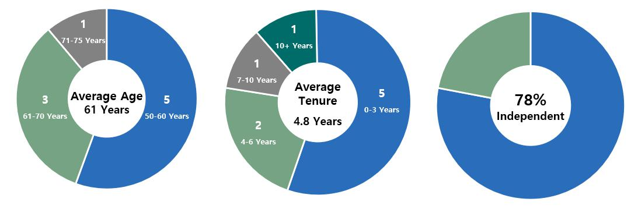

1. Metrics as of February 25, 2022.

The following table provides characteristics of our directors according to the categories required under Nasdaq listing standards.


Board Diversity Matrix (As of February 25, 2022)

 | Female |  | Male |  | Non-Binary | Did Not Disclose
 | Female |  | Male |  | Non-Binary | Gender
Part I: Gender Identity
Directors |  | 3 | 6 |  | 0 | 0
Part II: Demographic Background
African American or Black |  | 0 | 2 |  | 0 | 0
Alaskan Native or Native American |  | 0 | 0 |  | 0 | 0
Asian |  | 0 | 0 |  | 0 | 0
Hispanic or Latinx |  | 0 | 0 |  | 0 | 0
Native Hawaiian or Pacific Islander |  | 0 | 0 |  | 0 | 0
White |  | 3 | 4 |  | 0 | 0
Two or More Races or Ethnicities |  | 0 | 0 |  | 0 | 0
LGBTQ+ |  | 0 | 0 |  | 0 | 0
Did Not Disclose Demographic Background |  |  |  | 0

Oversight of Strategy and Key Risks

Our Board is responsible for the general oversight of the Company, including our strategic direction, the performance of our executive officers, environmental and social initiatives, and the Company’s risk management processes, to assure that the long-term interests of our stockholders are being served. In performing this oversight function, the Board, directly or through its standing committees, regularly reviews and discusses our corporate strategy and our material strategic, operational, financial, compensation, and compliance risks with senior management.

The Board receives updates from management at each regular meeting on the Company’s performance, market conditions, and other recent developments, including, among other things, risks and opportunities facing us, as well as the strategies used to hedge the Company’s exposure to market risks, including interest rate, spread, prepayment, and extension risks. The Board periodically reviews and discusses our broader business strategy with management and in executive session. The Board also regularly reviews our compliance with policies, procedures, risk limits, and processes addressing other operational risks. In addition to its regular quarterly meetings, the Board typically conducts an annual multi-day meeting devoted to reviewing the Company’s strategy, macro trends impacting our business, and other topics of interest to our directors, including relevant continuing education sessions. The Board's 2021 strategic meeting, which was originally scheduled to take place in-person in December 2021, was postponed due to increased health risks and logistical constraints resulting from the Pandemic and is expected to be held in the second quarter of 2022.

AGNC INVESTMENT CORP. - Proxy Statement 5

Table of Contents

BOARD AND GOVERNANCE MATTERS

The Board considers the Company's cybersecurity posture and risk exposure with management taking into consideration our operations and the

types of data retained on our systems as part of its periodic review of enterprise-wide risk management. Our primary business involves investments in mortgages and mortgage-related instruments. We do not currently perform mortgage servicing, maintain customer accounts, or provide any direct mortgage lending, and thus we do not receive personal information on individual mortgage borrowers as part of our regular operations. The Company contracts with third-party security firms to provide threat detection and conduct annual testing on our systems. The Board has delegated oversight of AGNC’s cybersecurity risk to the Audit Committee, which is also responsible for oversight of information technology and data security controls related to our financial reporting. The Audit Committee reviews the Company’s cybersecurity program and risk exposure with the Company’s Senior Vice President for Information Technology on at least an annual basis, and it receives reports from him on these matters at least quarterly. The Audit Committee may also conduct additional cybersecurity reviews or receive additional updates or reports as it deems necessary.

The Board recognizes the importance of effective executive leadership and the promotion of an ethical and professional culture throughout our organization. The Board and the Compensation Committee are actively engaged in overseeing succession planning, including a routine review of staffing for critical roles, considering the operational needs of the Company and the potential leadership, industry knowledge, and investment skills of existing employees. The completed transition of Mr. Kain to Executive Chair of the Board and the promotion of Messrs. Federico and Kuehl that took effect in July 2021 were consistent with our Board’s long-term commitment to sound succession planning and effective development of employees. Executives and other key employees in the Company are given exposure to the Board during meetings and other events to assist with their development and the Board’s evaluation. In addition, the Board receives updates on management’s strategies for recruiting, developing, and retaining outstanding personnel and minimizing employee turnover, as applicable. At least annually, the Audit Committee reviews employee compliance with our Code of Ethics, and the Compensation Committee annually reviews the sufficiency of the Code of Ethics.
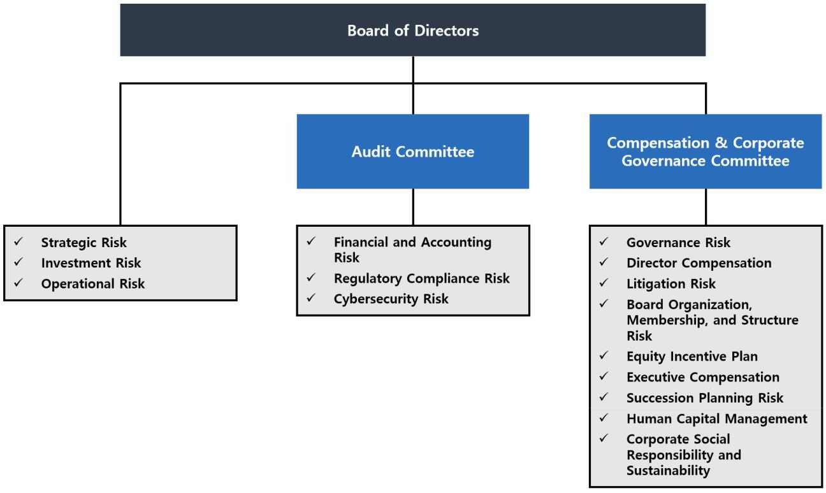

The Board has delegated certain risk management oversight responsibility to its committees as follows:

- Regulatory Compliance Risk: The Board, both directly and through the Audit Committee, receives regular reports from the Company’s legal, accounting, tax, and internal audit representatives on regulatory compliance matters, including the Company’s compliance with its REIT qualification and exemption from the Investment Company Act of 1940 and compliance with our Code of Ethics.

- Financial and Accounting Risk: The Audit Committee oversees the Company’s management of its financial and accounting systems, its internal control over financial reporting, and disclosure controls and procedures through regular meetings with our Chief Financial Officer, senior representatives of the Company’s accounting, internal audit, and legal departments, and representatives of the Company’s independent public accountant.

- Litigation Risk: The Compensation Committee monitors the Company’s litigation, if any.

- AGNC INVESTMENT CORP. - Proxy Statement

Table of Contents

BOARD AND GOVERNANCE MATTERS

- Governance Risk: The Compensation Committee also oversees risks related to Board organization, membership, structure, and corporate governance.

- Succession Planning and Human Capital Risk: The Compensation Committee is responsible for ensuring that a succession plan is in place for our executive officers and other key employees and overseeing the Company’s management and development of its human capital.

ESG and Corporate Responsibility

We understand the importance of incorporating environmental, social, and governance considerations into our business and day-to-day operations, and we appreciate the increased interest of our stockholders in these matters. We consider the interests of all our stakeholders—our stockholders, employees, lenders, other counterparties, vendors, and community—in pursuing the long-term success of our business. Our review and evaluation of corporate social responsibility is focused on two areas: our operations and our investment activity.

Our primary operational focus from a social perspective is our human capital. AGNC is committed to providing our employees an engaging, supportive, and inclusive atmosphere in which to grow professionally and contribute to our corporate objectives. We pride ourselves on providing a wide selection of resources to protect and promote our employees’ professional development, health, well-being, financial security, safety, and work-life balance. We offer our employees comprehensive benefits and participation in our long-term equity incentive program, and we have implemented programs that promote cross training, collaboration, and professional growth. We have also approached the workplace disruptions of the Pandemic with flexibility and ensured that the health and safety of our workforce is protected, while our business operations continue uninterrupted. As a 50 person organization engaged in managing a portfolio primarily consisting of mortgage-backed securities, our operations have a limited environmental impact, but we continuously evaluate opportunities to minimize our direct environmental effects.

From an investment perspective, our business supports home ownership in the United States, which has long been viewed as an important vehicle of individual wealth creation and aids in the development of strong communities. Our investments in residential mortgage-backed securities and other mortgage related instruments play a meaningful role in helping Americans become homeowners. As an investor predominantly in Agency mortgage-backed securities, we have limited insight into the location, age, or other characteristics of individual homes or the identity of the mortgage borrowers included in these investments. We expect to provide further disclosure on our efforts regarding social and environmental data and disclosure within the housing and mortgage sector in our 2022 ESG Report.

Our Board has elected to allocate oversight of ESG matters amongst the Board and our Compensation and Audit Committees rather than delegating responsibility for oversight of all ESG matters to a single committee. By separating areas of focus and attention encompassed within ESG considerations, each of these Committees and the Board govern and oversee areas of corporate responsibility within their respective areas of focus.

Our Compensation Committee oversees our approach to human capital management and development, the governance and operations of our Board (including its governance and oversight of corporate social responsibility and sustainability), and the composition and diversity of our Board. As part of its oversight of human capital management and corporate responsibility, the Compensation Committee receives reports on the results of employee surveys and updates from management regarding actions taken to promote development and engagement of our workforce. Our Audit Committee oversees our management’s governance of our business conduct in the areas of financial reporting, information security, legal and regulatory compliance, and compliance with our Code of Ethics. Our full Board oversees our investment guidelines, portfolio and risk management framework, and overall strategic direction, which incorporates our responsibility to the people and communities we serve.

In March 2021, we issued our inaugural ESG Report, which provided disclosures consistent with the Sustainability Accounting Standards Board disclosure framework and included information about our efforts to implement ESG factors in the operation of our business. Our ESG Report is available in the Corporate Responsibility section of our website at www.AGNC.com/corporate-responsibility.

Throughout 2021, we continued to consider opportunities to improve our ESG disclosure and practices and solicited the views of stakeholders, including our stockholders and employees, regarding these issues. As a result of this analysis and outreach, we expect to expand our disclosures by incorporating TCFD disclosures into our 2022 ESG Report, which we anticipate publishing in the second quarter of 2022.

Director Compensation

As described in more detail below, we compensate our independent directors with cash retainers and equity-based awards. Directors who are employees of the Company or our subsidiaries do not receive any compensation for service as a member of the Board, although we reimburse all directors for travel expenses incurred in connection with Board and committee meetings and Board-related functions. The Compensation Committee periodically reviews the form and amount of compensation paid to our independent directors to ensure it remains consistent with quality corporate governance practices. In these reviews, the Compensation Committee regularly consults with FW Cook for advice on the design and structure of the program, information on recent trends and

AGNC INVESTMENT CORP. - Proxy Statement | 7

Table of Contents

BOARD AND GOVERNANCE MATTERS

developments in non-employee director compensation, general industry data, and analyses of the competitiveness of our non-employee director compensation levels relative to comparable companies.

In 2021, independent directors received a cash retainer for service on the Board at the annual rate of $112,500, payable quarterly in advance. The 2021 cash retainer level was established in 2019 in consultation with FW Cook following the Compensation Committee’s review of market practices at a group of comparable companies and taking into consideration the level of work required of our directors. The Chairs of our Audit Committee and Compensation Committee each received an additional retainer at an annual rate of $25,000, each payable quarterly in advance. In 2021, the Compensation Committee recommended increasing the annual retainer paid to our Vice Chair and Lead Independent Director from $50,000 to $100,000, payable

quarterly in advance. In making this recommendation, the Compensation Committee considered the advice of FW Cook, comparable market practices for

compensation of independent board leadership positions, and its assessment of the level of work expected to be devoted to fulfilling the duties and responsibilities of the Lead Independent Director, including by serving as Vice Chair. After considering the recommendation of the Compensation Committee and materials prepared by FW Cook, the Board elected to increase the annual retainer for our Lead Independent Director effective July 1, 2021 to $100,000, payable quarterly in advance. The Compensation Committee, in consultation with FW Cook, concluded that the cash retainers for independent directors and committee chair positions remained reasonable for 2021 in light of the work expected in each role.

The Board believes that a substantial portion of director compensation should consist of equity-based compensation to assist in aligning the long-term interests of our directors with those of our stockholders. On April 22, 2021, each of our independent directors serving on the Board at that time received 8,481 RSUs under the Amended and Restated AGNC Investment Corp. 2016 Equity and Incentive Compensation Plan (the “2016 Equity Plan”), which is described in more detail below. The RSUs vest on the earlier of April 22, 2022 or the date of the 2022 Annual Meeting of Stockholders, subject to the director’s continued service on our Board through the vesting date. Each RSU represents the right to receive an equivalent number of shares of our common stock, plus dividend equivalents, subject to the terms of the 2016 Equity Plan. The grant date fair value of the 2021 RSU awards reflects an increase of $22,500 relative to RSU awards made to each independent director in 2020, which level had not been adjusted since 2015. The Compensation Committee recommended this increase in annual equity awards in consultation with FW Cook as part of its review of our director compensation relative to our compensation philosophy and objectives, comparable market practices for independent director compensation, and the work required of our directors.

The following table sets forth the compensation received by each independent director during 2021:

 | Fees Earned | Stock
 | or Paid in | Stock | Total
Name | Cash | Awards | Total
Name | ($) | ($) 1 | ($)
Donna J. Blank | 137,500 | 147,500 | 285,000
Morris A. Davis | 137,500 | 147,500 | 285,000
John D. Fisk | 112,500 | 147,500 | 260,000
Andy A. Johnson, Jr. ² | 112,500 | 147,500 | 260,000
Andy A. Johnson, Jr. ² | 22,077 | — | 22,077
Prue B. Larocca | 187,500 | 147,500 | 335,000
Paul E. Mullings | 112,500 | 147,500 | 260,000
Frances R. Spark | 112,500 | 147,500 | 260,000

- The amounts reported in the “Stock Awards” column represent the grant date fair value of each award granted calculated in accordance with Financial Accounting Standards Board ASC Topic 718, Compensation-Stock Compensation (“ASC 718”), as required by Securities and Exchange Commission (“SEC”) regulations. Each award represents the right to receive 8,481 shares of common stock (calculated by dividing the value of the award by the closing price of a share of common stock on the grant date, which was $17.39 on April 22, 2021). As of December 31, 2021, in connection with these awards, each independent director had unvested RSUs relating to 9,049 shares of common stock, including dividend equivalents on the RSUs.
- Mr. Johnson was appointed to the Board effective October 21, 2021.

The 2016 Equity Plan

The Company maintains the 2016 Equity Plan to provide our directors, executive officers, and other employees with equity incentive compensation. Stockholders initially approved the Company's equity plan in December 2016 and subsequently approved an amendment and restatement with 92.8% of the shares voted in support at the 2021 Annual Meeting. Subject to adjustment as described in the 2016 Equity Plan, total awards under the 2016 Equity Plan are currently limited to 40,000,000 shares, inclusive of dividend equivalents paid on such awards. These shares may be shares of original issuance or treasury shares or a combination of the two, and awards may be time-vested or performance-vested.

The 2016 Equity Plan authorizes the Compensation Committee to provide equity-based compensation in the form of stock options, appreciation rights, restricted shares, restricted stock units, performance shares, performance units, dividend equivalents, and certain other awards denominated or payable in, or otherwise based on, shares of common stock, plus cash incentive awards, for the purpose of providing our non-employee directors, officers, and other employees, and those of our subsidiaries, incentives and rewards for service or performance. The 2016 Equity Plan places a limit on the dollar value of awards and other compensation that may be made to a director in any year. Members of our Board may elect to defer distribution of their awards under the 2016 Equity Plan for a period of up to ten years.

- AGNC INVESTMENT CORP. - Proxy Statement

Table of Contents

BOARD AND GOVERNANCE MATTERS

Independent Director Plan

In connection with our IPO in 2008, we established the American Capital Agency Corp. Equity Incentive Plan for Independent Directors (the “Independent Director Plan”), which provided for the issuance of equity-based awards, including stock options, restricted stock, restricted stock units, unrestricted stock awards, and other awards based on our common stock that may be made by us to our independent directors. The Independent Director Plan was terminated when our stockholders approved the 2016 Equity Plan on December 9, 2016, except with respect to then outstanding awards. Restricted stock units awarded under the Independent Director Plan conferred to the participant the right to receive cash, common stock, or other property, as determined by the plan administrator, having a value equal to the number of shares of our common stock that were subject to the award. The holders of awards of restricted stock units were also entitled to receive dividend equivalents and could elect to defer distribution of their equity-based awards for a period of up to ten years.

Stock Ownership Guidelines

Our Board believes that directors more effectively represent the best interests of the Company if they are stockholders themselves. Thus, each independent director is encouraged to own shares of our common stock equal in value to at least 5x the annual cash retainer paid to independent directors (which was $112,500 in 2021) by the later of his or her fifth anniversary of joining the Board or the date of any increase in applicable ownership guideline levels. The Board revised these guidelines in 2021 to increase the guideline level of holdings for independent directors from 3x to 5x the annual cash retainer. Shares of deferred or restricted stock or units (both vested and unvested and including shares for which a deferral election was made) granted to directors under the Independent Director Plan and the 2016 Equity Plan are included in determining the number of shares held for this purpose. Until the stated minimum is met, each independent director must retain at least 50% of the shares of common stock received upon vesting, net of any shares withheld or sold to pay or reimburse taxes on such income.

In addition, our Board has adopted a policy prohibiting our executive officers and directors from any hedging, pledging, or entering into margin loans with respect to any shares of our common stock (regardless of whether such stock is owned directly or indirectly, as such terms are used in the SEC rules promulgated under the Exchange Act) or from engaging in short sales of our common stock or entering into any other transaction or derivative agreement where he or she would earn a profit or offset losses due to a decline of our stock price.

The following table sets forth the total stock ownership of our independent directors, including beneficially owned, unvested, and deferred shares, as calculated pursuant to our stock ownership guidelines as of February 25, 2022:

 | Beneficially | Unvested | Deferred | Total
Name | Owned | Shares | Shares | Total
Name | Shares (#) | (#) | (#) | (#)

Donna J. Blank

Morris A. Davis

John D. Fisk

Andy A. Johnson, Jr.

Prue B. Larocca

Paul E. Mullings

Frances R. Spark

Director Resignation Policy

Our Bylaws require a candidate in an uncontested election for director to receive a majority of the votes cast in order to be elected as a director. Under this provision, each vote is specifically counted “for” or “against” the director’s election, unless a common stockholder abstains from voting with respect to the matter. A director nominee is required to receive more votes “for” than “against” to be elected. Pursuant to Delaware law, a director shall remain in office until his or her successor is elected and qualified even if the director has not received a vote sufficient for re-election. Thus, a corporation could have a “holdover” director. However, pursuant to our Board-approved director resignation policy, an incumbent director must tender his or her resignation to the Board if the director is nominated but not re-elected. The policy also requires the Compensation Committee to make a recommendation to the full Board on whether to accept or reject the resignation within 90 days of receipt of the tendered resignation and the full Board to make that determination. The Board would publicly disclose its decision by filing a Current Report on Form 8-K with the SEC within four days of making its determination.

Any director who tenders his or her resignation pursuant to this policy may not participate in the Compensation Committee recommendation or Board action regarding whether to accept the resignation offer. If each member of the Compensation Committee does not receive a vote sufficient for re-election, then the independent directors who did receive a sufficient vote shall appoint a committee amongst themselves to consider the resignation offers and recommend to the Board whether to accept them. If only three or fewer directors receive a sufficient vote for re-election, all directors (other than the director who tendered the resignation under review) may participate in the action regarding whether to accept the resignation offers.

AGNC INVESTMENT CORP. - Proxy Statement 9

Table of Contents

BOARD AND GOVERNANCE MATTERS

Certain Transactions with Related Persons

Related Person Transaction Policies

Our Board has adopted a policy regarding the approval of any “related person transaction,” which is any transaction or series of transactions in which we or any of our subsidiaries is or are to be a participant, the amount involved exceeds $120,000, and a “related person” (as defined under SEC rules) has a direct or indirect material interest. Under the policy, a related person would need to promptly disclose to our Secretary any related person transaction and all material facts about the transaction. Our Secretary would then promptly assess and communicate that information to the Audit Committee. Based on its consideration of all of the relevant facts and circumstances, the Audit Committee will decide whether or not to approve such transaction and will generally approve only those transactions that do not create a conflict of interest. If we become aware of an existing related person transaction that has not been pre-approved under this policy, the transaction will be referred to the Audit Committee, which will evaluate all options available, including ratification, revision, or termination of such transaction. Our policy requires any director who may be interested in a related person transaction to recuse himself or herself from any consideration of such related person transaction.

Our Code of Ethics, which is reviewed annually by our Board and provided to all of our directors, officers, and employees, requires that all such persons avoid any situations or relationships that involve actual or potential conflicts of interest, or perceived conflicts of interest, between an individual’s personal interests and the interests of AGNC. Pursuant to our Code of Ethics, each of these persons must disclose any conflicts of interest, or actions or relationships that might give rise to a conflict, to their supervisor or our chief compliance officer. If a conflict is determined to exist, the person must disengage from the conflict situation or terminate his or her provision of services to us. Our president and chief executive officer, chief financial officer, principal accounting officer, controller, directors and certain other persons who may be designated by our Board or its Audit Committee, whom we collectively refer to as our financial executives, must consult with our chief compliance officer with respect to any proposed actions or arrangements that are not clearly consistent with our Code of Ethics. In the event that a financial executive desires to engage in a proposed action or arrangement that is not consistent with our Code of Ethics, the financial executive must obtain a waiver of the relevant provisions of our Code of Ethics in advance from our Audit Committee. We intend to post amendments to or waivers from the Code of Ethics (to the extent applicable to our financial executives) on our web site at www.AGNC.com.

Related Person Transactions

We did not enter into any transactions in 2021 in which any related person of ours had any material interest.

Compensation Committee Interlocks and Insider Participation

No member of the Compensation Committee during fiscal year 2021 served as an officer, former officer, or employee of ours or had a relationship required to be disclosed under “Board and Governance Matters—Certain Transactions with Related Persons.” Further, during 2021, none of our executive officers served as:

- a member of the compensation committee (or equivalent) of any other entity, one of whose executive officers served as one of our directors or was an immediate family member of a director, or served on our Compensation Committee; or

- a director of any other entity, one of whose executive officers or their immediate family member served on our Compensation Committee.

10 AGNC INVESTMENT CORP. - Proxy Statement

Table of Contents

PROPOSAL 1: ELECTION OF DIRECTORS

PROPOSAL 1: ELECTION OF DIRECTORS

Pursuant to our Certificate of Incorporation, our common stockholders elect each of the members of the Board annually. The term of each director will expire at the Annual Meeting. Each director has been nominated by the Compensation Committee of the Board, in accordance with our Bylaws, to stand for re-election at the Annual Meeting and to serve as a director until our Annual Meeting to be held in 2023 and until his or her successor is elected and qualified. It is expected that each of the nominees will be able to serve, but if any such nominee is unable to serve for any reason, the proxies reserve discretion to vote or refrain from voting for a substitute nominee or nominees. A common stockholder using the enclosed form of proxy can vote for or against any or all of the nominees or may abstain from voting for any or all of the nominees.

We believe that all of our nominees possess the personal and professional qualifications necessary to serve as a member of our Board and collectively represent a balance of industry knowledge, skills, and expertise. Our directors have been evaluated by the Compensation Committee pursuant to the guidelines described above under “Board and Governance Matters—Board Membership Criteria,” and the determination was made that each of them fulfills and exceeds the qualities that we look for in members of our Board. Mr. Kain is our Executive Chair and previously served as our Chief Executive Officer and Chief Investment Officer until July 1, 2021. Mr. Federico is our President and Chief Executive Officer. All other nominees are independent as defined in the Nasdaq rules.

Summary of Our Board’s Industry and Functional Expertise

We believe that our directors have a diversity of experience and a wide variety of skills and qualifications that strengthen their ability to provide guidance and oversight to the Company and management on behalf of stockholders.

The information set forth below with respect to each of our directors, each of whom is a nominee for election at the Annual Meeting, is as of February 25, 2022. The business address of each nominee is c/o AGNC Investment Corp., 2 Bethesda Metro Center, 12th Floor, Bethesda, Maryland 20814. We have highlighted specific attributes for each Board member below.

Director Nominee Biographies and Qualifications
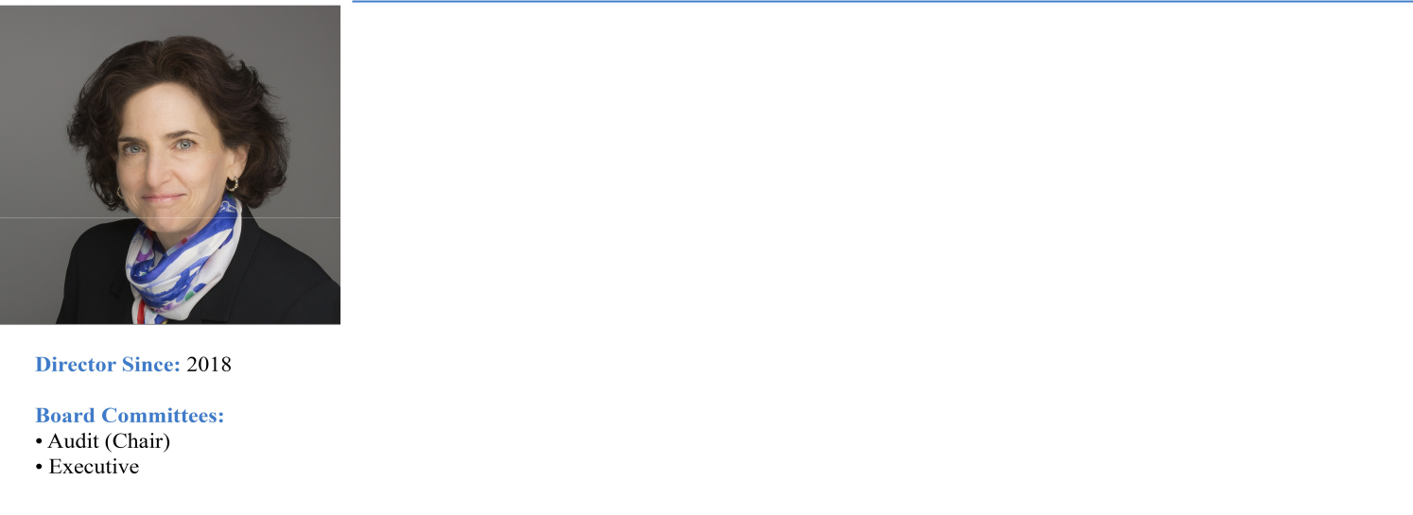

DONNA J. BLANK, 60

Professional Experience:
Ms. Blank is a finance executive with over 30 years of financial and operational experience, primarily in financial services. From 2015 through 2016, she was Chief Financial Officer at ZAIS Group, LLC, an alternative asset manager. While at ZAIS, Ms. Blank also served as the Chief Financial Officer of its externally managed publicly traded residential mortgage REIT and its public holding company. Prior to her role at ZAIS, she served as Chief Financial Officer and Executive Vice President at NFP Corp., a publicly traded insurance brokerage, from 2008 until 2013. From 2003 to 2008, Ms. Blank was Chief Financial Officer at Financial Guaranty Insurance Company, both before and subsequent to its sale by GE Capital to an investor group in late 2003. She has served as an independent director and member of the Audit Committee at American Enterprise Mutual Holding Company since March 2018 and has also served as chair of the Audit Committee since March 2020. Ms. Blank holds an MBA in Finance and a Master of International Affairs, both from Columbia University. Ms. Blank is an “audit committee financial expert” (as defined in Item 407 of Regulation S-K under the Securities Act).

Director Qualifications:
Ms. Blank’s extensive public company accounting and operational experience in the financial services sector, including her senior executive role at a publicly traded residential mortgage REIT, strengthens our Board’s collective qualifications, skills, experience, and viewpoints.

AGNC INVESTMENT CORP. - Proxy Statement 11

Table of Contents

PROPOSAL 1: ELECTION OF DIRECTORS

MORRIS A. DAVIS, 50

Professional Experience:
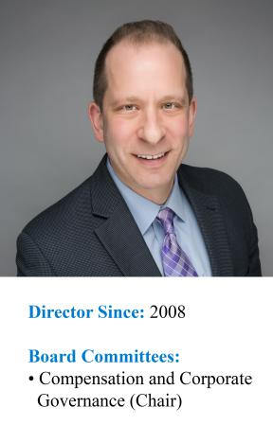
Dr. Davis is the Paul V. Profeta Chair of Real Estate and Academic Director of the Center for Real Estate at Rutgers Business School, where he has worked since September 2014. Dr. Davis is also currently an Adjunct Scholar at the American Enterprise Institute and is a Senior Scholar of the Opportunity and Inclusive Growth Institute of the Federal Reserve Bank of Minneapolis. Previously, Dr. Davis was the James A. Graaskamp Chair of Real Estate in the Department of Real Estate at the University of Wisconsin-Madison, where he worked from September 2006 through August 2014. Dr. Davis was also the Academic Director of the James A. Graaskamp Center for Real Estate at the University of Wisconsin-Madison. From July 2002 to August 2006, Dr. Davis was an economist at the Federal Reserve Board working in the Flow of Funds Section. From October 2001 to July 2002, he was Director of Yield Optimization at Return Buy, Inc. and from August 1998 to October 2001, Dr. Davis was an economist at the Macroeconomics and Quantitative Studies Section of the Federal Reserve Board. Dr. Davis also served on the board of directors of the SkyBridge Opportunity Zone Real Estate Investment Trust, Inc., a private REIT, from November, 2018 until September, 2019 where he was the chair of the valuation committee. Dr. Davis was also formerly on the Academic Advisory Council of the Federal Reserve Bank of Chicago and served as a Research Associate at the Federal Reserve Bank of Cleveland. Dr. Davis is widely published on issues related to the U.S. housing markets and a frequent lecturer. He holds a Ph.D. in Economics from the University of Pennsylvania.

Director Qualifications:
Dr. Davis’s extensive expertise in economics, housing policy, and finance matters strengthens our Board’s collective qualifications, skills, experience, and viewpoints.

PETER J. FEDERICO, 55

Professional Experience:
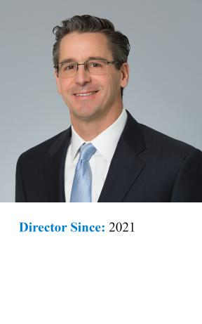
Mr. Federico has served as a Director and our Chief Executive Officer since July 2021 and as our President since March 2018. He previously served as our Chief Operating Officer from March 2018 until July 2021, as Executive Vice President and Chief Financial Officer from July 2016 until March 2018, and as Senior Vice President and Chief Risk Officer from June 2011 until our internalization in July 2016.

Prior to joining AGNC Investment Corp., Mr. Federico served as Executive Vice President and Treasurer of Freddie Mac from October 2010 through May 2011, where he was primarily responsible for managing the company’s investment activities for its retained portfolio and developing, implementing, and managing risk mitigation strategies. He was also responsible for managing Freddie Mac’s $1.2 trillion interest rate derivative portfolio and short- and long-term debt issuance programs. Mr. Federico also served in a number of other capacities at Freddie Mac, including as Senior Vice President, Asset & Liability Management, during his tenure with the company, which began in 1988.

Director Qualifications:
Mr. Federico’s knowledge and understanding of our business as our President and Chief Executive Officer and his expertise in risk mitigation strategies strengthens our Board’s collective qualifications, skills, experience, and viewpoints.

12 AGNC INVESTMENT CORP. - Proxy Statement

Table of Contents

PROPOSAL 1: ELECTION OF DIRECTORS

JOHN D. FISK, 65

Professional Experience:
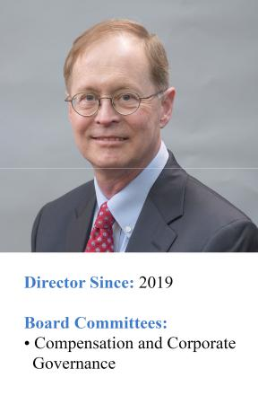
Mr. Fisk retired in March 2019 as the Chief Executive Officer of the FHLBanks Office of Finance, a division of the Federal Home Loan Banks that issues and services all debt securities for the regional Federal Home Loan Banks, supporting borrowings of $1 trillion. Mr. Fisk had previously served as the Deputy Managing Director and Chief Operating Officer of the FHLBanks Office of Finance from 2004 until 2007 when he became the Chief Executive Officer. Prior to joining the FHLBanks Office of Finance, Mr. Fisk was the Executive Vice President of Strategic Planning at MGIC Investment Corporation, one of the nation’s largest providers of mortgage insurance, from 2002 until 2004. Mr. Fisk also serves on the Board of Directors of Enact Holdings, Inc., where he chairs the Risk Committee and is a member of the Independent Capital Committee. Mr. Fisk holds an MBA in Finance and Public Management from The Wharton School at the University of Pennsylvania and a BA from Yale University.

Director Qualifications:
Mr. Fisk’s expertise in the US housing sector, including debt issuance and mortgage insurance, and his senior executive officer experience overseeing human capital management strengthens our Board’s collective qualifications, skills, experience, and viewpoints.

ANDREW A. JOHNSON, JR., 59
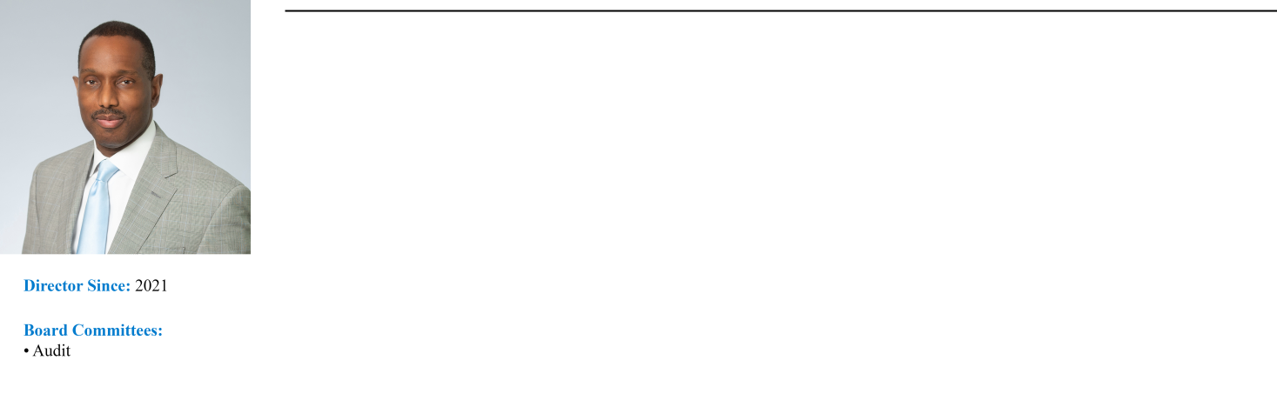

Professional Experience:
Mr. Johnson is an investment professional with over 20 years’ experience leading teams focused on fixed income investments. Mr. Johnson served as Managing Director, Head of Global Investment Grade Fixed Income and Chief Investment Officer for Neuberger Berman Investment Advisers, LLC and Neuberger Berman Fixed Income LLC from 2009 to 2019. He retired from his role as Managing Director and Chief Investment Officer in 2019 and transitioned to the role of Senior Diversity and Inclusion Leader at Neuberger Berman Services. In his current position, Mr. Johnson leads the firm’s efforts to improve diversity and inclusion in the workforce across Neuberger Berman entities. Prior to his roles at Neuberger Berman, from 2003 to 2009 Mr. Johnson was a Managing Director, Co-Head Investment Grade Fixed Income and Chief Investment Officer at Lehman Brothers Asset Management, LLC. He currently serves as a Non-Interested Trustee on the Board of Trustees of certain mutual funds advised by Hartford Mutual Funds, Inc. Mr. Johnson holds an MBA in Finance from the University of Chicago and a MSEE and BSEE from Illinois Institute of Technology.

Director Qualifications:
Mr. Johnson’s extensive background in fixed income investments and his experience working to improve diversity and inclusion in the workforce strengthens our Board’s collective qualifications, skills, experience, and viewpoints.

AGNC INVESTMENT CORP. - Proxy Statement 13

Table of Contents

PROPOSAL 1: ELECTION OF DIRECTORS

GARY D. KAIN, 57

Professional Experience:
Mr. Kain has served as the Executive Chair of our Board of Directors since July 2021 and has been a Director since March 2016. Previously, he was our Chief Executive Officer from March 2016 until July 2021, Chief Investment Officer from January 2009 until July 2021, and President from April 2011 until March 2018.
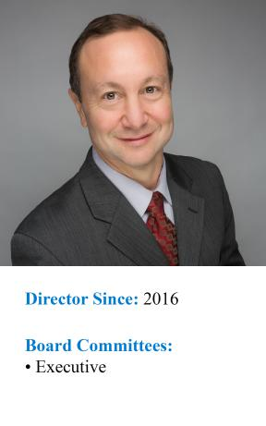

Prior to joining AGNC Investment Corp., Mr. Kain was Senior Vice President of Investments and Capital Markets of Freddie Mac from May 2008 to January 2009. He also served as Senior Vice President of Mortgage Investments & Structuring of Freddie Mac from February 2005 to April 2008, during which time he was responsible for managing all of Freddie Mac’s mortgage investment activities for the company’s $700 billion retained portfolio. From 2001 to 2005, Mr. Kain served as Vice President of Mortgage Portfolio Strategy at Freddie Mac. From 1995 to 2001, he was the head trader in Freddie Mac’s Securities Sales & Trading Group, where he was responsible for managing all trading decisions including REMIC structuring and underwriting, hedging all mortgage positions, income generation, and risk management. Prior to that, he served as a senior trader, responsible for managing the adjustable-rate mortgage and REMIC sectors. Mr. Kain previously served as a Director and Chief Executive Officer of MTGE Investment Corp. (Nasdaq: MTGE) from March 2016 until May 2018 and as Chief Investment Officer from March 2011 until May 2018. In addition, he served as President from March 2011 until March 2018 of MTGE.

Director Qualifications:
Mr. Kain’s extensive and lengthy expertise in the Agency mortgage sector and his deep knowledge of our business as our Chief Executive Officer and Chief Investment Officer strengthens our Board’s collective qualifications, skills, experience, and viewpoints.

PRUE B. LAROCCA, 70
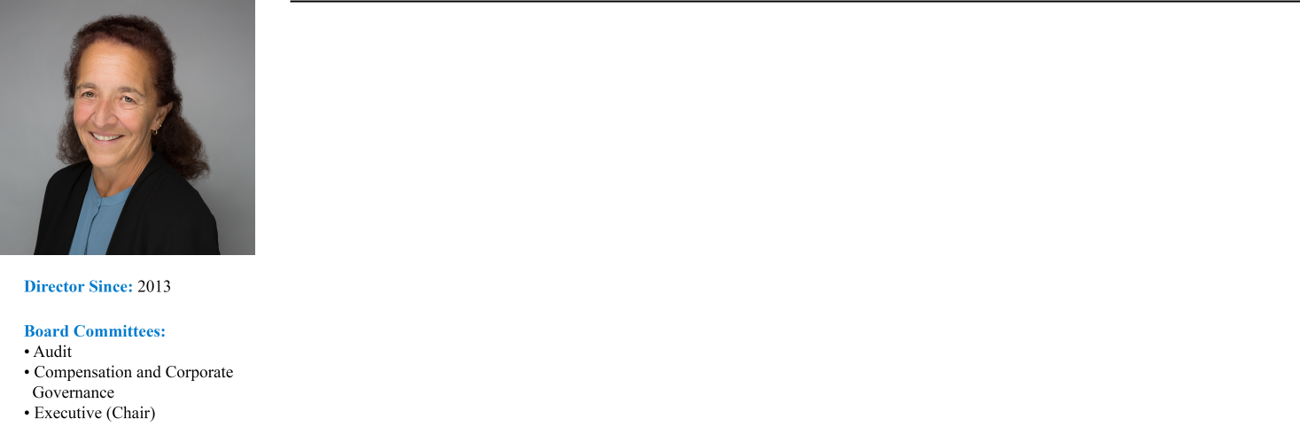

Professional Experience:
Ms. Larocca has served as our Lead Independent Director since May 2016 and has served as our Vice Chair since July 2021. She previously served as our Chair from May 2016 until July 2021. She is a retired investment banking executive and a widely recognized expert in the areas of housing finance and securitization. Ms. Larocca previously served as a member of the board of the Housing Preservation Foundation, the Washington School for Girls, and the American Securitization Trade Association. Ms. Larocca was a Managing Director of Royal Bank of Scotland (“RBS”) in the Mortgage Backed and Asset Backed Finance Group from 1997 until her retirement from RBS in 2011. Prior to joining RBS, Ms. Larocca was a Senior Vice President at Lehman Brothers in the mortgage finance business, managed the consumer and single-family securitization business for the Resolution Trust Corporation, and practiced law with the firms of Milbank, Tweed, Hadley and McCloy and Kutak Rock. She is a graduate of the Georgetown University Law Center and Indiana University.

Director Qualifications:
Ms. Larocca’s extensive and lengthy expertise in mortgage finance and asset securitization strengthens our Board’s collective qualifications, skills, experience, and viewpoints.

14 AGNC INVESTMENT CORP. - Proxy Statement

Table of Contents

PROPOSAL 1: ELECTION OF DIRECTORS

PAUL E. MULLINGS, 71
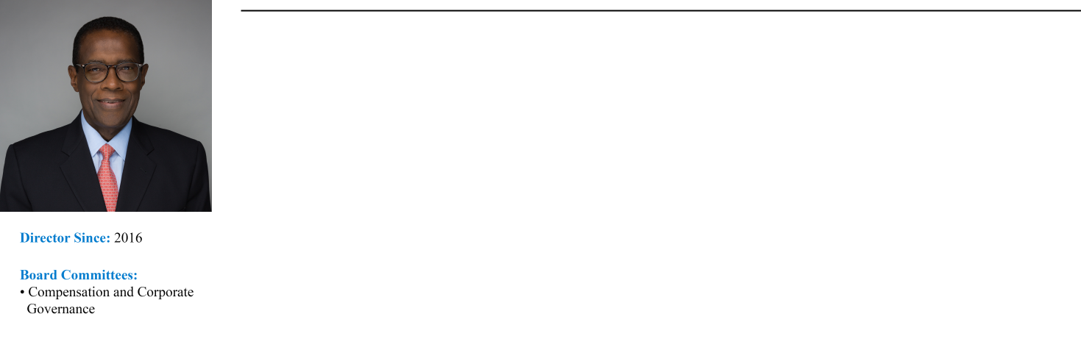

Professional Experience:
Mr. Mullings has over 40 years’ experience in the mortgage banking sector. Mr. Mullings served from 2015 until his retirement in 2020 as a Managing Director of The Collingwood Group, a SitusAMC company, a business advisory and risk management firm focused on the financial services industry. From 2005 to 2015, Mr. Mullings served as a Senior Vice President of Freddie Mac in the Single-Family Business division. While at Freddie Mac, he also served on the Operating, Management and Credit Risk Committees. Prior to joining Freddie Mac, Mr. Mullings was a Senior Vice President at J.P. Morgan Chase & Co. from 1997 to 2005 in the home finance area. Previously, Mr. Mullings was the President and Chief Executive Officer of the Mortgage Electronic Registration Systems, Inc. (MERS) and the President and Chief Executive Officer of the Residential Mortgage Division of the First Interstate Bank in Los Angeles. Mr. Mullings received his Overseas Certificate in Business Studies from the College of Arts, Science and Technology in Kingston, Jamaica, following which he became a Member of The Institute of Accounting Staff in conjunction with the Association of Certified Accountants in London, England.

Director Qualifications:
Mr. Mullings’ extensive senior executive officer experience in the mortgage banking sector and the secondary mortgage market strengthens our Board’s collective qualifications, skills, experience, and viewpoints.

FRANCES R. SPARK, 63

Professional Experience:
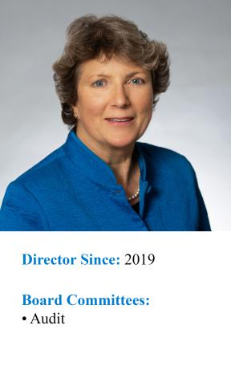
Ms. Spark is an experienced finance professional with broad expertise in mortgage finance and financial reporting for publicly traded companies, including mortgage REITs. Ms. Spark served as the Chief Financial Officer and Treasurer for CYS Investments, Inc., a publicly traded mortgage REIT that invested predominantly in Agency MBS, from 2009 through 2016. Prior to the internalization of CYS’s management in 2011, Ms. Spark also served as the Chief Financial Officer and Treasurer of CYS’s external manager, Sharpridge Capital Management, LP. She had served as a director and Audit Committee chair of CYS from its initial capitalization in 2006 until shortly after its initial public offering. Prior to CYS, Ms. Spark was the Chief Financial Officer for MVC Capital, Inc., a business development company, from 2003 until 2005. Ms. Spark’s career has included managing Spark Consulting, a privately owned strategic advisory and business consulting firm, and executive positions with financial services firms in the United States and the United Kingdom. She also served as an independent director and a member of the Audit and Risk Committees of Reverse Mortgage Investment Trust, a private finance company operating in the reverse mortgage industry, from

2015 to 2020. Ms. Spark is a Chartered Accountant and previously worked as an auditor with KPMG in the United Kingdom. She holds a BS from the University of Southampton in the United Kingdom. Ms. Spark is an “audit committee financial expert” (as defined in Item 407 of Regulation S-K under the Securities Act).

Director Qualifications:
Ms. Spark’s public company accounting, finance, and risk management expertise in the mortgage REIT sector, including her role as a senior executive officer at a publicly traded residential mortgage REIT, strengthens our Board’s collective qualifications, skills, experience, and viewpoints.

Conclusion and Recommendation; Vote Required

The election of directors nominated in Proposal 1 requires the affirmative vote of a majority of the votes cast by holders of our common stock at the Annual Meeting. The affirmative vote of a “majority” of the votes cast means that the number of votes cast “for” a director nominee must exceed the votes cast “against” that nominee. In the context of the election of nine directors at the Annual Meeting, it will mean that each of the nine candidates will be required to receive more votes “for” than “against” to be elected. Abstentions and broker non-votes will have no effect on the outcome of the proposal. THE BOARD OF DIRECTORS RECOMMENDS A VOTE FOR THE ELECTION OF ALL THE NOMINEES NAMED ABOVE.

AGNC INVESTMENT CORP. - Proxy Statement 15

Table of Contents

PROPOSAL 2: ADVISORY RESOLUTION TO APPROVE EXECUTIVE COMPENSATION

PROPOSAL 2:
ADVISORY RESOLUTION TO APPROVE EXECUTIVE COMPENSATION

General Information

As required by Section 14A of the Exchange Act, we are asking for your advisory vote to approve the compensation paid to our named executive officers as disclosed in this proxy statement. Our Board has determined to hold this “say-on-pay” vote every year.

We urge you to review carefully our compensation policies and decisions regarding our named executive officers as presented in the “Compensation Discussion and Analysis,” the accompanying compensation tables, and the related narrative disclosures section appearing on pages 24 to

- As described in detail in this proxy statement, we believe that our executive compensation program applies a pay-for-performance philosophy that effectively aligns the interests of our NEOs with those of our stockholders and allows us to attract, retain, and appropriately incent executives with the skills and experience necessary to achieve our key business objectives.

While the vote on this proposal is advisory in nature and not binding, the Board and the Compensation Committee will take the results of the vote into account in making future compensation decisions.

We are requesting our stockholders to approve, in a non-binding, advisory vote, the following resolution:

“RESOLVED, that the stockholders of the Company hereby approve the compensation paid to our named executive officers, as disclosed in the proxy statement for the 2022 Annual Meeting of Stockholders pursuant to the disclosure rules of the Securities and Exchange Commission, including the Compensation Discussion and Analysis, compensation tables, and related material disclosed in the proxy statement.”

Conclusion and Recommendation; Vote Required

The affirmative vote of a majority of all shares of common stock cast on the proposal is required for advisory approval of this proposal. Abstentions and broker non-votes will have no effect on the outcome of the proposal. THE BOARD OF DIRECTORS RECOMMENDS A VOTE FOR APPROVAL OF THE ADVISORY RESOLUTION ON EXECUTIVE COMPENSATION.

16 AGNC INVESTMENT CORP. - Proxy Statement

Table of Contents

PROPOSAL 3: RATIFICATION OF APPOINTMENT OF INDEPENDENT PUBLIC ACCOUNTANT

PROPOSAL 3:
RATIFICATION OF APPOINTMENT OF INDEPENDENT PUBLIC ACCOUNTANT

Ernst & Young LLP (“EY”) has served as our independent public accountant since our IPO. The Audit Committee evaluates EY’s performance on an annual basis and makes a determination as to whether the Company should re-engage EY or consider the engagement of another audit firm. At a meeting on February 17, 2022, the Audit Committee approved the appointment of EY to audit our financial statements for 2022. In making this determination, the Audit Committee carefully considered a number of factors including:

- EY’s independence, objectivity, and professional skepticism;
- EY’s significant knowledge of the Company’s operations, personnel, accounting policies and practices, internal control over financial reporting, and the impact of such knowledge on audit quality;
- EY’s significant industry and sector specific experience, including the number of other mortgage REITs audited by EY;
- the quality and efficiency of services provided by EY based on feedback from Audit Committee members and management;
- EY’s resources, capabilities, technical expertise, including sharing industry insights, trends, and latest practices with the Audit Committee and management;
- the quality and candor of EY’s communications;
- recent Public Company Accounting Oversight Board (PCAOB) reports on the firm;
- the appropriateness of fees charged for audit and non-audit services;
- EY’s compliance with, and practices regarding, the SEC’s rules requiring lead engagement partner rotation every five years; and
- the length of time EY has served as our independent public accountant, the benefits of longer tenure, and the impact of changing auditors.

Based on this evaluation, the Audit Committee determined that it was in the best interests of the Company and our stockholders to continue to engage EY as our independent public accountant. This appointment is subject to ratification or rejection by our common stockholders. A representative of Ernst & Young LLP is expected to be present at the Annual Meeting. The representative will have an opportunity to make a statement if he or she so desires and is expected to be available to respond to appropriate questions.

Independent Public Accountant’s Fees

EY performed various audit and other services for us during 2021 and 2020. Fees for professional services provided by EY in 2021 and 2020 in each of the following categories were:

 | 2021 | 2020
Audit Fees | $1,756,000 | $1,559,500
Audit-Related Fees | — | —
Tax Fees | 82,680 | 123,699
All Other Fees | — | —
Total Fees | $1,838,680 | $1,683,199

Audit Fees

“Audit Fees” relate to fees and expenses billed by EY for the annual audit, including the audit of our financial statements, services required by statute and regulation, audit of internal control over financial reporting, review of our quarterly financial statements, and for comfort letters and consents related to stock issuances.

Tax Fees

“Tax Fees” relate to fees billed for professional services for tax compliance and consulting on tax-related matters.

Pre-Approval Policy

All services rendered by EY were permissible under applicable laws and regulations and were pre-approved by the Audit Committee for 2021 in accordance with its pre-approval policy. The Audit Committee has established a policy regarding the pre-approval of all audit and permissible non-audit services provided by our independent public accountant. The policy requires the Audit Committee to approve each audit or non-audit engagement or accounting project involving the independent public accountant, and the related fees, prior to commencement of the engagement or project to make certain that the provision of such services does not impair the firm’s independence. The committee may delegate its pre-approval authority to one or more of its members, and such member(s) are required to report any pre-approval decisions to the Audit Committee at its next meeting. The Audit Committee has delegated authority to its Chair to pre-approve the engagement and related fees of the independent public accountant for any additional audit or permissible non-audit services. In addition, pursuant to the policy, pre-approval is not required for additional non-audit services if such services result in a de minimus amount of less than 5% of the total annual fees paid by us to the independent public accountant during the fiscal year in which the non-audit services are provided, were not recognized by us at the time of engagement to be non-audit services, and are reported to the Audit Committee promptly thereafter and approved prior to the completion of the annual audit.

AGNC INVESTMENT CORP. - Proxy Statement 17

Table of Contents

PROPOSAL 3: RATIFICATION OF APPOINTMENT OF INDEPENDENT PUBLIC ACCOUNTANT

Conclusion and Recommendation; Vote Required

The affirmative vote of the holders of a majority of all shares of our common stock cast on the proposal is required to ratify the appointment of our independent public accountant. Abstentions will have no effect on the outcome of the proposal. THE BOARD OF DIRECTORS RECOMMENDS A VOTE FOR RATIFICATION OF THE APPOINTMENT OF ERNST & YOUNG LLP AS OUR INDEPENDENT PUBLIC ACCOUNTANT FOR 2022.

18 AGNC INVESTMENT CORP. - Proxy Statement

Table of Contents

REPORT OF THE AUDIT COMMITTEE

REPORT OF THE AUDIT COMMITTEE

The Board of Directors has appointed an Audit Committee presently composed of four directors, Mss. Blank, Larocca, and Spark and
Mr. Johnson. Each of the directors is independent as defined in the Nasdaq rules. The Board of Directors has determined that Mss. Blank and Spark are each an “audit committee financial expert” (as defined in Item 407 of Regulation S-K under the Securities Act).

The Audit Committee’s responsibility is one of oversight as set forth in its charter, which is available in the Investors section of our website at ir.agnc.com/corporate-governance-documents. It is not the duty of the Audit Committee to prepare our financial statements, to plan or conduct audits, or to determine that our financial statements are complete and accurate and are in accordance with U.S. generally accepted accounting principles. Our management is responsible for preparing our financial statements and for maintaining internal controls. The independent auditors are responsible for auditing the financial statements and for expressing an opinion as to whether those audited financial statements fairly present our financial position, results of operations, and cash flows in conformity with U.S. generally accepted accounting principles.

The Audit Committee has reviewed and discussed our audited consolidated financial statements with management and with Ernst & Young LLP, our independent auditors for 2021.

The Audit Committee has discussed with Ernst & Young LLP the matters required to be discussed by the applicable requirements of the Public Company Accounting Oversight Board and the Securities and Exchange Commission.

The Audit Committee has received from Ernst & Young LLP the written statements required by Public Company Accounting Oversight Board Rule No. 3526, “Communications with Audit Committees Concerning Independence,” and has discussed Ernst & Young LLP’s independence with Ernst & Young LLP, and has considered the compatibility of non-audit services with the auditor’s independence.

Based on the review and discussions referred to above, the Audit Committee recommended to the Board of Directors that the audited consolidated financial statements for the year ended December 31, 2021 be included in our annual report on Form 10-K for the year ended December 31, 2021, for filing with the Securities and Exchange Commission.

The Audit Committee has approved the appointment of Ernst & Young LLP to serve as our independent public accountants for the year ending December 31, 2022 and has directed that the appointment of Ernst & Young LLP be submitted to our stockholders for ratification.

By the Audit Committee:
Donna J. Blank, Chair
Andrew A. Johnson, Jr.
Prue B. Larocca
Frances R. Spark

AGNC INVESTMENT CORP. - Proxy Statement 19

Table of Contents

PROPOSAL 4: APPROVAL OF AMENDMENTS TO OUR AMENDED AND RESTATED CERTIFICATE OF INCORPORATION ELIMINATING CERTAIN SUPERMAJORITY VOTING REQUIREMENTS

PROPOSAL 4:
APPROVAL OF AMENDMENTS TO OUR AMENDED AND RESTATED CERTIFICATE OF INCORPORATION ELIMINATING SUPERMAJORITY VOTING REQUIREMENTS

General Information

As part of our ongoing review and evaluation of our corporate governance practices, the Board has considered the advantages and disadvantages of the supermajority voting provisions in our Certificate of Incorporation. The Board believes that supermajority voting provisions can facilitate corporate governance stability by requiring broad stockholder support in order to effect fundamental changes. However, many investors and others believe that supermajority voting provisions conflict with principles of good corporate governance because the provisions may limit a board’s responsiveness and accountability to stockholders and restrict stockholder participation in corporate governance matters. After considering the advantages and disadvantages of the supermajority voting provisions and evaluating stockholder positions on the issue, on January 20, 2022, the Board approved and recommended that stockholders adopt certain amendments to our Certificate of Incorporation to replace the supermajority voting requirements with a majority voting standard.

Our Certificate of Incorporation currently includes supermajority voting requirements for amendments to certain provisions of our Certificate of Incorporation, amendments to our Bylaws, and removal of directors with or without cause. The Board is submitting the proposed amendments as three proposals for approval at the Annual Meeting, as described below. Stockholders will vote on Proposals 4A, 4B, and 4C separately, and the approval of each proposal is not conditioned on the approval of the other proposals. The proposed amendments to our Certificate of Incorporation would become effective upon the filing of a Certificate of Amendment with the Secretary of State of Delaware, which we would file promptly following the Annual Meeting if our stockholders approve the amendments.

Proposal 4A: Amendment to Eliminate the Supermajority Voting Standard for Certain Amendments to our Certificate of Incorporation

Article XII of our Certificate of Incorporation currently provides that the affirmative vote of the holders of at least 66% of the shares of all classes of capital stock then entitled to vote shall be required to amend, repeal, or adopt any provision inconsistent with Article V of the Certificate of Incorporation. Article V relates to the Company’s Board of Directors and includes provisions regarding the number, election, term, removal, and vacancies of directors and general powers of the Board. Proposal 4A requests that stockholders approve an amendment to delete the final sentence of Article XII requiring a supermajority vote. As a result of this amendment, the voting standard for amending any provision inconsistent with Article V would be the same standard as for amendments to other provisions of our Certificate of Incorporation and would require the affirmative vote of the holders of a majority of all the shares of the Company’s capital stock then entitled to vote generally in the election of directors. This majority vote requirement reflects the default voting standard under the Delaware General Corporation Law (the “DGCL”) for certificate of incorporation amendments.

The proposed amendment to Article XII also conforms certain language describing the voting standard in that Article to Section 5.5 to ensure identical language is used to describe the same voting standard throughout our Certificate of Incorporation.

The full text of the proposed amendment, marked to show the proposed deletion and insertion, is set forth in Appendix A of this proxy statement. The general description above of the amended provision on certain amendments to the Certificate of Incorporation is a summary and should be read in conjunction with, and is qualified in its entirety by reference to, the full text of the proposed amendment attached as Appendix A.

Proposal 4B: Amendment to Eliminate the Supermajority Voting Standard for Amendments to Our Bylaws

Article XI of our Certificate of Incorporation currently provides that stockholders may only adopt, amend, alter, change, or repeal the Bylaws of the Company by the affirmative vote of the holders of at least 66% of all classes of the Company’s capital stock entitled to vote generally in the election of directors. Proposal 4B requests that stockholders approve an amendment to Article XI to provide that stockholders may adopt, amend, alter, change, or repeal the Bylaws of the Company by the affirmative vote of the holders of a majority of all the shares of the Company’s capital stock then entitled to vote generally in the election of directors.

The proposed amendment to Article XI also conforms certain language describing the voting standard in that Article to Section 5.5 to ensure identical language is used to describe the same voting standard throughout our Certificate of Incorporation.

The full text of the proposed amendment, marked to show the proposed deletions and insertions, is set forth in Appendix B of this proxy statement. The general description above of the amended provision on amendment of the Company’s Bylaws is a summary and should be read in conjunction with, and is qualified in its entirety by reference to, the full text of the proposed amendment attached as Appendix B.

20 AGNC INVESTMENT CORP. - Proxy Statement

Table of Contents

PROPOSAL 4: APPROVAL OF AMENDMENTS TO OUR AMENDED AND RESTATED CERTIFICATE OF INCORPORATION ELIMINATING CERTAIN SUPERMAJORITY VOTING REQUIREMENTS

Proposal 4C: Amendment to Eliminate the Supermajority Voting Standard for Removal of Directors

Currently, Section 5.5 of our Certificate of Incorporation provides that stockholders may remove any director or the entire Board from office at any time with or without cause only by the affirmative vote of the holders of at least 66% of all shares of the capital stock of the Company entitled to vote generally in the election of directors. Proposal 4C requests that stockholders approve an amendment to this standard to provide that stockholders may remove directors with or without cause by the affirmative vote of the holders of a majority of all the shares of the Company’s capital stock then entitled to vote generally in the election of directors. This majority vote requirement reflects the default voting standard under the DGCL.

The full text of the proposed amendment, marked to show the proposed deletions and insertions, is set forth in Appendix C of this proxy statement. The general description above of the amended provision on removal of directors is a summary and should be read in conjunction with, and is qualified in its entirety by reference to, the full text of the proposed amendment attached as Appendix C.

As previously determined by the Board and announced by the Company, if Proposal 4C is not approved by the stockholders, the Company would continue not to enforce the supermajority voting requirement for the removal of directors reflected in Section 5.5 and will instead, to the extent permitted by law, allow such action, if any, to be determined under a majority voting standard.

Conclusion and Recommendation; Vote Required

The Board is submitting and recommending the amendments to the Certificate of Incorporation to replace supermajority voting provisions with a majority voting standard. The approval of Proposals 4A, 4B, and 4C each requires the affirmative vote by the holders of 66% of all shares of our common stock entitled to vote at the Annual Meeting. Abstentions and broker non-votes have the same effect as voting against Proposals 4A, 4B, or 4C. The Board believes that Proposals 4A, 4B, and 4C are each in our best interests and in the best interests of the stockholders and has unanimously approved the proposed amendments to the Certificate of Incorporation. THE BOARD RECOMMENDS A VOTE FOR THE APPROVAL OF PROPOSALS 4A, 4B, AND 4C TO AMEND THE CERTIFICATE OF INCORPORATION TO REPLACE SUPERMAJORITY VOTING REQUIREMENTS WITH A MAJORITY VOTING STANDARD.

AGNC INVESTMENT CORP. - Proxy Statement 21

Table of Contents

EXECUTIVE OFFICERS

EXECUTIVE OFFICERS OF REGISTRANT

Executive Officer Biographies

The Board generally elects officers annually following our annual meeting of stockholders to serve until the meeting of the Board following the next annual meeting. Set forth below is certain information about each executive officer as of February 25, 2022. The business address of each executive officer is c/o AGNC Investment Corp., 2 Bethesda Metro Center, 12th Floor, Bethesda, Maryland 20814.

GARY D. KAIN, 57
Director, Executive Chair

Mr. Kain has served as a Director since 2016 and as our Executive Chair since July 2021. He previously served as our Chief Executive Officer from March 2016 through July 2021, Chief Investment Officer from January 2009 through July 2021, and President from April 2011 until March 2018. Further information about Mr. Kain may be found under “Proposal 1: Election of Directors-Director Nominee Biographies and Qualifications” of this proxy statement.

PETER J. FEDERICO, 55
Director, President and Chief Executive Officer

Mr. Federico has served as a Director and as our Chief Executive Officer since July 2021 and as our President since March 2018. He previously served as our Chief Operating Officer from March 2018 until July 2021, Executive Vice President and Chief Financial Officer from July 2016 until March 2018, and Senior Vice President and Chief Risk Officer from June 2011 until July 2016. Further information about Mr. Federico may be found under “Proposal 1: Election of Directors-Director Nominee Biographies and Qualifications” of this proxy statement.

CHRISTOPHER J. KUEHL, 48
Executive Vice President, Agency Portfolio Investments and Chief Investment Officer

Mr. Kuehl has served as our Chief Investment Officer since July 2021 and as an Executive Vice President since November 2016. He was previously a Senior Vice President from March 2012 through October 2016.

Prior to joining AGNC Investment Corp., Mr. Kuehl served as Vice President of Mortgage Investments & Structuring of Freddie Mac. In this capacity, Mr. Kuehl was responsible for directing Freddie Mac’s purchases, sales, and structuring activities for all MBS products, including fixed-rate mortgages, ARMs, and CMOs. Prior to joining Freddie Mac in 2000, Mr. Kuehl was a Portfolio Manager with TeleBank/Etrade Bank.

BERNICE E. BELL, 50
Executive Vice President and Chief Financial Officer

Ms. Bell has served as our Executive Vice President since January 2022 and Chief Financial Officer since March 2018. Ms. Bell previously served as Senior Vice President from January 2016 to January 2022, Chief Accounting Officer from January 2016 to March 2018, Vice President from April 2011 to January 2016, and as our Controller from 2008 through December 2015.

Prior to joining AGNC Investment Corp., Ms. Bell served as the Vice President and Controller of American Capital, Ltd. from July 2003 to December 2009. Prior to joining American Capital, Ms. Bell was the Vice President and Controller of certain privately-held companies engaged in the business of telecommunications and software development from July 1998 to June 2003 and was with the accounting firm Price Waterhouse, LLP from July 1994 to June 1998.

KENNETH L. POLLACK, 54
Executive Vice President, General Counsel, Chief Compliance Officer, and Secretary

Mr. Pollack has served as our Executive Vice President since January 2022 and our General Counsel, Chief Compliance Officer, and Secretary since July 2016. Mr. Pollack previously served as Senior Vice President from July 2016 until January 2022.

Prior to joining AGNC Investment Corp., Mr. Pollack was Senior Vice President and Deputy General Counsel of American Capital, Ltd. At American Capital, Mr. Pollack served as lead counsel for American Capital’s portfolio investment activities in the areas of Real Estate, U.S. Sponsor Finance, U.S. Buyouts, International Power, Special Situations, Operations, and Financial Restructuring.

22 AGNC INVESTMENT CORP. - Proxy Statement

Table of Contents

EXECUTIVE OFFICERS

Mr. Pollack joined American Capital in 2004. Prior to American Capital, Mr. Pollack was a member of the Corporate and Securities and Real Estate Practice Groups of Arnold & Porter.

SEAN P. REID, 46
Executive Vice President, Strategy and Corporate Development

Mr. Reid has served as our Executive Vice President, Strategy and Corporate Development since January 2022. He previously served as Senior Vice President from July 2016 until January 2022 and as Senior Vice President, Corporate and Business Development from August 2013 to July 2016 for our former manager.

Mr. Reid was previously a Vice President in the Washington, D.C. Buyouts group of American Capital, Ltd. and, prior to that, an Assistant General Counsel with American Capital’s in-house legal team. Prior to joining American Capital, Mr. Reid was an Associate in the Corporate & Securities practice group of Covington & Burling in Washington, D.C.

AGNC INVESTMENT CORP. - Proxy Statement 23

Table of Contents

EXECUTIVE COMPENSATION

 | EXECUTIVE COMPENSATION
 | Compensation Discussion and Analysis
2021 NEOs
Our NEOs for 2021 are:
Name | Title
Peter J. Federico | President and Chief Executive Officer
Gary D. Kain | Executive Chair, Formerly Chief Executive Officer and Chief Investment Officer*
Christopher J. Kuehl | Executive Vice President and Chief Investment Officer
Bernice E. Bell | Executive Vice President and Chief Financial Officer
Aaron J. Pas | Senior Vice President, Non-Agency Portfolio Investments
Kenneth L. Pollack | Executive Vice President, General Counsel, Chief Compliance Officer, and Secretary

* Mr. Kain transitioned to the role of Executive Chair of our Board of Directors effective July 1, 2021.

Executive Summary

This Compensation Discussion and Analysis provides information on our executive compensation philosophy, objectives, and structure, and our process for setting compensation for our named executive officers, or NEOs.

Business Overview

AGNC is a leading provider of private capital to the U.S. housing market, enhancing liquidity in the residential real estate mortgage markets and, in turn, facilitating home ownership in the U.S. AGNC is an internally managed REIT that invests predominantly in Agency residential mortgage-backed securities on a leveraged basis. We seek to provide investors with attractive risk-adjusted returns over a wide range of market scenarios through monthly dividends and tangible net asset value accretion, while maintaining the lowest operating cost structure among residential mortgage REITs. We generate income from the interest earned on our investment assets, net of associated borrowing and hedging costs, and net realized gains and losses on our investments and hedging activities. As such, our business operations are similar to investment managers that focus on fixed income investments, although we exclusively invest AGNC’s capital rather than third-party client funds.

24 AGNC INVESTMENT CORP. - Proxy Statement

Table of Contents

EXECUTIVE COMPENSATION

Our Business in the Context of our Broader Industry

We are the second largest residential mortgage REIT overall by market capitalization, total assets, and total equity when compared to the 18 other residential-focused mortgage REITs included in the The Bloomberg Mortgage REIT Index (BBREMTG) as of December 31, 2021, and we refer to these other 18 REITs collectively as the “Resi mREIT Universe.” Some of these 18 REITs have an investment focus similar to AGNC, but most of these REITs have strategies that place a greater emphasis on credit-sensitive assets than our portfolio. Moreover, most mortgage REITs in the Resi mREIT Universe are externally managed by a third party and pay the third party a management fee as a set percentage of equity (plus, in some cases, a performance incentive fee) in lieu of compensating employees directly. In an external management structure, the third-party manager, rather than the REIT, is responsible for the compensation and benefits of its executives and other employees, which are paid out of the management fee. As an internally managed REIT, AGNC is directly responsible for determining executive compensation and providing disclosure regarding its compensation philosophy and programs. We believe our internal management structure allows us to closely align our compensation programs to our and our stockholders' long-term interests.

AGNC seeks to generate attractive risk-adjusted returns for our stockholders and offers a track-record of industry leading financial performance and the lowest cost operating structure in the residential mortgage REIT industry. Our value proposition to stockholders includes five key aspects of our business:
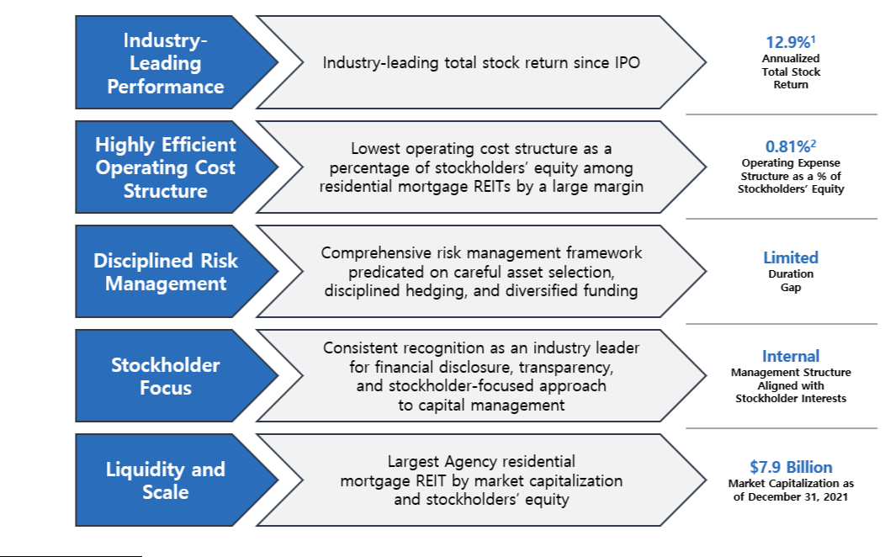

- Annualized total stock return is measured from AGNC’s IPO in 2008 through December 31, 2021. Total stock return over a period includes price appreciation and dividend reinvestment; dividends are assumed to be reinvested at the closing price of the security on the ex-dividend date. Source: S&P Global Market Intelligence.
- AGNC’s operating cost structure is based on average stockholders’ equity for the twelve-month period ended December 31, 2021; it includes compensation and benefits and general and administrative expenses and, if applicable, excludes one-time or nonrecurring charges.

AGNC INVESTMENT CORP. - Proxy Statement 25

Table of Contents

EXECUTIVE COMPENSATION

Recent Performance


2021 Performance Highlights:

AGNC significantly outperformed our Agency REIT Peer Group¹ on both an economic and total stock return basis despite the substantial volatility in 2021 driven by the continuing Pandemic and speculation regarding the ultimate path of Federal Reserve monetary policy actions, including reductions in asset purchases, interest rate hikes, and balance sheet normalization. In addition, while our primary focus remains on generating risk-adjusted returns for our stockholders, AGNC executed upon a number of strategic and operational initiatives in 2021 to enhance our franchise value.

Highlights of our financial performance in 2021 include:

- Annual economic return of 2.9%, which was the highest economic return within our Agency REIT Peer Group and materially exceeded our Agency REIT Peer Group average return of -6.7% in 2021

- 1-, 3- and 5-year annualized total stock returns of 5%, 5%, and 7%, respectively, significantly better than the Agency REIT Peer Group average, which generated negative total stock returns over each corresponding period at -1%, -10%, and -4%, respectively

- Operating Expenses for 2021 were 0.81% as a percentage of Stockholders’ Equity, the lowest among residential mortgage REITs and a fraction of the average of our Agency REIT Peer Group at 2.53% for the twelve-month period ended September 30, 2021, the most recent date for which sufficient data is available

In addition to our strong financial performance relative to our Agency REIT Peer Group, we also completed or advanced a number of strategic and operational initiatives in 2021:

- Completed our previously announced management succession on July 1 without disruption

- Published our inaugural ESG report in March, providing insight into our commitment to the core principles of ESG and approach to key ESG topics such as human capital management, diversity and inclusion, business ethics, risk management, corporate governance, and environmental stewardship

- Conducted significant outreach and engaged with the investment community (including current stockholders), ESG rating agencies and other stakeholders regarding our ESG report and practices and continued our annual Fall engagement campaign with institutional investors and proxy advisors on governance, executive compensation, and other topics

- Took significant actions to enhance employee development, engagement, health, and well-being as the Pandemic entered its second year

- Enhanced our IT infrastructure, including migration to the cloud, to bolster information security and enhance AGNC’s hybrid work model

- Established custody clearing / settlement services at AGNC’s captive broker-dealer, generating substantial cost savings and reducing exposure to third-party custodial operations

- Repurchased $257 million² of common stock at meaningful discounts to tangible net book value

In recognition of AGNC’s investor relations and employee engagement efforts, AGNC received the 2021 Nareit Gold Investor CARE Award and was certified as a “Great Place to Work™.”

- Our Agency REIT Peer Group is unweighted and includes Annaly Capital Management, Inc. (“NLY”), ARMOUR Residential REIT, Inc. (“ARR”), Dynex Capital, Inc. (“DX”), Invesco Mortgage Capital Inc. (“IVR”), and Two Harbors Investment Corp. (“TWO”), (collectively, the “Agency REIT Peer Group”).
- Excludes shares repurchased in December 2020 that settled in January 2021.

26 AGNC INVESTMENT CORP. - Proxy Statement

Table of Contents

EXECUTIVE COMPENSATION
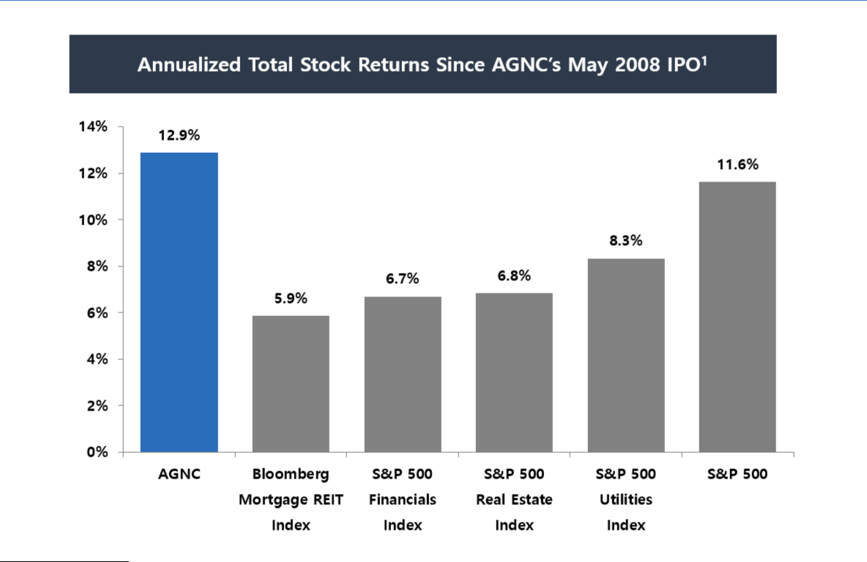

- Total stock return is measured from AGNC’s IPO through December 31, 2021. Total stock return over a period includes price appreciation and dividend reinvestment; dividends are assumed to be reinvested at the closing price of the security on the ex-dividend date. Source: S&P Global Market Intelligence and Bloomberg.

AGNC INVESTMENT CORP. - Proxy Statement 27

Table of Contents

EXECUTIVE COMPENSATION
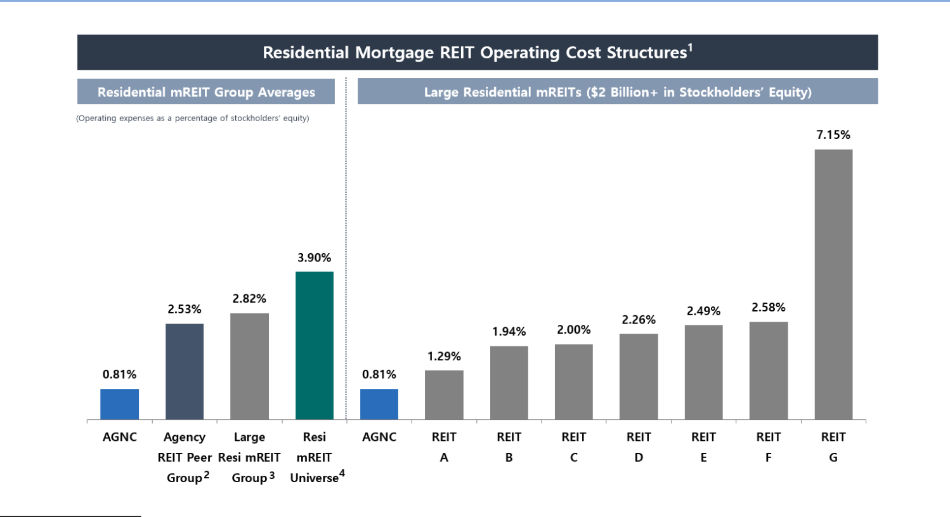

- For all mortgage REITs (“mREITs”) other than AGNC, cost structures are based on operating expenses and average stockholders’ equity (excluding noncontrolling interests, as applicable) over the trailing twelve-month period ended September 30, 2021 as publicly reported by such REITs. Operating costs include expenses for compensation and benefits, management fees, incentive fees (if applicable), and general and administrative expenses. To the extent publicly disclosed by such REITs, operating costs exclude one-time or nonrecurring expenses and direct costs associated with operating activities, such as loan acquisition costs, securitization costs and servicing expenses. AGNC’s operating cost structure is based on average stockholders’ equity for the twelve-month period ended December 31, 2021; it includes compensation and benefits and general and administrative expenses and, if applicable, excludes one-time and nonrecurring charges. Source: Company filings and S&P Global Market Intelligence.

- For Agency-focused residential mortgage REIT peer comparison purposes, AGNC’s peer group is unweighted and includes Annaly Capital Management, Inc. (“NLY”), ARMOUR Residential REIT, Inc. (“ARR”), Dynex Capital, Inc. (“DX”), Invesco Mortgage Capital Inc. (“IVR”), and Two Harbors Investment Corp. (“TWO”), (collectively, the “Agency REIT Peer Group”).

- The large residential mREIT group is unweighted and includes residential mREITs with greater than $2 billion in total stockholders’ equity as of September 30, 2021: Chimera Investment Corporation (“CIM”), MFA Financial, Inc. (“MFA”), NLY, New Residential Investment Corp. (“NRZ”), New York Mortgage Trust, Inc. (“NYMT”), PennyMac Mortgage Investment Trust (“PMT”), and TWO (collectively, the “Large Resi mREIT Group”).
- The residential mREIT universe is unweighted and includes the Agency REIT Peer Group, the Large Resi mREIT Group in addition to Great Ajax Corp. (“AJX”), Cherry Hill Mortgage Investment Corporation (“CHMI”), Ellington Financial, Inc. (“EFC”), Ellington Residential Mortgage REIT (“EARN”), AG Mortgage Investment Trust, Inc. (“MITT”), Orchid Island Capital, Inc. (“ORC”), Redwood Trust, Inc. (“RWT”), and Western Asset Mortgage Capital Corporation (“WMC”) (collectively, the “Resi mREIT Universe”).

Compensation Philosophy and Objectives

Compensation Program Objectives

The compensation programs for all of our employees, including our NEOs, are designed to focus on key strategic and financial objectives including:

Pay-for-Performance |  | Link compensation to achievement of short- and long-term financial and strategic goals
Attraction and Retention |  | Attract and retain a high-quality team with skills necessary to outperform industry peers and achieve AGNC’s
 |  | strategic objectives
Alignment with Stockholders |  | Align the interests of executive officers, employees, and stockholders by tying elements of realized compensation to
 |  | stockholder value
Financial Efficiency |  | Maintain a low-cost operating structure that maximizes financial efficiency from a tax, accounting, and cash flow
 |  | perspective
Strong Compensation |  | Employ high quality practices in governance of executive compensation
Governance
28 | AGNC INVESTMENT CORP. - Proxy Statement

Table of Contents

EXECUTIVE COMPENSATION

In support of these objectives, AGNC provides all of its employees total compensation in the form of base salary, annual performance-based incentives, and long-term incentive awards. The following describes the components of our NEO compensation program.
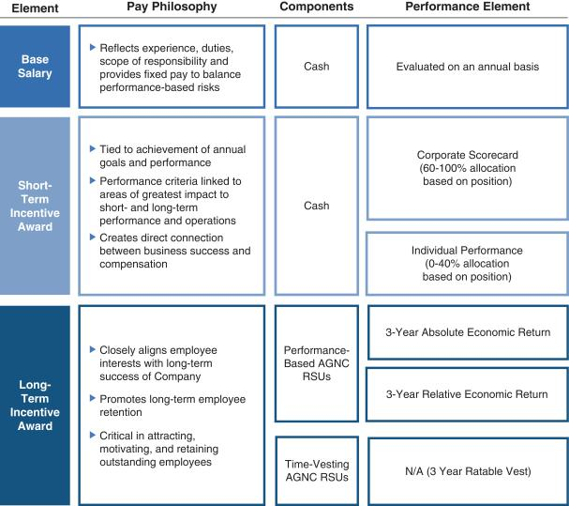

AGNC INVESTMENT CORP. - Proxy Statement 29

Table of Contents

EXECUTIVE COMPENSATION

Stockholder Engagement

In 2021, 92% of our stockholders present or represented at the meeting and entitled to vote on the matter supported our advisory resolution on executive compensation, which we believe reflects the positive support for the construction of our executive compensation program after taking into account stockholder feedback.

We value regular engagement with our stockholders, including through our quarterly earnings calls, investor conferences, fall and spring engagement campaigns, and outreach through our Investor Relations department. We continued our robust program in 2021 in spite of the limitations imposed by the Pandemic. Throughout the year, we participated in 11 investor conferences, held over 85 meetings and calls with institutional investors, and responded to over 320 letters, emails, and calls from retail investors. We engaged with our retail investors through our Investor Relations Department and as facilitated through collaboration with our proxy solicitor. In the Fall of 2021 and early 2022, we sought meetings with institutional stockholders holding 74% of our institutionally-held common stock and comprising 51% of our outstanding common stock to engage on governance related topics, including executive compensation. Many of our institutional investors declined our request, noting that there was no need to engage this year. Stockholders with whom we met expressed support for the handling of our leadership transition and did not voice concerns about our executive compensation program.

We continuously work to improve our stockholder engagement efforts and value the feedback provided to us during this process. Engagement with our stockholders regarding our compensation policies and practices has played a significant role in the evolution of our compensation program.

30 AGNC INVESTMENT CORP. - Proxy Statement

Table of Contents

EXECUTIVE COMPENSATION

Summary of Compensation Changes for 2021

The Compensation Committee continually evaluates our compensation program and considers stockholder feedback, industry trends, and comparative pay analysis. In 2021, the compensation packages for Messrs. Kain, Federico, and Kuehl were adjusted as a result of the promotion of Messrs. Federico and Kuehl to the roles of Chief Executive Officer and Chief Investment Officer, respectively, and Mr. Kain’s transition to the role of Executive Chair. The base salaries for Messrs. Federico and Kuehl remain unchanged in 2021, but each received increases in their target bonus levels and their target LTI. As a result of these changes, our CEO's target total direct compensation for 2021 was $7,000,000, and his target total direct compensation for 2022 is set at $9,000,000. Mr. Kain’s base salary, target bonus, and target LTI were reduced as a result of his transition to the role of Executive Chair of our Board and corresponding adjustment in his day to day responsibilities to the Company, though 67% of his LTI continues to be allocated to performance-based RSUs. After examining compensation practices at comparable companies and considering the roles and functions performed by our other NEOs, the Compensation Committee also increased target annual compensation for Messrs. Pas and Pollack and Ms. Bell to the levels reflected in this Compensation Discussion and Analysis. These changes have significantly narrowed the pay gap between our CEO and other executive officers.

Composition of NEO Compensation

Under the Compensation Committee’s philosophy, incentive compensation should be a substantial component of each executive’s total compensation package. All executives receive at least 40% of their total compensation in the form of LTI, with at least 50% and up to 67% of LTI awards at target being performance vesting. The charts demonstrate the pay mix for our NEOs based on the annualized target pay rates for Messrs. Federico, Kain, and Kuehl in their respective roles as of December 31, 2021.
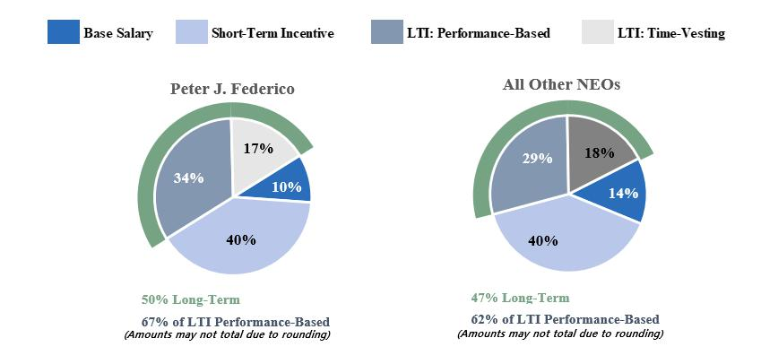

AGNC INVESTMENT CORP. - Proxy Statement 31

Table of Contents

EXECUTIVE COMPENSATION

Compensation Governance Practices

To support our compensation philosophy and objectives, we are committed to the following compensation governance practices:

What we do:

- Focus on retention of high-performing employees
- Pay for performance
- Align executive and stockholder interests
- Impose stock ownership guidelines for our executive officers
- Prohibit our directors and executive officers from hedging, pledging, and short selling Company stock
- Engage an independent compensation consultant
- Maintain a clawback policy
- Provide long-term equity incentive compensation to all of our employees
- Conduct an annual review of our compensation program based on market conditions, performance, and stockholder feedback

What we don’t do:

- Pay based on a percentage of assets under management
- Tax gross-ups
- Provide special perquisites for executives
- Maintain supplemental retirement benefits
- Make option grants below fair market value
- Reprice stock options
- Provide for “single-trigger” severance or vesting acceleration

Compensation Program in Detail

Compensation Program Elements

The Compensation Committee believes it is important to pay our NEOs in a manner that balances short- and long-term compensation and cash and equity-based compensation. Our NEOs’ compensation program includes three primary elements: base salary, short-term incentives in the form of an annual cash bonus, and long-term equity incentives, with a significant portion subject to multi-year performance-based vesting.

The Compensation Committee’s philosophy on pay mix applies throughout the entire organization, with all AGNC employees receiving a portion of their compensation in the form of short-term and long-term incentives. The proportion of an individual’s target total direct compensation opportunity in the form of variable incentive-based elements relative to fixed elements is directly correlated to the individual’s level of responsibility and role in the organization. Employees with greater seniority and greater responsibility have higher proportions of incentive-based compensation in their target mix. Similarly, within the incentive-based elements, the proportion of LTI generally corresponds with the individual’s level of responsibility in the organization.

Base Salary

Base salary provides a baseline level of cash compensation to our NEOs and is a fixed expense for the Company. The Compensation Committee established base salaries for our NEOs considering a variety of factors, including:

- the competitive market for executive officers
- the scope of each executive officer’s responsibilities
- the highly complex and unique services provided by our NEOs
- the desire to retain our NEOs
- the duties and responsibilities of the NEOs
- internal and external pay equity

The Compensation Committee reviews the base salaries for our NEOs annually and at the time of a promotion or other change in responsibilities, and salaries may be adjusted after considering the above factors. The annual base salaries set forth in the

32 AGNC INVESTMENT CORP. - Proxy Statement

Table of Contents

EXECUTIVE COMPENSATION

table below are the minimum levels required in each executive’s respective employment agreement and, except for Messrs. Kain and Pas, are unchanged from their 2019 and 2020 levels.

NEO | 2021 Base Salary | 2022 Base Salary
Peter J. Federico | $900,000 | $900,000
Gary D. Kain | $700,000 ¹ | $500,000
Christopher J. Kuehl | $900,000 | $900,000
Bernice E. Bell | $500,000 | $500,000
Aaron J. Pas | $450,000 | $450,000
Kenneth L. Pollack | $500,000 | $500,000

1. Mr. Kain’s annual base salary rate declined from $900,000 to $500,000 at the time of his transition to the role of Executive Chair on July 1, 2021.

Annual Bonus

The Compensation Committee has established performance criteria for short-term incentives that directly correspond to the areas of greatest impact to our short- and long-term performance and operations, creating a direct connection between business success and our NEOs' compensation. Each NEO’s target for short-term incentive compensation, set forth in the table below, is determined based on an evaluation of the same factors used in setting base salaries.

NEO | 2021 Target Annual Bonus | 2022 Target Annual Bonus
Peter J. Federico | $2,700,000 ¹ | $3,600,000
Gary D. Kain | $4,500,000 ² | $3,600,000
Christopher J. Kuehl | $1,800,000 ³ | $2,000,000
Bernice E. Bell | $1,000,000 | $1,250,000
Aaron J. Pas | $787,500 | $900,000
Kenneth L. Pollack | $850,000 | $1,000,000

- Reflects a prorated amount based on a target annual bonus of $1,800,000 for the period from January 1, 2021 through June 30, 2021 and $3,600,000 for the period from July 1, 2021 through December 31, 2021.
- Reflects a prorated amount based on a target annual bonus of $5,400,000 for the period from January 1, 2021 through June 30, 2021 and $3,600,000 for the period from July 1, 2021 through December 31, 2021.
- Reflects a prorated amount based on a target annual bonus of $1,600,000 for the period from January 1, 2021 through June 30, 2021 and $2,000,000 for the period from July 1, 2021 through December 31, 2021.

The target bonuses for Messrs. Kain, Federico, and Kuehl were adjusted effective July 1, 2021, upon Mr. Kain’s transition to the role of Executive Chair and the promotion of Messrs. Federico and Kuehl to the roles of Chief Executive Officer and Chief Investment Officer, respectively. In 2022, the Compensation Committee evaluated the compensation package provided to our other NEOs in consultation with FW Cook. As part of this review, the Compensation Committee examined compensation practices at comparable companies and considered the scope of each NEO’s responsibilities. After considering these factors, the Compensation Committee determined it was appropriate to increase Ms. Bell's bonus target to 250% of her base salary and increase Messrs. Pas' and Pollack's bonus targets to 200% of their respective base salaries.

Corporate Scorecard for Calculating Annual Bonus

The Compensation Committee uses a Corporate Scorecard to assist in its evaluation of NEO performance and awarding annual cash bonuses. The Corporate Scorecard establishes a framework that incentivizes and rewards behavior over a broad range of circumstances, and as described in greater detail below, the 2021 Corporate Scorecard was based on a mix of financial and strategic measures that corresponded to the core elements of our value proposition for stockholders. We believe the goals and measures included in the Corporate Scorecard effectively align NEO short-term incentives with financial, strategic, and operational performance of greatest importance to our business. Under the Corporate Scorecard, actual payouts can range from 0% to 150% of target for each metric, with category and metric weights as assigned by the Compensation Committee, and payouts for performance between the threshold and maximum level of each measure are determined through linear interpolation. The cash bonuses for Messrs. Kain and Federico were based solely on achievement of the Corporate Scorecard measures. The other NEOs’ short-term cash incentives were based predominantly on the Corporate Scorecard measures and to a lesser extent on personal performance.

2021 Corporate Scorecard

The Compensation Committee annually reviews the appropriateness of the Corporate Scorecard and considers feedback from stockholders as part of their deliberations. In response to feedback received during investor outreach in prior years, we revised the Corporate Scorecard to increase the weighting of financial performance and realign the strategic and operational objectives more directly with the Company’s value proposition to stockholders. We also increased the rigor of the relative annual economic return measure by raising the base target to 1% (above peer group average) from 0% (equal to peer group average), with the threshold and outperformance bounds each also increased by 1% to reflect appropriate ranges based upon the historical distribution of results and

AGNC INVESTMENT CORP. - Proxy Statement 33

Table of Contents

EXECUTIVE COMPENSATION

other factors. The Compensation Committee applied the same framework for its 2021 Corporate Scorecard, and determined that the Corporate Scorecard measures, performance levels, and relative weightings adopted in January 2020 remained appropriate for 2021 when taking into consideration numerous factors, including continued alignment of the Corporate Scorecard with the Compensation Committee’s overall compensation philosophy, the level of rigor of the goals and objectives in light of market conditions, and relevant feedback from stockholders. As in prior years, the Compensation Committee set financial measures for the Corporate Scorecard in January 2021 following an evaluation of historic performance over a five-year period, back-testing financial measures over this period to evaluate hypothetical payout levels when applying the Corporate Scorecard to those periods, and our high-level forecast. Following this review, the Compensation Committee concluded that the threshold, target, and outperformance levels for the Corporate Scorecard financial measures, weighted at 75% of the overall Corporate Scorecard, remained appropriately challenging for 2021 in a market environment marked by ongoing recovery from the Pandemic's economic shocks and continued economic uncertainty. The Compensation Committee also determined that it remained appropriate to continue including non-financial strategic and operational objectives weighted at 25% of the overall Corporate Scorecard, and these objectives remained tied to our value proposition to stockholders, as they were in 2020.

Our Corporate Scorecard was designed to incentivize and reward results over a broad range of circumstances through balanced weightings of absolute and relative financial performance and strategic and operational objectives.

Financial Metrics (75% of Total Corporate Scorecard)

Performance Continuum

Category | Performance | Metric | Below | Threshold | Target | Out-
Weight | Metric | Weight | Threshold | Threshold | Target | performance
 | Absolute Economic Return(1) | 25.0% | < 0.0% | 0.0% | 10.0% | ≥ 17.0%
75% | Economic Return vs. Peer Index(1)(2) | 25.0% | < (5.0%) | (5.0%) | 1.0% | ≥ 5.5%
 | Price-to-Tangible Book Ratio vs. Peer Index(2) | 25.0% | < (6.5%) | (6.5%) | 3.5% | ≥ 11.0%
 |  |  | Payout Continuum (% of Metric Weight)
 |  |  | 0% | 50% | 100% | 150%

- Economic return is calculated on tangible common equity per share.
- Reflects AGNC’s relative performance to the unweighted, simple average of the Agency REIT Peer Group. Our relative economic return measure is calculated on an October 1 – September 30 year basis due to the availability of comparative data.

The financial measures emphasized our focus on generating strong absolute and relative economic returns and maintaining a strong common stock trading price to tangible book value relative to our peers.

Our economic return reflects the overall return we generate on our common equity capital and is comprised of our dividends paid and the change in the tangible net asset value per share of common stock over the relevant period. As such, it incorporates all aspects of our investment activity, including interest received on our investments, net of borrowing costs, and realized and unrealized gains and losses on our investments, hedging instruments, and other assets and liabilities. We believe this measure best reflects a composite view of AGNC’s financial performance over any time period. Most investors and research analysts active in the residential mortgage REIT sector utilize this metric as a primary factor in analyzing residential mortgage REIT performance.

Our Compensation Committee has included both absolute and relative economic return as separate financial performance measures. Our inclusion of absolute economic return is reflective of our focus on generating positive economic returns for our stockholders and supporting our dividend, regardless of overall macroeconomic conditions. Relative economic return has been included to provide a comparison of our performance against our peers and to reward our management team and employees for outperformance. While a favorable macroeconomic climate may drive a strong absolute economic return, relative economic return requires out-performance relative to peers, all of which are subject to the same prevailing macroeconomic conditions. For 2021, our Compensation Committee retained our target goal of absolute economic return at 10% and set the target goal for relative economic return at 1% above the Agency REIT Peer Group average. These goals reflect the Committee’s view that an absolute economic return target of 10% would be appropriately challenging and that outperformance of the peer average by 1% should be the base target for relative economic return.

Our third financial measure is our stock price to tangible net asset value per share, or “price-to-book ratio,” relative to peers. Our Compensation Committee has set our target relative price-to-book ratio at a significant premium of 3.5% to the Agency REIT Peer Group average. Price-to-book ratio is a valuation metric utilized by many investors and research analysts and reflects the premium (or discount) to tangible net asset value of a company implied by the company’s stock price. As such, the price-to-book ratio for AGNC relative to peers may in certain market environments imply the relative perception by the market of, or outlook for, AGNC as compared to its peer group. We believe that our value proposition to stockholders – industry-leading returns, low-cost operating structure, disciplined risk management, stockholder focus, and significant scale and liquidity – should position AGNC for a premium valuation relative to our peer group in most market environments.

Collectively, our three financial measures incentivize our management team to drive favorable returns – on both an absolute and relative basis – for our stockholders. Our success in generating economic returns at or above target levels while maintaining

34 AGNC INVESTMENT CORP. - Proxy Statement

Table of Contents

EXECUTIVE COMPENSATION

targeted premium valuation levels on a price-to-book basis should translate into favorable total stock returns for our stockholders. As such, we believe these metrics appropriately align our short-term incentive plan with our stockholders.

Strategic and Operational Metrics (25% of Total Corporate Scorecard)

As noted above, our Compensation Committee believes our value proposition should position AGNC for a premium valuation. Our Compensation Committee seeks to drive management performance in these areas and focuses our strategic and operational efforts on the following components:
- Highly Efficient Operating Cost Structure: maintain low operating cost structure relative to peers
- Disciplined Risk Management: mitigate risk based on the Company’s comprehensive risk management framework
- Stockholder Focus: focus on financial disclosure, stockholder engagement, and ESG practices
- Liquidity and Scale: active stockholder-friendly capital management approach

AGNC INVESTMENT CORP. - Proxy Statement 35

Table of Contents

EXECUTIVE COMPENSATION

Annual 2021 Corporate Scorecard Incentive Compensation Determination

Following a review of each of the components of the 2021 Corporate Scorecard, the Compensation Committee calculated a total scorecard payout for 2021 of 97.5% of target. A more detailed discussion regarding each of the elements included in the Corporate Scorecard is provided below.

Index | Index |  | Index | Weighted
Index | Weight |  | Payout | Payout
Financial Metrics |  | 75% | 96.7% | 72.5%
Strategic / Operational Metrics |  | 25% | 100.0% | 25.0%
Corporate Scorecard Payout |  |  |  | 97.5%

2021 Financial Metric Results

Based on our 2021 Corporate Scorecard, a review of our 2021 financial performance indicated a 96.7% payout for the financial metric portion. AGNC generated a positive economic return of 2.9% for the year, below the base 10% target. Continued macroeconomic uncertainty regarding the Pandemic, the Federal Reserve’s monetary policy (including balance sheet normalization and interest rate setting activities), and broader fiscal stimulus measures drove substantial interest rate volatility and mortgage spread widening relative to benchmark interest rates, which in turn weighed on our absolute economic return for the year. Notwithstanding these challenges, AGNC significantly outperformed the Agency REIT Peer Group by 9.7% on the relative economic return metric, as most peers posted negative economic returns for the measurement period. For the relative price-to-tangible book ratio measure,

AGNC underperformed the Agency REIT Peer Group by 1.3%, below the +3.5% target.
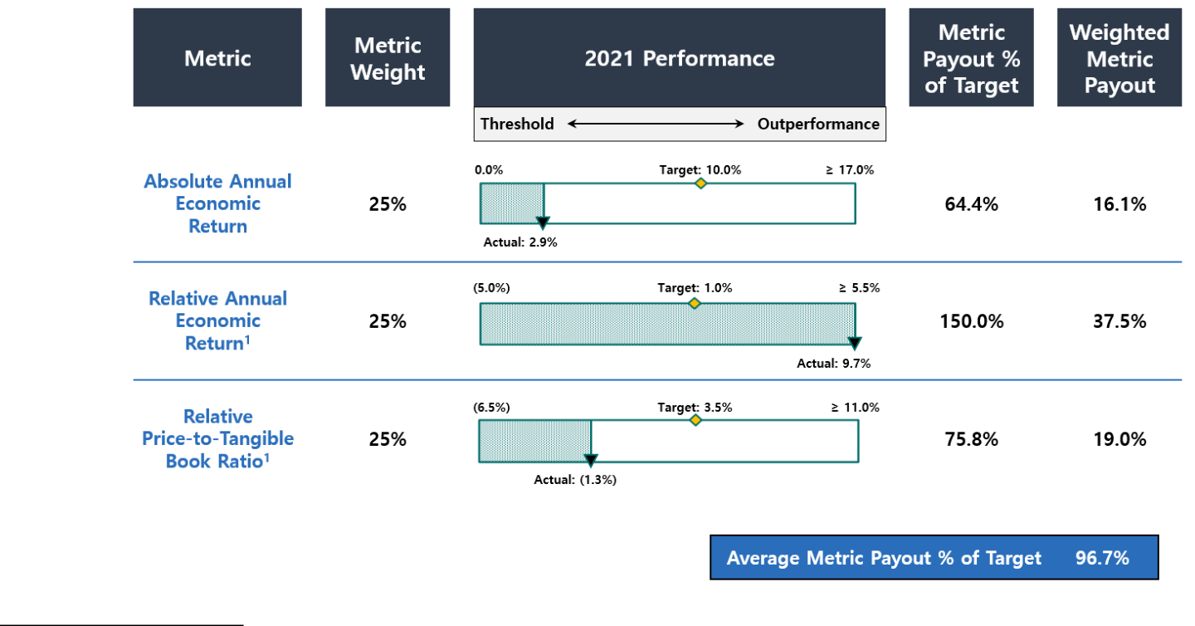

- Under pre-established peer group criteria, if a peer undergoes a merger or acquisition, its price to tangible book ratio is included for the quarterly period ending just prior to announcement, and its economic return is included through the quarter ended just prior to completion of the transaction. Anworth Mortgage Asset Corporation and Capstead Mortgage Corporation each underwent mergers in 2021 and were included in the Corporate Scorecard calculations for 2021 on a partial year basis in accordance with these criteria.

36 AGNC INVESTMENT CORP. - Proxy Statement

Table of Contents

EXECUTIVE COMPENSATION

2021 Strategic and Operational Review

In evaluating our performance under the operational and strategic objective portion of the Corporate Scorecard, the Compensation Committee noted the following accomplishments, among others, in determining that the Company met target expectations and achieved 100% performance on the operational and strategic objectives.

Component of Value Objective / Focus
Proposition
Highly Efficient Operating ü Maintain low operating cost structure relative
Cost Structure to the residential mortgage REIT and
broader asset management industries, a significant benefit of AGNC’s internal management structure that enhances return potential for investors

Highlights

- Continued to out perform mREIT industry on an operating cost basis by a wide margin

- Negotiated materially lower haircuts on repurchase agreement financing
- Established custody clearing / settlement services at Bethesda Securities, our wholly-owned broker dealer, generating substantial cost savings and reducing exposure to third-party custodian operations

Disciplined Risk Management ü Mitigate risk through AGNC’s comprehensive
risk management framework, which is
predicated on careful asset selection,
disciplined hedging, and diversified funding,
with the goal of preserving tangible net book
value across market scenarios over the long-
term, and on operational performance

Stockholder Focus ü Provide detailed and transparent public
financial disclosure, actively engage with investors, and incorporate high quality corporate environmental, social, and governance practices into AGNC's strategy, business, and operations

ü Maintain investor confidence during executive

management transition
Liquidity and Scale ü Continue active, stockholder-friendly capital

management approach that is consistent with broader market considerations

- Maintained compliance with all reporting, listing, and REIT regulatory requirements
- Implemented new and more efficient processes, including new pricing process for non-Agency securities, reporting framework, and REIT compliance testing

- Implemented significant IT infrastructure enhancements that bolster information security and a hybrid work model
- Completed first office reopening phase in July for voluntary hybrid work option
- Managed succession of CEO and CIO positions without internal or external disruption
- Enhanced investor outreach to retail investors through retail networks
- Made significant progress on branding and website development
- Engaged institutional and other stakeholders on ESG topics
- Published first annual ESG report and disclosures consistent with SASB reporting framework

- Implemented new shelf registration and updated ATM facility providing capacity for future capital raises

- Repurchased $257 million (excluding shares repurchased in December 2020 that settled in January 2021) of common stock at meaningful discount to tangible net book value

Individual Bonus Decisions

Short-term incentives for Messrs. Kain and Federico in 2021 were based solely on achievement of the Corporate Scorecard measures. Based on the Compensation Committee’s assessment of the 2021 Corporate Scorecard, this resulted in a payout of 97.5% of target for Messrs. Kain and Federico.

Other NEOs’ short-term cash incentives were based predominantly on the Corporate Scorecard measures and to a lesser extent on individual performance. Mr. Kuehl was awarded a cash bonus at 98.0% of his target based on a relative weighting of the Corporate Scorecard at 80% and his personal performance at 20% (awarded at target). In evaluating his personal performance, the Compensation Committee considered his development of new investment analytic tools and their positive impact on the performance of the Company's investment portfolio. In addition, the Compensation Committee considered Mr. Kuehl’s input into new processes developed throughout the Company and his participation in the development and mentoring of AGNC's employees. Ms. Bell and Messrs. Pas and Pollack each were awarded 98.5% of their target bonus, which reflects a relative weighting of the Corporate Scorecard at 60% and their individual personal performance at 40% (awarded at target). For Ms. Bell, the Compensation Committee considered, among other things, her leadership in the development of new processes and improvement of our existing procedures for valuation and compliance matters. Ms. Bell was also recognized for her efforts to support employee engagement efforts and mentoring other employees as we continue to operate in a hybrid work environment. For Mr. Pas, the Compensation Committee considered, among other things, his efforts in significantly increasing the size of our non-agency portfolio in 2021. Mr. Pas was also recognized for his work supporting our Chief Investment Officer in the successful executive transition and for his development and mentoring of our employees. For Mr. Pollack, the Compensation Committee considered, among other things, his leadership in promoting the development of our Board of Directors, including the appointment of two new directors in 2021 and maintaining appropriate communication among management and the Board. In addition, the Compensation Committee noted Mr. Pollack’s work in the amendment and restatement of our equity compensation plan, his support in accomplishing other key corporate initiatives, and his engagement with our employees.

AGNC INVESTMENT CORP. - Proxy Statement 37

Table of Contents

EXECUTIVE COMPENSATION

These 2021 bonus payments are reflected in the following table:

NEO | Short-Term Incentive Award ($) | Percentage of 2021 Target
Peter J. Federico | $2,632,500 | 97.5%
Gary D. Kain | $4,387,500 | 97.5%
Christopher J. Kuehl | $1,764,000 | 98.0%
Bernice E. Bell | $985,000 | 98.5%
Aaron J. Pas | $775,688 | 98.5%
Kenneth L. Pollack | $837,250 | 98.5%

2022 Corporate Scorecard

As part of its annual compensation processes, the Compensation Committee adopts a Corporate Scorecard for the coming year after considering numerous factors, including continued alignment of the Corporate Scorecard with the Committee’s overall compensation philosophy, the level of rigor of the goals and objectives, and any relevant feedback from stockholders. Based on its review, the Compensation Committee has established a Corporate Scorecard for 2022 using comparable measures to those used in 2021. In establishing weightings among measures for 2022, the Compensation Committee has considered the ongoing relative significance of the financial measures in light of market trends and conditions and trading patterns following the March 2020 financial crisis. In addition, the Compensation Committee has selected strategic and operational objectives aimed at our long-term value proposition, with greater emphasis on our ESG reporting and practices.

Equity Incentive Compensation

The Compensation Committee believes that equity incentive compensation is an important component of our NEO compensation package and is critical in attracting, motivating, and retaining outstanding employees. Equity incentive compensation is intended to closely align our NEOs’ and other employees’ interests with our long-term success and promote long-term employee retention. Our long-term incentive program consists of a combination of performance-based RSUs and time-vesting RSUs.

Performance-based RSUs are designed to reward creation of long-term economic returns for our stockholders both on an absolute and relative basis. To establish challenging economic thresholds and motivate long-term performance, the awards vest at the end of a three-year performance period based 50% on our absolute economic return and 50% on our economic return relative to the unweighted average of economic returns of the Agency REIT Peer Group. In establishing vesting criteria for these awards, the Compensation Committee considers historical returns for us and our peers and our forecast. Absolute and relative economic returns are calculated on a cumulative basis over the three-year performance period. Achievement of these goals will be determined in the same manner, including the same peer group, as described above with respect to the short-term incentive awards for such year. For performance between the threshold, target, and outperformance measures, the number of shares vested will be determined through linear interpolation.

2021 Long-Term Incentive Awards

The 2021 long-term incentive awards made by the Compensation Committee in February 2021 were at each NEO’s target levels as specified in their respective employment agreement and are reflected in the following table:

Mix of Long-Term Incentive Awards

NEO | Time-Vested | Performance-Vested | Total Value
NEO | RSUs ($) 1 | RSUs ($) 2 | of Awards ($) 3
Peter J. Federico ⁴ | 1,122,000 | 2,278,000 | 3,400,000
Gary D. Kain ⁵ | 2,029,500 | 4,120,500 | 6,150,000
Christopher J. Kuehl ⁶ | 701,250 | 1,423,750 | 2,125,000
Bernice E. Bell | 550,000 | 550,000 | 1,100,000
Aaron J. Pas | 427,500 | 427,500 | 855,000
Kenneth L. Pollack | 475,000 | 475,000 | 950,000

- Awards vest ratably over a three-year and one-half month period in equal annual installments.

- Represents grant-date fair value assuming performance achievement at 100% of target. Performance payouts may range from 0% to 200% of target based on actual performance. Awards are subject to cliff vesting two years and eleven and one-half months after the grant date, subject to a three-year performance period. See “Equity Incentive Compensation” in “Compensation Discussion and Analysis.”

- Awards were granted on March 1, 2021 based on a $15.96 stock price.

- Reflects a prorated amount based on a target long-term incentive award of $2,300,000 for the period from January 1, 2021 through June 30, 2021 and $4,500,000 for the period from July 1, 2021 through December 31, 2021.
- Reflects a prorated amount based on a target long-term incentive award of $8,100,000 for the period from January 1, 2021 through June 30, 2021 and $4,200,000 for the period from July 1, 2021 through December 31, 2021.
- Reflects a prorated amount based on a target long-term incentive award of $1,650,000 for the period from January 1, 2021 through June 30, 2021 and $2,600,000 for the period from July 1, 2021 through December 31, 2021.

38 AGNC INVESTMENT CORP. - Proxy Statement

Table of Contents

EXECUTIVE COMPENSATION

The fair value of these awards as of their March 1, 2021 grant date is included in the Summary Compensation Table and Grants of Plan-Based Awards Table. The ultimate value of the RSUs will depend on AGNC’s total stockholder return over the vesting period, and in the case of the performance-based RSUs, AGNC’s absolute and relative economic return over the three-year performance period.

In setting the level of awards to our NEOs, the Compensation Committee considered a number of factors, including the compensation practices at comparable companies, and our ongoing commitment to link NEO compensation to our long-term performance. The Compensation Committee also considered the roles and ongoing responsibilities of each of our NEOs, including following the executive transition that occurred on July 1, 2021, and relevant market data. The grant levels for our NEOs in 2021 reflected the following changes relative to 2020:

- Messrs. Federico and Kuehl received increases in their target long-term incentives from $2,300,000 to $3,400,000 and $1,650,000 to

$2,125,000, respectively. These award levels for Messrs. Federico and Kuehl reflect the proration between their target LTI award levels for their new roles as Chief Executive Officer and Chief Investment Officer, respectively, during the second half of 2021 and their former roles during the first half of 2021. Their 2021 target LTI awards continued to be allocated 67% performance-based and 33% time-based. In 2022, Messrs. Federico's and Kuehl's target LTI awards are $4,500,000 and $2,600,000, respectively.
- Mr. Kain’s long-term incentive target was decreased from $8,100,000 to $6,150,000, with the allocation among performance-based and time-based

awards, at target, remaining unchanged at 67% performance-based and 33% time-based. This award level reflects a proration between Mr. Kain's target LTI award level in his role as Chief Executive Officer and Chief Investment Officer during the first half of 2021 and his target LTI award level in his role as Executive Chair during the second half of 2021. In 2022, his target LTI award is $4,200,000.

- Ms. Bell’s long-term incentive target was increased from $875,000 to $1,100,000 in 2021, with the allocation among time-based and performance-based awards remaining unchanged at an equal weighting. Her target LTI award in 2022 is $1,250,000, with the allocation of awards, at target, being 67% performance-based and 33% time-based.
- Mr. Pas’s long-term incentive target was increased from $807,500 to $855,000 in 2021, with the allocation among time-based and performance-based awards remaining unchanged at an equal weighting. In 2022, his target LTI award is $900,000.
- Mr. Pollack’s long-term incentive target was increased from $800,000 to $950,000 in 2021, with the allocation among time-based and performance-based awards remaining unchanged at an equal weighting. His target LTI award in 2022 is $1,000,000, with the allocation of awards, at target, being 67% performance-based and 33% time-based.

In granting awards in 2021, the Compensation Committee also reviewed the measures used for performance-based RSUs and determined that it was appropriate to retain the measures established in 2020 without adjustment, concluding these measures remained appropriately challenging in the current market environment for awards made in 2021. The table below sets forth the below threshold, threshold, target, and outperformance levels established by the Compensation Committee for performance-based RSU awards made in 2021.

Performance | Metric | Below | Threshold | Base Performance | Outperformance
Variable | Weight | Threshold | Threshold | Target | Outperformance
Absolute Three-Year Economic Return | 50% | < 0.0% | 0.0% | 30.0% | ≥ 60.0%
Relative Three-Year Economic Return | 50% | < (4.5%) | (4.5%) | 3.0% | ≥ 10.5%
Payout Factor (% of Target Shares) | 100% | 0% | 0% | 100% | 200%

2019 Performance-Based Restricted Stock Unit Awards

The three-year performance period for the performance-based RSU awards made to our employees in March 2019 was completed on
December 31, 2021. The performance calculations included absolute economic return measured from December 31, 2018 through December 31, 2021 and
relative economic return as compared to an Agency mortgage REIT peer group determined at the time of the grant and measured from September 30, 2018
through September 30, 2021. AGNC generated an absolute economic return of 25.3% and relative economic return of +40.5% for the applicable
measurement period, resulting in a vesting factor of 142.2% of the target number of shares for the 2019 performance-based RSUs, as validated by the
Compensation Committee. Unless deferred by the NEO, distribution of shares in settlement of these awards occurred on February 15, 2022, provided that
the recipient remained employed by the Company on that date. The diagram below includes the performance targets and details the performance
calculations for these awards. Additional details regarding these RSUs are provided in the Outstanding Equity Awards table on page 46 of this proxy
statement. These measures were established in 2019 based on then anticipated ranges of performance deemed to be appropriately challenging based on the
Compensation Committee’s analyses, including back-testing.

AGNC INVESTMENT CORP. - Proxy Statement 39

Table of Contents

EXECUTIVE COMPENSATION
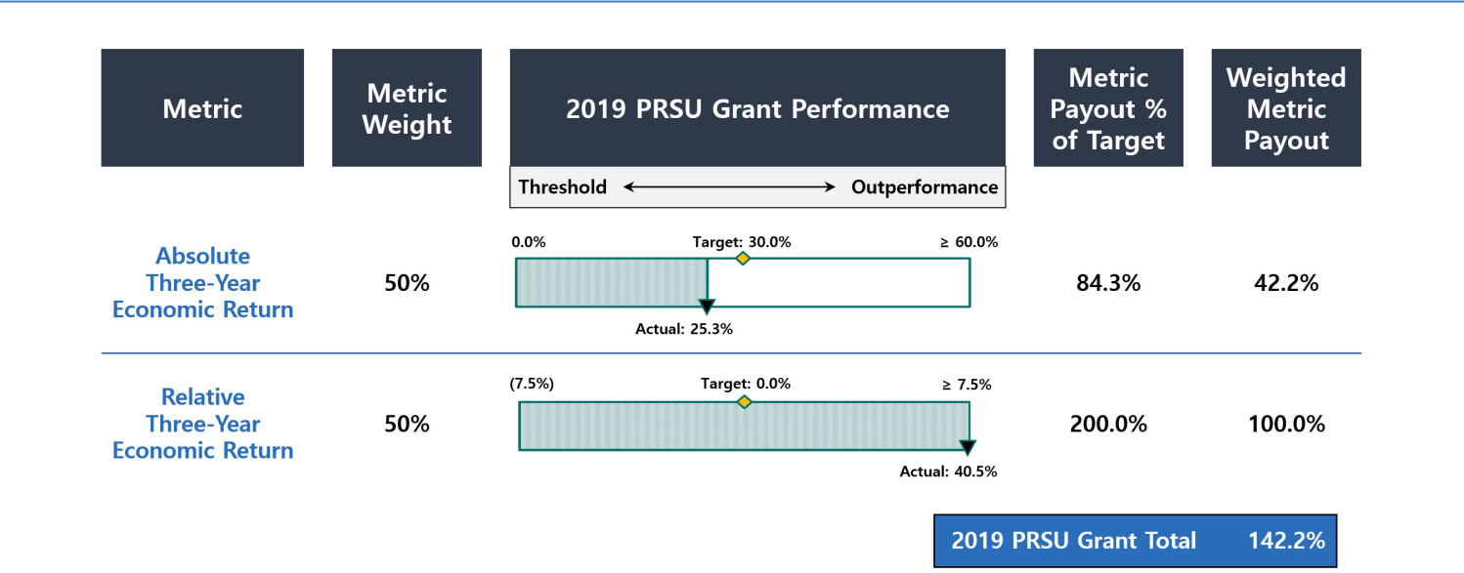

2022 Target Compensation

The chart below details the target level of direct compensation for our NEOs in 2022.

2022 Target Compensation

 |  |  | Target Long-
 |  | Target Annual | Term
NEO | Base Salary | Target Annual | Incentive
NEO | Base Salary | Bonus | Awards
Peter J. Federico | $900,000 | $3,600,000 | $4,500,000
Gary D. Kain | $500,000 | $3,600,000 | $4,200,000
Christopher J. Kuehl | $900,000 | $2,000,000 | $2,600,000
Bernice E. Bell | $500,000 | $1,250,000 | $1,250,000
Aaron J. Pas | $450,000 | $900,000 | $900,000
Kenneth L. Pollack | $500,000 | $1,000,000 | $1,000,000

Savings and Health and Welfare Benefits

Our executive officers participate in a broad-based 401(k) retirement savings plan generally applicable to all our employees, which includes an opportunity to receive employer matching contributions. We do not currently provide for pension plans, supplemental retirement plans, or deferred compensation plans for our executive officers. We previously provided our executive officers the option to elect to defer payments of long-term incentive awards. In addition, all of our executive officers also participate in medical, dental, vision, disability, life and long-term care insurance, and qualified transportation benefits that are provided generally to all our employees.

Perquisites and Other Personal Benefits

We do not believe our executive officers should receive special perquisites and benefits and do not currently provide our executive officers with any perquisites or other personal benefits that are not available on a non-discriminatory basis to all employees.

Compensation Decision Process

Compensation Comparator Group

AGNC’s internal management structure, size, and scale relative to other residential mortgage REITs and our Agency mortgage-backed securities investment focus are significant differentiators relative to other potential comparative public companies and have made identifying a peer group for AGNC challenging. As a result, the Compensation Committee has not adopted a policy to benchmark compensation levels against comparative companies.

We are the second largest residential mortgage REIT overall by market capitalization, total assets, and total equity when compared with the Resi mREIT Universe. Only seven other REITs in the Resi mREIT Universe are internally managed, and all other mortgage REITs in the Resi mREIT Universe are externally managed by a third party and provide only limited public compensation disclosure. Moreover, only five other internally managed mREITs in the Resi mREIT Universe had a market capitalization above $1.5

40 AGNC INVESTMENT CORP. - Proxy Statement

Table of Contents

EXECUTIVE COMPENSATION

billion as of December 31, 2021, and only two of those REITs had an Agency mortgage-backed securities focus comparable to AGNC. Residential mREITs that primarily invest in non-Agency mortgage-backed securities involve different risk and return profiles and will have performance that is not well correlated to ours. The business and operations of commercial mortgage REITs center on commercial real estate finance rather than single-family home mortgages and will have performance linked to credit risk decisions, including geographic and sector weightings, that are less relevant for our business model.

Although we are internally managed, our business of investing primarily in Agency mortgage-backed securities makes our operations somewhat

comparable to asset management firms. However, asset management firms employ a different business model: they primarily generate income from management fees charged to clients based on, among other things, the level of assets under management or financial returns that clients earn on their

investments. By comparison, AGNC generates income primarily from its investments in Agency securities. As a result, AGNC’s performance may vary materially from asset management firms given the vastly different asset base and significant leverage and hedging activities inherent in our business model.

Although we have few close peers considering our internal management structure, size, and scale relative to other mortgage REITs and investment focus on Agency mortgage-backed securities, the Compensation Committee, with the assistance of FW Cook, reviews compensation levels and practices at various financial services companies as part of its consideration of our compensation structure, programs, and practices. In 2021, the Compensation Committee reviewed the compensation practices at 18 companies, including seven internally managed publicly traded mortgage REITs and 11 publicly traded asset management companies and non-bank financial services companies. The Compensation Committee determined the highly specialized and unique skill sets required of executives in these industries are most comparable to those required of AGNC’s NEOs, although very few would be an exact match for our Company. However, in considering this analysis, the Compensation Committee believes that, due to their vastly different business models, capital allocations, and assets, these companies collectively will have performance that is not well correlated to AGNC's performance, and accordingly they are not a suitable peer set for purposes of evaluating management's relative performance or the alignment of our compensation program to our performance.

Mortgage REITs: | Asset Management and Financial Services Companies:
Annaly Capital Management, Inc. | Affiliated Managers Group, Inc.
Arbor Realty Trust, Inc. | AllianceBernstein Holding L.P.
Chimera Investment Corporation | Ameriprise Financial, Inc.
Ladder Capital Corp. | Apollo Global Management LLC
MFA Financial, Inc. | Ares Management LP
Redwood Trust, Inc. | DigitalBridge Group, Inc.
Two Harbors Investment Corp. | Eaton Vance Corp.
 | Invesco Ltd.
 | KKR & Co. L.P.
 | The Blackstone Group L.P.
 | The Carlyle Group L.P.

Performance Comparator Group

The Compensation Committee has determined that a subset of the Resi mREIT Universe, which we refer to as the “Agency REIT Peer Group,” provides a better basis for comparison to evaluate our performance and operations under our Corporate Scorecard and performance-based LTI awards. For purposes of 2021 incentive awards, these REITs were:

- Annaly Capital Management, Inc.

- Anworth Mortgage Asset Corporation

- ARMOUR Residential REIT, Inc.

- Capstead Mortgage Corporation

- Dynex Capital, Inc.

- Invesco Mortgage Capital, Inc.

- Two Harbors Investment Corp.

The Agency REIT Peer Group companies have portfolios and investment objectives that most closely resemble our own focus on Agency securities. Non-agency REITs in the Resi mREIT Universe have strategies that place a greater emphasis on credit-sensitive assets than our portfolio and those of our Agency REIT Peer Group. As such, these REITs would be expected to achieve divergent returns from our own Agency securities-focused portfolio through various economic cycles and conditions. The Compensation Committee thus determined that our economic returns and trading price relative to book value are appropriately measured against a simple, unweighted average of the Agency REIT Peer Group for purposes of determining our relative performance. Only two of the seven REITs in the Agency REIT Peer Group were included in the group of companies whose executive

AGNC INVESTMENT CORP. - Proxy Statement 41

Table of Contents

EXECUTIVE COMPENSATION

compensation practices were reviewed by the Compensation Committee, Annaly Capital Management and Two Harbors Investment Corp. The other five companies included in the Agency REIT Peer Group were excluded from our compensation comparator group because these five REITs either are significantly smaller than AGNC or are externally managed.

The Compensation Committee continues to evaluate our peer group construction in response to changes in market conditions and the mortgage REIT sector. The Compensation Committee desires to limit the number of year-over-year changes to this peer group in order to provide meaningful ongoing comparative analyses for its work. Thus, despite shifting capital allocations and changes in size among the Agency REIT Peer Group in 2019 and 2020, the Compensation Committee concluded that changes to the Agency REIT Peer Group were not necessary for 2021. However, the Compensation Committee has elected to add Orchid Island Capital Inc. to the Agency REIT Peer Group for 2022 incentive compensation awards based on guiding parameters, including a minimum of $500 million in total stockholders’ equity and approximately 50% or greater allocation of capital to Agency residential mortgage-backed securities. Two other companies that completed a merger in 2021 and thus only included in the Agency REIT Peer Group for compensation purposes for a partial period, Anworth Mortgage Asset Corporation and Capstead Mortgage Corporation, will be removed from the Agency REIT Peer Group for 2022.

Role of the Compensation and Corporate Governance Committee

Our Compensation Committee, which is comprised solely of independent directors, is responsible for establishing and overseeing our philosophy regarding executive compensation and for making decisions relating to the compensation of our NEOs. The Compensation Committee is also responsible for ensuring that the total compensation offered to our executive officers is fair and competitive and motivates high performance. The terms of any employment agreements with our NEOs and actions on compensation under the employment agreements are also under the primary direction of the Compensation Committee. Decisions that set the compensation of our CEO or Executive Chair are subject to the review and approval of the Company’s independent directors based on the Compensation Committee’s evaluation of goals and objectives.

The Compensation Committee periodically reviews the Company’s compensation policies and programs and makes any modifications that the Committee deems necessary or advisable, subject to the terms of such policies or programs. The Compensation Committee annually reviews and approves the Company’s goals and objectives relevant to the compensation of the NEOs and other employees of the Company.

Role of Management

All compensation decisions related to our executive officers are at the discretion of the Compensation Committee or independent directors of our Board. The Compensation Committee considers the advice and counsel of the CEO when evaluating compensation of the other NEOs given his direct day-to-day working and supervisory relationship with those executives. Taking this feedback into consideration, the Compensation Committee engages in discussions and either determines the compensation of our NEOs or makes a final recommendation to the Board related to compensation paid to NEOs. Neither our CEO nor our Executive Chair is present or a participant in the portions of meetings of the Compensation Committee or of the Board at which his performance is evaluated and his compensation is discussed and determined; only independent directors participate in such matters.

Role of the Independent Compensation Consultant

Under its charter, the Compensation Committee has the authority to select, retain, and terminate compensation consultants. The Compensation Committee has retained FW Cook to provide advice and counsel on executive compensation opportunities and program design and structure. Representatives of FW Cook attended certain meetings of the Compensation Committee, including meeting with members of the Compensation Committee without members of management present. FW Cook assists the Compensation Committee in its analysis and evaluation of our executive compensation program, practices, and communications, and provides the Compensation Committee with market data and analysis of certain comparator companies that hire personnel and executives with similar skills and experience as our executive management team. FW Cook also provides advice with respect to our Corporate Scorecard, our long-term incentive awards, the setting of measures for performance-based incentive compensation, and other work that informs executive compensation decisions. During 2021, the Compensation Committee reviewed the independence of FW Cook using assessment criteria under applicable stock exchange and SEC rules and concluded FW Cook was independent and had no conflicts of interest.

Risk Assessment and Compensation

The Compensation Committee regularly monitors the risks and rewards associated with our compensation program. The Compensation Committee established our compensation program with the intent to align our interests with stockholders and prevent unnecessary or excessive risk-taking. We believe that our compensation policies and practices are well balanced and designed to avoid creating incentives that encourage unnecessary or excessive risks that could potentially have a material adverse effect on the Company. We use variable compensation for all of our NEOs, with a focus on performance based compensation. We have designed a compensation program with a mix of short- and long-term incentives to ensure management focuses on the long-term impact of short-term decisions and that management’s interests are aligned with stockholders. At least 50% and up to 67% of our NEOs' long-term incentive awards vest based on performance over a three-year period. Compliance with the risk management framework designed to address excessive risk taking and approved by our Board is an integral part of the strategic and operational objectives of the Corporate Scorecard used for short-term incentive compensation decisions. The Compensation Committee continually assesses our executive compensation programs and has implemented additional policies and practices that we believe have further mitigated compensation driven risk, including the adoption of a clawback policy and executive officer stock ownership guidelines.

42 AGNC INVESTMENT CORP. - Proxy Statement

Table of Contents

EXECUTIVE COMPENSATION

Other Compensation Policies and Practices

Stock Ownership Guidelines

We have adopted stock ownership guidelines for our executive officers requiring them to own, within five years of becoming subject to the policy or the date of any increase in applicable ownership guidelines, a minimum number of shares of our common stock based on a multiple of base salary. The requirement is 6x for our Executive Chair and our CEO and 4x for our Chief Investment Officer. In 2021, we also increased the guideline level from 2x to 3x for all other executive officers. Until the foregoing ownership requirements are met, each individual is expected to retain at least 50% of the shares of common stock received upon vesting or earn-out of stock-based compensation, net of any shares withheld or sold to pay taxes on such income. Shares of time-vested RSUs granted under the 2016 Equity Plan (whether vested, unvested, or subject to a deferral election) are included in determining the number of shares held for this purpose, net of anticipated tax withholdings. Shares of unvested performance-based RSUs are not included for this purpose prior to completion of the applicable performance period. As of February 25, 2022, Mr. Kain held x, Mr. Federico held x, and Mr. Kuehl held x or more of their respective 2021 base salaries calculated in accordance with our guidelines. As of February 25, 2022, Ms. Bell and Messrs. Pas and Pollack each owned x, x, and x, respectively, of their respective base salaries as calculated in accordance with our guidelines, and each is expected to reach the guideline amount within the phase-in period under the policy.

The following table sets forth the total stock ownership of all our NEOs, including beneficially owned, unvested, and deferred shares, as calculated pursuant to our stock ownership guidelines as of February 25, 2022:

 | Beneficially | Unvested Shares | Deferred Shares | Total
Name | Owned | Unvested Shares | Deferred Shares | Total
Name | Shares (#) | (#) ² | (#) ² | (#)
Peter J. Federico |  | [ ] ¹
Gary D. Kain |  | [ ] ¹
Christopher J. Kuehl
Bernice E. Bell
Aaron J. Pas
Kenneth L. Pollack

- Includes shares held in a family trust over which shares Mr. Kain has voting and dispositive power.
- Share amounts are net of anticipated tax withholdings.

Anti-Hedging and Pledging Policy

Our Board has adopted a policy prohibiting our executive officers and directors from any hedging, pledging, or entering into margin loans with respect to any shares of our common stock or from engaging in short sales of our common stock or entering into any other transaction or derivative agreement where he or she would earn a profit or offset losses due to a decline of our stock price. By way of example, transactions prohibited under the policy may include options, short sales, puts, calls, or derivative actions such as forwards, futures, or swaps. In addition to the restrictions imposed on our executive officers and directors, the AGNC Mortgage Management, LLC Personal Investments Code prohibits all employees from engaging in financial transactions that directly hedge or offset, or are designed to directly hedge or offset, any decrease in the market value of our common stock.

Clawback Policy

We have adopted a clawback policy relating to recovery of certain performance-based compensation in the event of an accounting restatement by the Company due to material noncompliance with any financial reporting requirement under U.S. federal securities laws resulting at least in part from the willful fraud, dishonesty, or recklessness of one of the Company’s executive officers in the performance of his or her duties to the Company. Under this policy, the Company would be entitled to seek recovery of the portion of performance-based compensation paid to our executive officers that would not have been earned had the Company’s restated financial statements been used in the determination of the amount of performance-based compensation originally awarded. This policy includes a three year look back period.

Employment Agreements

The Company has entered into employment agreements with each of our NEOs, the terms of which are reflected in this Compensation Discussion and Analysis. The Compensation Committee has consulted with FW Cook on each of the agreements and believes that they provide appropriate and balanced incentives toward achieving the annual and long-term strategic objectives set by the Compensation Committee and to create a stronger alignment of interests between our executives and our stockholders.

The Compensation Committee reviews the compensation of our executive officers on an annual basis and will make adjustments when warranted by personal performance and internal and external pay equity. The Company entered into restated employment agreements with Messrs. Kain, Federico, and Kuehl in December 2020 as a result of the announced transition of Mr. Kain to the role of Executive Chair of the Board and the promotions of Messrs. Federico and Kuehl to the positions of Chief Executive

AGNC INVESTMENT CORP. - Proxy Statement 43

Table of Contents

EXECUTIVE COMPENSATION

Officer and Chief Investment Officer, respectively. The revised employment agreements adjust their respective compensation arrangements in light of their new roles and responsibilities and are described in more detail herein.

In 2021, after considering the feedback we heard during our prior stockholder engagement, the compensation practices at comparable companies, and our ongoing commitment to link NEO compensation to performance, the Compensation Committee entered into amended and restated employment agreements dated January 22, 2021 with Ms. Bell and Messrs. Pas and Pollack to increase their target compensation, and in 2022, as part of its annual review of NEO compensation, the Committee further adjusted their compensation levels in effect for 2022. The Compensation Committee also considered the further effect these compensation changes would make to promote internal and external pay equity among our NEOs and employee retention and to further stockholder alignment by emphasizing incentive-based compensation as a significant portion of overall target compensation.

The employment agreements for each NEO include certain severance payments and benefits if a NEO that is party to an employment agreement is terminated by the Company, including without “cause” or by the NEO for “good reason,” as each term is defined in each respective employment agreement and were the result of arms-length negotiations with these NEOs. The severance provisions included in the employment agreements related to a change of control include a “double trigger” requirement, which we determined was appropriate and in the best interest of our stockholders. See “Severance and Change of Control Payments” on page 48. The employment agreements with these NEOs also include covenants related to post-employment obligations in areas such as competition with us, solicitation of our employees, and the confidentiality of certain information.

Report of the Compensation and Corporate Governance Committee

Our Compensation and Corporate Governance Committee reviewed and discussed with our management the “Compensation Discussion and Analysis” contained in this proxy statement. Based on that review and discussions, our Compensation and Corporate Governance Committee recommends to the Board of Directors that the “Compensation Discussion and Analysis” be included in this proxy statement.

By the Compensation and Corporate
Governance Committee:
Morris A. Davis, Chair
John D. Fisk
Prue B. Larocca

Paul E. Mullings

44 AGNC INVESTMENT CORP. - Proxy Statement

Table of Contents

EXECUTIVE COMPENSATION

2021 Summary Compensation Table

The following table provides information concerning the compensation of our NEOs earned during our fiscal years ended December 31, 2021, 2020, and 2019.

In the column “Salary,” we disclose the amount of base salary paid to the NEO during the fiscal year. See “Base Salary” under “Compensation Program in Detail” above, for a description of the base salaries payable under each NEO’s employment agreement. In the column “Bonus,” we disclose the amount of short-term cash incentive payments earned by the NEO during the fiscal year. See “2021 Corporate Scorecard” for a description of the annual scorecard for calculating the cash component of our incentive compensation awards for 2021 that were paid in 2022, and which are included in the Summary Compensation Table for 2021. In the column “Stock Awards,” we disclose awards of RSUs under the 2016 Equity Plan, which includes both performance-based vesting and time-based vesting awards. The grant date fair value of the performance-based vesting RSU awards assumes performance achievement at 100% of the target amount. Performance payouts may range from 0% to 200% of the target amount based on actual performance achieved. See “Equity Incentive Compensation” under “Compensation Discussion and Analysis,” above.

The amounts in the column “All Other Compensation” represent employer matches for employee contributions to our 401(k) plan. The NEOs did not have any perquisites or other personal benefits in excess of the reporting thresholds during the fiscal year.

 |  | Salary | Bonus | Stock | All Other | Total
Name and Principal Position | Year | Salary | Bonus | Awards ¹ | Compensation | Total
Name and Principal Position | Year | ($) | ($) | ($) | ($) | ($)
Peter J. Federico | 2021 | 900,000 | 2,632,500 | 3,400,000 | 17,400 | 6,949,900
President and Chief Executive Officer | 2020 | 900,000 | 2,269,800 | 2,300,000 | 17,100 | 5,486,900
 | 2019 | 900,000 | 2,349,000 | 1,800,000 | 8,400 | 5,057,400
Gary D. Kain | 2021 | 700,000 | 4,387,500 | 6,150,000 | 17,400 | 11,254,900
Executive Chair² | 2020 | 900,000 | 6,809,400 | 8,100,000 | 17,100 | 15,826,500
 | 2019 | 975,000 | 7,047,000 | 8,100,000 | 8,400 | 16,130,400
Christopher J. Kuehl | 2021 | 900,000 | 1,764,000 | 2,125,000 | 17,400 | 4,806,400
Executive Vice President and Chief Investment Officer | 2020 | 900,000 | 1,936,818 | 1,650,000 | 17,100 | 4,503,918
 | 2019 | 900,000 | 1,992,888 | 1,400,000 | 8,400 | 4,301,288
Bernice E. Bell | 2021 | 500,000 | 985,000 | 1,100,000 | 17,400 | 2,602,400
Executive Vice President and Chief Financial Officer | 2020 | 500,000 | 983,450 | 875,000 | 17,100 | 2,375,550
 | 2019 | 500,000 | 591,500 | 750,000 | 8,400 | 1,849,900
Aaron J. Pas | 2021 | 450,000 | 775,688 | 855,000 | 17,400 | 2,098,088
Senior Vice President, Non-Agency Portfolio Investments | 2020 | 425,000 | 860,519 | 807,500 | 17,100 | 2,110,119
 | 2019 | 425,000 | 754,163 | 750,000 | 8,400 | 1,937,563
Kenneth L. Pollack | 2021 | 500,000 | 837,250 | 950,000 | 17,400 | 2,304,650
Executive Vice President, General Counsel, Chief | 2020 | 500,000 | 809,900 | 800,000 | 17,100 | 2,127,000
Compliance Officer and Secretary | 2019 | 500,000 | 591,500 | 750,000 | 8,400 | 1,849,900

- The amounts reported in the “Stock Awards” column represent the aggregate grant date fair value of each NEO’s awards calculated in accordance with FASB ASC Topic 718, as required by SEC regulations. The fair market value of a stock award is based on the fair market value of our stock on the date of grant with the value of the performance-based RSUs based on the probable outcome of the performance conditions as of the grant date and is set at 100% of the target amount. For fiscal year 2021, the grant date fair value of performance-based RSUs at 100% of the target amount was $2,278,000 for Mr. Federico, $4,120,500 for Mr. Kain, $1,423,750 for Mr. Kuehl, $550,000 for Ms. Bell, $427,500 for Mr. Pas, and $475,000 for

Mr. Pollack, and the grant date fair value of the performance-based RSUs assuming the highest level of performance conditions is met, was $4,556,000 for Mr. Federico, $8,241,000 for Mr. Kain, $2,847,500 for Mr. Kuehl, $1,100,000 for Ms. Bell, $855,000 for Mr. Pas, and $950,000 for Mr. Pollack. See below in the Grants of Plan Based Awards in Fiscal Year 2021 table for further details regarding the allocation of grants between time-vesting and performance-based RSUs.

- Mr. Kain transitioned from the role of Chief Executive Officer and Chief Investment Officer to Executive Chair on July 1, 2021.

AGNC INVESTMENT CORP. - Proxy Statement 45

Table of Contents

EXECUTIVE COMPENSATION

Grants of Plan-Based Awards in Fiscal Year 2021

In the following table we provide information about each grant of an award made to an NEO during our fiscal year ended December 31, 2021 under the 2016 Equity Plan. See “Equity Incentive Compensation” in “Compensation Discussion and Analysis” above for a description of the plan and awards. Amounts included in the “Grant date fair value of stock awards” column are valued in accordance with ASC 718 without reduction of any assumed forfeitures.

 |  |  | Estimated Future Payouts Under Equity |  |  | All Other
 |  |  | Incentive Plan Awards ³ |  |  | Stock
 |  |  |  |  |  | Awards: | Grant date fair
Name | Award Type ¹ | Grant Date ² | Threshold | Target | Maximum | Number | value of stock
Name | Award Type ¹ | Grant Date ² | (#) | (#) | (#) | of Units | awards ⁴
Peter J. Federico
 | Time-Based Vesting RSUs | 3/1/21 |  |  |  | 70,300 | $1,122,000
 | Performance-Based Vesting RSUs | 3/1/21 | 0 | 142,731 | 285,462 |  | $2,278,000
Gary D. Kain
 | Time-Based Vesting RSUs | 3/1/21 |  |  |  | 127,161 | $2,029,500
 | Performance-Based Vesting RSUs | 3/1/21 | 0 | 258,176 | 516,352 |  | $4,120,500
Christopher J. Kuehl
 | Time-Based Vesting RSUs | 3/1/21 |  |  |  | 43,937 | $701,250
 | Performance-Based Vesting RSUs | 3/1/21 | 0 | 89,207 | 178,414 |  | $1,423,750
Bernice E. Bell
 | Time-Based Vesting RSUs | 3/1/21 |  |  |  | 34,461 | $550,000
 | Performance-Based Vesting RSUs | 3/1/21 | 0 | 34,461 | 68,922 |  | $550,000
Aaron J. Pas
 | Time-Based Vesting RSUs | 3/1/21 |  |  |  | 26,785 | $427,500
 | Performance-Based Vesting RSUs | 3/1/21 | 0 | 26,785 | 53,570 |  | $427,500
Kenneth L. Pollack
 | Time-Based Vesting RSUs | 3/1/21 |  |  |  | 29,761 | $475,000
 | Performance-Based Vesting RSUs | 3/1/21 | 0 | 29,761 | 59,522 |  | $475,000

- AGNC time-based vesting RSU awards vest ratably over a three-year and one-half month period in three equal annual installments. AGNC performance-based vesting RSU awards are subject to cliff vesting two years and eleven and one-half months after the grant date after a three-year performance period and meeting performance conditions. Awards were granted to each NEO pursuant to the terms of his or her respective employment agreement.
- The Compensation Committee approved all grants of plan-based awards in fiscal year 2021 at a meeting held on February 18, 2021.

- Excludes accrued dividend equivalent units.

- AGNC performance-based vesting RSUs’ grant date fair value assumes performance achievement at 100% of target. Performance payouts may range from 0% to 200% of target based on actual performance achieved.

Outstanding Equity Awards at 2021 Fiscal Year-End

In the table on the following page we provide information about stock awards under the 2016 Equity Plan that have not vested and are outstanding as of December 31, 2021, for each NEO.

46 AGNC INVESTMENT CORP. - Proxy Statement

Table of Contents

EXECUTIVE COMPENSATION

 |  |  | Stock awards
 |  |  | Market value of | Equity incentive plan | Equity incentive plan
 |  | Number of shares or | Market value of | Equity incentive plan | awards: market or
 |  | Number of shares or | shares or units of | awards: number of | payout value
 |  | units of stock that | stock that | unearned units that | of unearned
Name | Grant Date | have not vested ¹ | have not vested ² | have not vested ¹ | units ²
Name | Grant Date | (#) | ($) | (#) | ($)
Peter J. Federico | 3/1/2019 ³ | 22,079 | $332,068
 | 3/1/2019 ⁴ |  |  | 97,466 | $1,465,889
 | 2/20/2020 ⁵ | 31,079 | $467,428
 | 2/20/2020 ⁶ |  |  | 94,659 | $1,423,671
 | 3/1/2021 ³ | 75,547 | $1,136,227
Gary D. Kain | 3/1/2021 ⁴ |  |  | 153,389 | $2,306,971
Gary D. Kain | 3/1/2019 ³ | 66,267 | $996,656
 | 3/1/2019 ⁴ |  |  | 584,806 | $8,795,482
 | 2/20/2020 ⁵ | 110,566 | $1,662,913
 | 2/20/2020 ⁶ |  |  | 331,711 | $4,988,933
 | 3/1/2021 ³ | 136,655 | $2,055,291
Christopher J. Kuehl | 3/1/2021 ⁴ |  |  | 277,450 | $4,172,848
Christopher J. Kuehl | 3/1/2019 ³ | 17,167 | $258,192
 | 3/1/2019 ⁴ |  |  | 75,808 | $1,140,152
 | 2/20/2020 ⁵ | 22,289 | $335,227
 | 2/20/2020 ⁶ |  |  | 67,908 | $1,021,336
 | 3/1/2021 ³ | 47,217 | $710,144
Bernice E. Bell | 3/1/2021 ⁴ |  |  | 95,867 | $1,441,840
Bernice E. Bell | 3/1/2019 ³ | 9,520 | $143,181
 | 3/1/2019 ⁴ |  |  | 40,605 | $610,699
 | 2/20/2020 ⁵ | 17,907 | $269,321
 | 2/20/2020 ⁶ |  |  | 26,874 | $404,185
 | 3/1/2021 ³ | 37,033 | $556,976
Aaron J. Pas | 3/1/2021 ⁴ |  |  | 37,033 | $556,976
Aaron J. Pas | 3/1/2019 ³ | 9,520 | $143,181
 | 3/1/2019 ⁴ |  |  | 40,605 | $610,699
 | 2/20/2020 ⁵ | 16,523 | $248,506
 | 2/20/2020 ⁶ |  |  | 24,798 | $372,962
 | 3/1/2021 ³ | 28,785 | $432,926
Kenneth L. Pollack | 3/1/2021 ⁴ |  |  | 28,785 | $432,926
Kenneth L. Pollack | 3/1/2019 ³ | 9,520 | $143,181
 | 3/1/2019 ⁴ |  |  | 40,605 | $610,699
 | 2/20/2020 ⁵ | 16,372 | $246,235
 | 2/20/2020 ⁶ |  |  | 24,572 | $369,563
 | 3/1/2021 ³ | 31,983 | $481,024
 | 3/1/2021 ⁴ |  |  | 31,983 | $481,024

- Includes accrued dividend equivalent units.
- Market value computed by multiplying the closing market price of our stock on December 31, 2021, or $15.04, by the number of units.

- Time-based vesting RSUs vest ratably over a three-year and one-half month period that commenced on the Grant Date with the next vesting date on March 15, 2022.

AGNC INVESTMENT CORP. - Proxy Statement 47

Table of Contents

EXECUTIVE COMPENSATION

- Performance-based vesting RSUs which, subject to meeting the performance conditions calculated over a three-year period, cliff vest two years and eleven and one-half months from the Grant Date.
- Time-based vesting RSUs vest ratably over a three-year and three-quarter month period that commenced on the Grant Date with the next vesting date on March 15, 2022.

- Performance-based vesting RSUs which, subject to meeting the performance conditions calculated over a three-year period, cliff vest three years from the Grant Date.

Option Exercises and Stock Vested for Fiscal Year 2021

The following table provides information about stock awards under the 2016 Equity Plan that vested in 2021 for each NEO.

 |  | Stock Awards
Name | Number of shares | Value realized on vesting ($)
Name | acquired on vesting (#) | Value realized on vesting ($)
Peter J. Federico | 138,399 | $2,286,351
Gary D. Kain | 425,025 | $7,021,413
Christopher J. Kuehl | 103,265 | $1,705,938
Bernice E. Bell | 26,058 | $430,478
Aaron J. Pas | 32,246 | $532,704
Kenneth L. Pollack | 29,038 | $479,708

Severance and Change of Control Payments

Employment Agreements

Each of the employment agreements with Ms. Bell and Messrs. Kain, Federico, Kuehl, Pas, and Pollack contains provisions for payments upon certain events as set forth below. In the event of a termination by the Company of any of our NEOs for Cause (as defined in their respective employment agreements), our NEOs are not entitled to receive any supplemental payments or incremental benefits.

Termination by the Board Without Cause or Termination by the Executive for Good Reason

If the employment of Ms. Bell or Messrs. Kain, Federico, Kuehl, Pas, or Pollack terminates by reason of a Termination Without Cause or Termination For Good Reason, each as defined in their employment agreements, and such termination does not occur during the 21-month period (24 months in the case of Ms. Bell or Messrs. Pas or Pollack) following a Change of Control, each such executive would be entitled to the following payments from the Company, as applicable, in addition to the payments listed below under “All Terminations” (a) an amount equal to the product of (i) 1.5 for Messrs. Federico, Kain or Kuehl or 1.0 for Ms. Bell or Messrs. Pas and Pollack, multiplied by (ii) the sum of (A) the executive’s annual base salary at the time of such termination, plus (B) the target value of the executive’s annual cash bonus for the year in which such termination occurs (the “Severance Amount”), paid over 18 months for Messrs. Federico, Kain, and Kuehl, and 12 months to Ms. Bell and Messrs. Pas and Pollack, respectively; (b) a pro rata portion of the annual cash bonus the executive would have been entitled to receive if he or she had remained employed through December 31 of the year in which such termination occurs (as determined by the Compensation Committee but assuming that all qualitative and subjective performance metrics were achieved at their target level); (c) reimbursements under COBRA, or substitute payments, for the executive and his or her eligible dependents for up to 18 months in the case of Messrs. Federico, Kain and Kuehl and 12 months in the case of Ms. Bell and Messrs. Pas and Pollack; and (d) acceleration of any outstanding unvested equity awards. Mr. Kain’s Severance Amount (and his eligibility for reimbursements under COBRA or substitute payments) will be proportionally reduced for each month that he remains employed between July 1, 2021 and December 31, 2022.

Termination by the Board Without Cause or Termination by the Executive For Good Reason Following a Change of Control

If the employment of Ms. Bell or Messrs. Kain, Federico, Kuehl, Pas or Pollack terminates by reason of a Termination Without Cause or Termination For Good Reason, and such termination occurs during the 21-month period following a Change of Control (24 months in the case of Ms. Bell and Messrs. Pas or Pollack), as defined in their employment agreements, each such executive would be entitled to the following (as applicable), in addition to the payments listed below under “All Terminations”: (a) an amount equal to the product of (i) 2.0 (for Messrs. Federico or Kuehl) or 1.5 (for Ms. Bell and Messrs. Kain, Pas, or Pollack), multiplied by (ii) the sum of (A) the executive’s annual base salary at the time of such termination, plus (B) the target value of the executive’s annual cash bonus for the year in which such termination occurs, paid in a lump sum; (b) a pro rata portion of the target value of his or her annual cash bonus for the year in which such termination occurs; (c) COBRA reimbursements (or substitute payments) for the executive and his or her eligible dependents for up to 18 months; and (d) acceleration of any outstanding unvested equity awards. The amount payable to Mr. Kain as described in clause (a) of this paragraph (and his eligibility for reimbursements under COBRA or substitute payments) will be proportionally reduced for each month that he remains employed between July 1, 2021 and December 31, 2022.

48 AGNC INVESTMENT CORP. - Proxy Statement

Table of Contents

EXECUTIVE COMPENSATION

Death or Disability

If the employment period of Ms. Bell or Messrs. Kain, Federico, Kuehl, Pas, or Pollack terminates early by reason of death or disability, each executive (or his or her estate or eligible dependents, if applicable) is entitled to receive, in addition to the payments listed below under “All Terminations”:

- a pro rata portion of the annual cash bonus the executive would have been entitled to receive if he or she had remained employed through December 31 of the year in which such termination occurs (as determined by the Compensation Committee but assuming that the executive achieved all qualitative and subjective performance metrics at their target level), payable in a lump sum; (ii) COBRA reimbursements (or substitute payments) for the executive and his or her eligible dependents for up to 18 months (12 months in the case of Ms. Bell and Messrs. Pas or Pollack); and (iii) acceleration of any outstanding unvested equity awards. After July 1, 2021, the eligibility of Mr. Kain and his eligible dependents to COBRA reimbursements or substitute payments will be proportionately reduced for each month that he remains employed between July 1, 2021 and December 31, 2022.

Voluntary Termination

Pursuant to the terms of his amended and restated employment agreement, effective as of July 1, 2021, if Mr. Kain’s employment terminates by reason of a voluntary termination on or after July 1, 2021 but before January 1, 2022 (with at least 90 days prior notice to the Board), (i) Mr. Kain’s unvested time-based LTI awards granted to him in 2020 or earlier, as well as the unvested portion of the time-based LTI awards granted to him in 2021 that is attributable to the portion of 2021 during which he served as Chief Executive Officer and Chief Investment Officer would vest in full upon such termination and (ii) his performance-based LTI awards granted in 2020 or earlier, as well as the performance-based LTI award granted to him in 2021 that is attributable to the portion of 2021 during which he served in such roles would vest on the same terms as though Mr. Kain had remained employed for the remainder of the applicable vesting period. For a voluntary termination during 2022, in addition to the vesting described above, the remaining portion of the time-based LTI awards granted to Mr. Kain in 2021 would vest in full, with the performance-based awards continuing to vest on the same terms as though Mr. Kain had remained employed for the remainder of the applicable vesting period. For a voluntary termination after 2022, Mr. Kain would also receive a pro rata portion of his annual cash bonus for the year in which his employment is terminated, and any unvested LTI awards granted in 2022 or later will be subject to the same accelerated vesting described above, except that, for such LTI awards granted in the year of the voluntary termination, such terms would only apply to a pro rata portion of the awards based on the number of full calendar months Mr. Kain was employed in such year. The continued vesting of any performance-based vesting described in this section shall only occur if Mr. Kain continues to comply with certain covenants contained in the agreement during such time.

All Terminations

If the employment period of Ms. Bell and Messrs. Kain, Federico, Kuehl, Pas, or Pollack terminates early for any reason, each executive is entitled to receive (i) any earned but unpaid base salary; (ii) any annual cash bonus that has been earned for a calendar year prior to termination but is unpaid (but only if not a Termination For Cause or (other than Mr. Kain) a voluntary termination by the executive for any reason other than Good Reason); (iii) any unpaid reimbursable expenses that have been incurred by the executive; (iv) any plan benefits which by their terms extend beyond termination of employment; and (v) any COBRA benefits generally available to employees.

In addition, each of the employment agreements contains a non-competition provision that prevents the officer from participating as an officer, employee, director, partner, stockholder, consultant or otherwise, in any type of business that engages in the Company’s business for a certain restricted period. Each of the employment agreements also contains a provision preventing the executive from soliciting any of our employees or interfering in a similar manner with our business during such restricted period.

Equity Plans

The 2016 Equity Plan includes “double-trigger” acceleration provisions with respect to the vesting of awards in connection with a Change of Control of the Company (as defined in the 2016 Equity Plan). Under the 2016 Equity Plan, the vesting of awards may accelerate in connection with a Change of Control where either (1) within a specified period the participant experiences a qualifying termination of employment or service, as applicable, in a manner described in the award agreement or (2) the award is not continued, assumed, or converted into a replacement award in a manner described in the applicable award agreement.

The following table summarizes the estimated payments to be made under the employment agreement for each NEO at, following, or in connection with any termination of employment, including by the Company without cause or by the executive for good reason, death or disability and upon a change of control. In accordance with SEC regulations, the following table does not include any amount to be provided to an NEO under any arrangement that does not discriminate in scope, terms or operation in favor of the NEO and that are available generally to all salaried employees. Also, the following table does not duplicate information already provided in the outstanding equity awards at fiscal year-end table, except to the extent that the amount payable to the NEO would be enhanced by the termination event. The amounts in the following table are hypothetical and based on SEC regulations. Actual payments will depend on the circumstances and timing of any termination.

In accordance with SEC regulations, for purposes of the quantitative disclosure in the following table, we have assumed that the termination took place on December 31, 2021, and that the price per share of our common stock is the closing market price as of December 31, 2021, which was $15.04.

AGNC INVESTMENT CORP. - Proxy Statement 49

Table of Contents

EXECUTIVE COMPENSATION

The information below constitutes forward-looking statements for purposes of the Private Litigation Securities Reform Act of 1995.

 |  | Termination by
 |  | Company Without
 | Termination by | Cause or
 | Termination by | Termination by |  |  | Voluntary
 | Company Without | Executive for |  |  | Voluntary
 | Cause or Termination | Good Reason, each in |  |  | Termination by
NEO Benefits and Payments | by Executive for | connection with a |  | Death or Disability | Executive without
NEO Benefits and Payments | Good Reason ¹ | Change in Control | 2 | Death or Disability | Good Reason
upon Termination | ($) | ($) |  | ($) | ($)
Gary D. Kain
Severance Amount | 5,000,000 | 5,000,000 |  | — | —
Base Salary | — | — |  | — | —
Cash Bonus ³ | 4,387,500 | 4,387,500 |  | 4,387,500 | —
Accelerated Equity Awards ⁴ | 22,672,123 | 22,672,123 |  | 22,672,123 | 20,545,442
Insurance Benefits ⁵ | 31,898 | 31,898 |  | 31,898 | —
TOTAL: | 32,091,521 | 32,091,521 |  | 27,091,521 | 20,545,442
Peter J. Federico
Severance Amount | 5,400,000 | 7,200,000 |  | — | —
Base Salary | — | — |  | — | —
Cash Bonus ³ | 2,632,500 | 2,632,500 |  | 2,632,500 | —
Accelerated Equity Awards ⁴ | 7,132,254 | 7,132,254 |  | 7,132,254 | —
Insurance Benefits ⁵ | 47,847 | 47,847 |  | 47,847 | —
TOTAL: | 15,212,601 | 17,012,601 |  | 9,812,601
Christopher J. Kuehl
Severance Amount | 4,050,000 | 5,400,000 |  | — | —
Base Salary | — | — |  | — | —
Cash Bonus ³ | 1,764,000 | 1,764,000 |  | 1,764,000 | —
Accelerated Equity Awards ⁴ | 4,906,890 | 4,906,890 |  | 4,906,890 | —
Insurance Benefits ⁵ | 47,847 | 47,847 |  | 47,847 | —
TOTAL: | 10,768,737 | 12,118,737 |  | 6,718,737
Bernice E. Bell
Severance Amount | 1,500,000 | 2,250,000 |  | — | —
Base Salary | — | — |  | — | —
Cash Bonus ³ | 985,000 | 985,000 |  | 985,000 | —
Accelerated Equity Awards ⁴ | 2,541,339 | 2,541,339 |  | 2,541,339 | —
Insurance Benefits ⁵ | 31,898 | 47,847 |  | 31,898 | —
TOTAL: | 5,058,237 | 5,824,186 |  | 3,558,237
Aaron J. Pas
Severance Amount | 1,237,500 | 1,856,250 |  | — | —
Base Salary | — | — |  | — | —
Cash Bonus ³ | 775,688 | 775,688 |  | 775,688 | —
Accelerated Equity Awards ⁴ | 2,241,201 | 2,241,201 |  | 2,241,201 | —
Insurance Benefits ⁵ | 31,898 | 47,847 |  | 31,898 | —
TOTAL: | 4,286,287 | 4,920,986 |  | 3,048,787
Kenneth L. Pollack
Severance Amount | 1,350,000 | 2,025,000 |  | — | —
Base Salary | — | — |  | — | —
Cash Bonus ³ | 837,250 | 837,250 |  | 837,250 | —
Accelerated Equity Awards ⁴ | 2,331,726 | 2,331,726 |  | 2,331,726 | —
Insurance Benefits ⁵ | 31,898 | 47,847 |  | 31,898 | —
TOTAL: | 4,550,874 | 5,241,823 |  | 3,200,874

- Severance amounts are payable over a period of 18 months for Messrs. Federico and Kuehl and over a period of 12 months for each of Messrs. Kain, Pas, and Pollack and Ms. Bell.
- Severance amounts are payable in a lump sum on the first payroll date 60 days after termination.
- Payable in a lump sum by March 15 of the calendar year following the calendar year in which termination occurs. Reflects cash bonus NEO is entitled to receive for fiscal year 2021 based on achievement of Corporate Scorecard measures and personal performance, as applicable.

50 AGNC INVESTMENT CORP. - Proxy Statement

Table of Contents

EXECUTIVE COMPENSATION

- Reflects performance achievement of 142.2% of target for March 1, 2019 performance-based vesting RSUs award. Assumes performance achievement at 100% of target for February 20, 2020 and March 1, 2021 performance-based vesting RSUs awards.
- Insurance Benefits are based on the December 2021 monthly payment for Health, Dental and Vision coverage for each NEO.

CEO Compensation Pay Ratio

As required by Section 953(b) of the Dodd-Frank Wall Street Reform and Consumer Protection Act, and Item 402(u) of Regulation S-K, we determined that the 2021 total compensation of Peter Federico, our President and Chief Executive Officer of $9,017,400, was approximately 32.06 times

the total compensation of a median employee in 2021 of $281,305. The 2021 total compensation of Mr. Federico shown above equals his compensation as

shown in the Summary Compensation Table (the “CEO Compensation”) plus an additional amount that reflects the annualizing of his short-term incentive bonus and long-term incentive stock awards for 2021, in each case at the levels applicable to him as of and following the date of his July, 1, 2021 appointment as Chief Executive Officer, consistent with applicable SEC guidance.

We identified the median employee using the annual base salary and expected bonus, as of December 31, 2021, plus any long-term incentive stock awards granted in 2021 for all individuals, excluding our Chief Executive Officer, who were employed by us on December 31, 2021, the last day of our payroll year (whether employed on a full-time, part-time, or seasonal basis). After identifying the median employee, we calculated annual total compensation for such employee using the same methodology we used for determining the CEO Compensation shown in the Summary Compensation Table.

AGNC INVESTMENT CORP. - Proxy Statement 51

Table of Contents

INFORMATION REGARDING COMPANY VOTING SECURITIES

INFORMATION REGARDING COMPANY VOTING SECURITIES

Security Ownership of Management and Certain Beneficial Owners

The following table sets forth, as of February 25, 2022 (unless otherwise indicated), the beneficial ownership of common stock of each current director, each nominee for director, each of our named executive officers, our executive officers and directors as a group, and each stockholder known to management to own beneficially more than 5% of the outstanding shares of our common stock. Unless otherwise indicated, we believe that the beneficial owners set forth in the table below have sole voting and investment power. As of February 25, 2022, there were shares of our common stock outstanding.

Name and Address of Beneficial Owner

Beneficial Owners of more than 5%:

The Vanguard Group 2

100 Vanguard Blvd.
Malvern, PA 19355

 | Percentage of
Number of Shares of | Common
Number of Shares of | Stock
Common Stock | Beneficially
Beneficially Owned ¹ | Owned
47,416,547 | 9.03%

BlackRock, Inc.3 | 40,347,651 | 7.7%
55 East 52nd Street
New York, NY 10055

Directors and Named Executive Officers: 4

Peter J. Federico

Gary D. Kain ⁵
Christopher J. Kuehl

Donna J. Blank

Bernice E. Bell

Morris A. Davis

John D. Fisk

Andrew A. Johnson, Jr.

Prue B. Larocca

Paul E. Mullings

Aaron J. Pas

Kenneth L. Pollack

Frances R. Spark

Directors and Executive Officers as a group (13 persons)

* Less than one percent.
- The amounts shown reflect shares of our common stock. Mr. Kain also owns shares of our 6.875% Series D Fixed-to-Floating Rate Cumulative Redeemable Preferred Stock (“Series D Preferred Stock”), representing less than one percent of the shares of Series D Preferred Stock issued and outstanding as of February 25, 2022. Holders of Series D Preferred Stock generally do not have any voting rights. Other than Mr. Kain’s ownership of Series D Preferred Stock, our Directors and executive officers do not own shares of our 7.00% Series C Fixed-to-Floating Rate Cumulative Redeemable Preferred Stock, 6.875%, Series D Fixed-to-Floating Rate Cumulative Redeemable Preferred Stock, 6.50% Series E Fixed-to-Floating Rate Cumulative Redeemable Preferred Stock, or 6.125% Series F Fixed-to-Floating Rate Cumulative Redeemable Preferred Stock.
- This information is based on a Schedule 13G/A filed with the SEC on February 9, 2022 by The Vanguard Group, Inc. (“Vanguard”), as an investment adviser. Vanguard is the beneficial owner of 47,416,547 shares and has the sole power to dispose or direct the disposition of 46,315,080 of such shares, shared power to dispose or direct the disposition of 1,101,467 of such shares, and shared power to vote or direct the vote of 453,164 of such shares.
- This information is based on a Schedule 13G/A filed with the SEC on February 3, 2022 by BlackRock, Inc., as a parent holding company or control person of certain named funds (“BlackRock”). BlackRock is the beneficial owner of 40,347,651 shares and has the sole power to dispose or direct the disposition of 40,347,651 of such shares and sole power to vote or direct the vote of 34,726,588 of such shares.
- The address of each of the executive officers and directors listed above is c/o AGNC Investment Corp., 2 Bethesda Metro Center, 12th Floor, Bethesda, MD 20814.
- Includes shares held in a family trust over which shares Mr. Kain has voting and dispositive power.

52 AGNC INVESTMENT CORP. - Proxy Statement

Table of Contents

QUESTIONS AND ANSWERS ABOUT STOCKHOLDER COMMUNICATIONS AND PROPOSALS

QUESTIONS AND ANSWERS ABOUT STOCKHOLDER COMMUNICATIONS AND PROPOSALS

1. WHO IS RESPONSIBLE FOR STOCKHOLDER COMMUNICATIONS?

The Board is of the view that management is primarily responsible for all communications on behalf of AGNC with stockholders and the public at large. Thus, in addition to our executive officers, we employ a Vice President, Investor Relations, whose primary responsibilities include investor and stockholder relations.

2. HOW DO I COMMUNICATE WITH THE COMPANY’S BOARD?

Stockholders who wish to communicate with our Board or with a particular director may send a letter to our Secretary at AGNC Investment Corp., 2 Bethesda Metro Center, 12th Floor, Bethesda, MD 20814. Any communication should clearly specify that it is intended to be made to the entire Board or to one or more particular director(s).

Under this process, our Secretary reviews all such correspondence and will forward to the Board a summary of all such correspondence and copies of all correspondence that, in the opinion of the Secretary, deals with the functions of the Board or committees thereof or that he otherwise determines requires their attention. Directors may at any time review a log of all correspondence received by AGNC that is addressed to members of the Board and request copies of any such correspondence. Concerns relating to accounting, internal controls, or auditing matters are immediately brought to the attention of the Chair of the Audit Committee and handled in accordance with procedures approved by the Board with respect to such matters.

A copy of such procedures for the submission and handling of complaints or concerns regarding accounting, internal accounting controls, or auditing matters is included in our Code of Ethics, which is published in the Investors section of our web site at ir.agnc.com/corporate-governance-documents.

3. HOW CAN A STOCKHOLDER NOMINATE A DIRECTOR OR SUBMIT A PROPOSAL FOR THE 2022 ANNUAL MEETING?

Stockholder proposals or nominees for election to the Board must be made in accordance with the procedures set forth in our Bylaws and described in the following question, and not the procedures set forth in the preceding question.

4. HOW CAN A STOCKHOLDER SUBMIT A PROPOSAL FOR THE 2023 ANNUAL MEETING OF STOCKHOLDERS?

Proposals received from common stockholders in accordance with Rule 14a-8 under the Exchange Act are given careful consideration by our Compensation Committee and our Board. If a common stockholder intends to present a proposal at the 2023 annual meeting of stockholders pursuant to Rule 14a-8 under the Exchange Act, in order for such stockholder proposal to be included in our proxy statement and proxy card for that meeting, the stockholder proposal must be received by our Secretary at AGNC Investment Corp., 2 Bethesda Metro Center, 12th Floor, Bethesda, Maryland 20814, on or before November 11, 2022, unless the date of the 2023 annual meeting of stockholders has been changed by more than 30 days from April 21, 2023, in which event the deadline is a reasonable time before we begin to print and send our proxy materials.

If such proposal is in compliance with all of the requirements of Rule 14a-8 under the Exchange Act, the proposal will be included in our proxy statement and proxy card relating to such meeting. Nothing in the response to this question shall be deemed to require us to include any stockholder proposal that does not meet all the requirements for such inclusion established by the SEC in effect at that time.

In order for a proposal by a common stockholder submitted outside of Rule 14a-8, including any nominations for election to the Board made by common stockholders, to be considered at the 2023 annual meeting of stockholders, such proposal must be made by written notice (setting forth the information required by our current Bylaws) and received by our Secretary not less than 90 and not more than 120 days in advance of the 2023 annual meeting.

Such proposals should be submitted by certified mail, return receipt requested.

5. HOW CAN I OBTAIN A COPY OF THE COMPANY’S 2021 ANNUAL REPORT ON FORM 10-K AND OTHER SEC FILINGS?

A copy of our 2021 annual report on Form 10-K containing audited financial statements was delivered or made available with this proxy statement. Additional copies of our 2021 annual report on Form 10-K (without exhibits, unless otherwise requested) are available in print, free of charge, to stockholders requesting a copy by writing to: AGNC Investment Corp., Investor Relations, 2 Bethesda Metro Center, 12th Floor, Bethesda, Maryland 20814, or by calling (301) 968-9300. You may review our filings with the SEC by visiting the SEC’s home page on the internet at http://www.sec.gov or by visiting the Investors section of our web site at ir.agnc.com/financial-information/sec-filings.

AGNC INVESTMENT CORP. - Proxy Statement 53

Table of Contents

QUESTIONS AND ANSWERS ABOUT THE 2021 ANNUAL MEETING AND VOTING

QUESTIONS AND ANSWERS ABOUT THE 2022 ANNUAL MEETING AND VOTING

1. WHY DID I RECEIVE THESE PROXY MATERIALS?

Our Board is furnishing this proxy statement to you to solicit proxies on its behalf to be voted at the 2022 Annual Meeting on Thursday, April 21, 2022, at 9:00 a.m., Eastern Time. This year’s Annual Meeting will be held in a virtual format only through a live audio webcast. The proxies also may be voted at any postponement or adjournment of the meeting.

All properly executed written proxies, and all properly completed proxies submitted by telephone or by the internet, that are timely delivered pursuant to this solicitation, will be voted at the Annual Meeting in accordance with the directions given in the proxy unless the proxy is revoked before the completion of voting at the meeting.

2. WHAT ITEMS WILL BE CONSIDERED AND VOTED ON AT THE ANNUAL MEETING?

Proposal |  | Board
 |  | Recommendations
1) | Election of nine directors, each to serve a one-year term and until his or | FOR each of the nominees of the Board of
 | her successor is elected and qualified | Directors
2) | Approval of an advisory resolution on executive compensation | FOR the advisory resolution
3) | Ratification of the appointment of Ernst & Young LLP to serve as our | FOR the ratification of appointment
 | independent public accountant for the year ending December 31, 2022
4) | Approval of amendments to our Amended and Restated Certificate of
 | Incorporation eliminating supermajority voting requirements for
 | stockholders to: | FOR the proposed amendment to the Certificate of
 | A. amend certain provisions of our Certificate of Incorporation | FOR the proposed amendment to the Certificate of
 |  | Incorporation
 | B. amend our Bylaws | FOR the proposed amendment to the Certificate of
 |  | Incorporation
 | C. remove directors | FOR the proposed amendment to the Certificate of
 |  | Incorporation

The Board does not intend to bring other matters before the Annual Meeting except items incidental to the conduct of the meeting. However, on all other matters properly brought before the meeting, or any postponement or adjournment thereof, by the Board or others, the persons named as proxies in the accompanying proxy card, or their substitutes, will vote in accordance with their discretion.

3. WHAT IS A PROXY?

It is your legal designation of another person to vote the stock you own. That other person is called a proxy. If you designate someone as your proxy in a written document, that document is also called a proxy or a proxy card. Peter J. Federico and Kenneth L. Pollack have been designated as proxies by the Board for the Annual Meeting.

4. WHAT IS THE RECORD DATE AND WHAT DOES IT MEAN?

The record date for the Annual Meeting is February 25, 2022 (the “record date”). The record date is established by the Board and only common stockholders of record at the close of business on the record date are entitled to:

- receive notice of the meeting; and

- vote at the meeting and any postponement or adjournment of the meeting.

Each common stockholder of record on the record date is entitled to one vote for each share of common stock held. On the record date, there were shares of common stock outstanding.

- WHAT IS THE DIFFERENCE BETWEEN A STOCKHOLDER OF RECORD AND A STOCKHOLDER WHO HOLDS STOCK IN STREET NAME?

If your shares of common stock are registered in your name on the books and records of our transfer agent, you are a common stockholder of record.

If your shares of common stock are held for you through an intermediary in the name of your broker, bank or other nominee, your shares are held in street name. The answer to Question 10 below describes brokers’ discretionary voting authority and when your broker, bank, or other nominee is permitted to vote your shares of common stock without instructions from you. For shares held through a benefit or compensation plan or a broker, bank, or other nominee, you may vote by submitting voting instructions to your

54 AGNC INVESTMENT CORP. - Proxy Statement

Table of Contents

QUESTIONS AND ANSWERS ABOUT THE 2021 ANNUAL MEETING AND VOTING

plan trustee, broker, bank, or nominee. If you attend the virtual Annual Meeting, you may withdraw your proxy and vote online during the meeting using your 16-digit control number included on your notice, proxy card, or the voting instruction form.

It is important that you vote your shares of common stock if you are a stockholder of record and, if you hold shares in street name, that you provide appropriate voting instructions to your broker, bank, or other nominee as discussed in the answer to Question 10 below.

6. WHAT ARE THE DIFFERENT METHODS THAT I CAN USE TO VOTE MY SHARES OF COMMON STOCK?

You may submit your proxy or vote your shares of our common stock by any of the following methods:

By Telephone or the Internet—Common stockholders can vote their shares via telephone or the internet as instructed in the proxy card or the voting instruction form. The telephone and internet procedures are designed to authenticate a stockholder’s identity, to allow common stockholders to vote their shares, and to confirm that their instructions have been properly recorded.

By Mail—A common stockholder who receives a paper proxy card or voting instruction form or requests a paper proxy card or voting instruction form by telephone or internet may elect to vote by mail and should complete, sign, and date the proxy card or voting instruction form and mail it in the pre-addressed envelope that accompanies the delivery of the proxy card or voting instruction form. For common stockholders of record, proxy cards submitted by mail must be received by the date and time of the Annual Meeting. For common stockholders who hold their shares through an intermediary, such as a broker, bank, or other nominee, the voting instruction form submitted by mail must be mailed by the deadline imposed by your broker, bank, or other nominee for your shares to be voted.

Online during the Meeting—Shares of common stock may be voted online during the Annual Meeting using the 16-digit control number included on your notice, proxy card, or the voting instruction form.

7. WHO COUNTS THE VOTES?

A representative of Broadridge Investor Communication Solutions, Inc. will serve as the inspector of election and will receive and tabulate the proxies and certify the results.

8. WHAT IF A STOCKHOLDER DOES NOT SPECIFY A CHOICE FOR A MATTER WHEN RETURNING A PROXY?

Stockholders should specify their voting choice for each matter on the accompanying proxy. If no specification is made, such shares will be voted “FOR” the election of the nine director nominees, “FOR” the advisory resolution on executive compensation, “FOR” the ratification of the appointment of Ernst & Young LLP as our independent public accountant for the year ending December 31, 2022, and "FOR" the approval of amendments to our Certificate of Incorporation eliminating supermajority voting requirements.

9. WHAT DOES IT MEAN IF I RECEIVE MORE THAN ONE PROXY CARD?

It means that you have multiple accounts with brokers and/or our transfer agent. Please vote all of these shares.

We recommend that you contact your broker and/or our transfer agent to consolidate as many accounts as possible under the same name and address. Our transfer agent is Computershare Investor Services. Computershare’s address is 462 South 4th St., Suite 1600, Louisville, KY 40202; you can reach Computershare at 1-800-733-5001 (from within the United States or Canada) or 781-575-3400 (from outside the United States or Canada) or via their Investor Centre™ portal at www.computershare.com/investor.

- WILL MY SHARES BE VOTED IF I DO NOT PROVIDE MY PROXY?

Stockholders of Record—If you are a stockholder of record (see Question 5 above), your shares of common stock will not be voted if you do not provide your proxy unless you vote online during the Annual Meeting. It is important that you vote your shares.

Street Name Holders—If your shares of common stock are held in street name (see Question 5 above) and you do not provide your signed and dated voting instruction form to your broker, bank, or other nominee, your shares may be voted by your broker, bank, or other nominee but only under certain circumstances. Specifically, under applicable rules, shares held in the name of your broker, bank, or other nominee may be voted by your broker, bank, or other nominee on certain “routine” matters if you do not provide voting instructions.

The only proposals to be voted on at the Annual Meeting that are considered a “routine” matter for which brokers, banks or other nominees may vote uninstructed shares is the ratification of the appointment of Ernst & Young LLP as the Company’s independent public accountant. The other proposals (specifically, the election of director nominees, the approval of the advisory resolution on executive compensation, and the amendments to our Certificate of Incorporation to remove supermajority voting provisions) are not considered “routine” under applicable rules, so the broker, bank, or other nominee cannot vote your shares on these proposals unless you provide to the broker, bank, or other nominee voting instructions for these matters. If you do not provide voting instructions on a non-routine matter, your shares of common stock will not be voted on the matter, which is referred to as a “broker non-vote.” It is, therefore, important that you vote your shares.

AGNC INVESTMENT CORP. - Proxy Statement 55

Table of Contents

QUESTIONS AND ANSWERS ABOUT THE 2021 ANNUAL MEETING AND VOTING

11. ARE ABSTENTIONS AND BROKER NON-VOTES COUNTED?

Abstentions and broker non-votes will not be counted as votes cast and will not affect the outcome of the votes on Proposals 1, 2 and 3 at the Annual Meeting. Approval of Proposal 4, the amendment of our Certificate of Incorporation, requires the affirmative vote of at least 66% of the shares of our common stock outstanding and entitled to vote. Instructions to "Abstain" with respect to any of these amendments will be counted for purposes of determining the number of share represented and entitled to vote. Accordingly, an abstention will have the effect of a vote "Against" these amendments. Broker non-votes will also count as a vote "Against" these amendments. See Question 10 above for more information about broker non-votes.

12. HOW CAN I REVOKE A PROXY?

The enclosed proxy is solicited on behalf of the Board and is revocable at any time prior to the voting of the proxy, by the filing of an instrument revoking it, or a duly executed proxy bearing a later date, with our Secretary, addressed to our principal executive offices at 2 Bethesda Metro Center, 12th Floor, Bethesda, Maryland 20814. In the event that you attend the Annual Meeting, you may revoke your proxy and cast your vote personally online during the meeting.

- WHO WILL PAY THE COST OF THIS PROXY SOLICITATION?

We will bear the cost of soliciting proxies on the accompanying form. In addition to the use of mail, our officers and employees may solicit proxies by telephone or email. Upon request, we will reimburse brokers, dealers, banks and trustees, or their nominees, for reasonable expenses incurred by them in forwarding our proxy materials to beneficial owners of our common stock. The Company has also retained D.F. King & Co., Inc. to assist in the solicitation of proxies in connection with the Annual Meeting and will pay D.F. King a fee of $10,000 for its services. In addition, the Company may pay D.F. King additional fees depending on the extent of additional services requested by the Company and will reimburse D.F. King for expenses incurred in connection with its engagement by the Company.

- HOW DO I OBTAIN ADMISSION TO THE ANNUAL MEETING?

Attendance at the virtual Annual Meeting will be limited to common stockholders of record as of the close of business on the record date, February 25, 2022. To be admitted to the Annual Meeting at www.virtualshareholdermeeting.com/AGNC2022, you must enter the 16-digit control number which is located on your notice, proxy card, voting instruction form, or in the email sending you the Proxy Statement. If you are a beneficial stockholder, you may contact the bank, broker, or other institution where you hold your account if you have questions about obtaining your control number. Participants will be able to access the virtual meeting site 15 minutes before the meeting begins on April 21, 2022. Stockholders experiencing technical difficulties when logging into the virtual meeting platform may access technical assistance provided by Broadridge Financial Solutions, Inc., the hosting platform for the Annual Meeting, toll-free in the United States at 1-844-986-0822 or internationally at 303-562-9302 beginning 15 minutes in advance of the meeting.

- WILL STOCKHOLDERS BE ABLE TO ASK QUESTIONS AT THE MEETING?

The Annual Meeting will include a question and answer session and will address questions submitted in writing in advance of and during the virtual meeting. Common stockholders of record on the record date may submit questions at www.proxyvote.com beginning up to 24 hours in advance of the meeting. We will endeavor to answer as many questions submitted by stockholders as time permits. We reserve the right to edit profanity or other inappropriate language and to exclude questions regarding topics that are not pertinent to meeting matters or Company business in accordance with our rules of conduct for the meeting. If we receive substantially similar questions, we may group such questions together and provide a single response to avoid repetition. Additional information regarding the rules and procedures for participating in the virtual Annual Meeting will be provided in our meeting rules of conduct, which stockholders can view during the meeting at the virtual meeting website.

- HOW MANY VOTES MUST BE PRESENT TO HOLD THE ANNUAL MEETING?

In order for us to conduct the Annual Meeting, holders representing a majority of our outstanding shares of common stock entitled to vote as of the close of business on the record date must be present online or by proxy at the meeting. This is referred to as a quorum.

Your shares are counted as present at the Annual Meeting if you attend the virtual meeting online and vote in person or if you properly return a proxy by internet, telephone, or mail.

Abstentions and broker non-votes will be considered present for the purpose of determining whether a quorum is present.

OTHER MATTERS

The Board does not intend to bring other matters before the Annual Meeting except items incidental to the conduct of the meeting. However, on all other matters properly brought before the meeting, or any postponement or adjournment thereof, by the Board or others, the persons named as proxies in the accompanying proxy card, or their substitutes, will vote in accordance with their discretion.

56 AGNC INVESTMENT CORP. - Proxy Statement

Table of Contents

PROPOSED AMENDED PROVISIONS OF THE AGNC INVESTMENT CORP. AMENDED AND RESTATED CERTIFICATE OF INCORPORATION

APPENDIX A

The proposed amendment to our Certificate of Incorporation to eliminate the supermajority voting requirement applicable to an amendment of our Certificate of Incorporation (Proposal 4A) is set forth below.

ARTICLE XII
AMENDMENT OF CERTIFICATE OF INCORPORATION

The Corporation hereby reserves the right to amend, alter, change or repeal any provision contained in this Certificate of Incorporation. Except as may be provided in a resolution or resolutions providing for any class of Preferred Stock pursuant to Article IV hereof and which relate to such class of Preferred Stock and except as provided in Article IV hereof, any such amendment, alteration, change or repeal shall require the affirmative vote of both (a)

a majority of the members of the Board of Directors then in office and (b) a majority of the combined voting power of all of the shares of all classes of capital stock of the Corporation then entitled to vote generally in the election of directors, voting together as a single class.

By a vote of the majority of the Board of Directors then in office, the Board of Directors may adopt a resolution providing that at any time prior to the filing of the amendment with the Secretary of State, notwithstanding authorization of the proposed amendment by the stockholders, the Board of Directors may abandon such proposed amendment without further action by the stockholders.

Notwithstanding anything contained in this Certificate of Incorporation to the contrary, the affirmative vote of the holders of at least sixty-six percent (66%) of the combined voting power of all of the shares of all classes of capital stock of the Corporation then entitled to vote shall be required to amend, repeal or adopt any provision inconsistent with Article V herein.

APPENDIX B

The proposed amendment to our Certificate of Incorporation to eliminate the supermajority voting requirement applicable to an amendment of our By-laws (Proposal 4B) is set forth below.

ARTICLE XI
AMENDMENT OF BY-LAWS

The Board of Directors shall have power to adopt, amend, alter, change and repeal any By-laws by a vote of the majority of the Board of Directors then in office. In addition to any requirements of the General Corporation Law (and notwithstanding the fact that a lesser percentage may be specified by the General Corporation Law), any adoption, amendment, alteration, change or repeal of any By-laws by the stockholders of the Corporation shall require the affirmative vote of the holders of at least sixty-six percent (66%)a majority of the combined voting power of all of the shares of all classes of capital stock of the Corporation then entitled to vote generally in the election of directors, voting together as a single class.

APPENDIX C

The proposed amendment to our Certificate of Incorporation to eliminate the supermajority voting requirement to remove directors (Proposal 4C) is set forth below.

Section 5.5 Removal of Directors. Except as may be provided in a resolution or resolutions providing for any class of Preferred Stock pursuant to Article IV hereof, with respect to any directors elected by the holders of such class, any director, or the entire Board of Directors, may be removed from office at any time with or without cause by the affirmative vote of the holders of at least sixty-six percent (66%)a majority of the voting power of all of the shares of capital stock of the Corporation then entitled to vote generally in the election of directors, voting together as a single class.

AI-1

Table of Contents
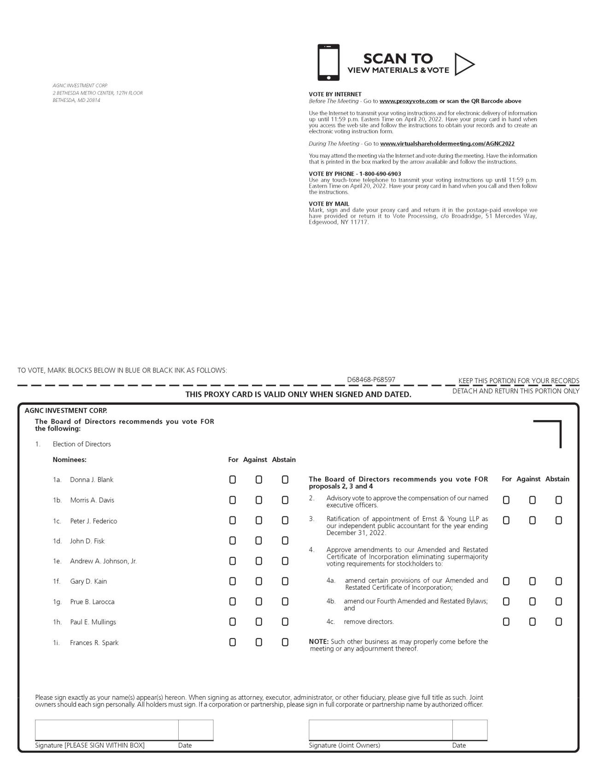

AI-2

Table of Contents
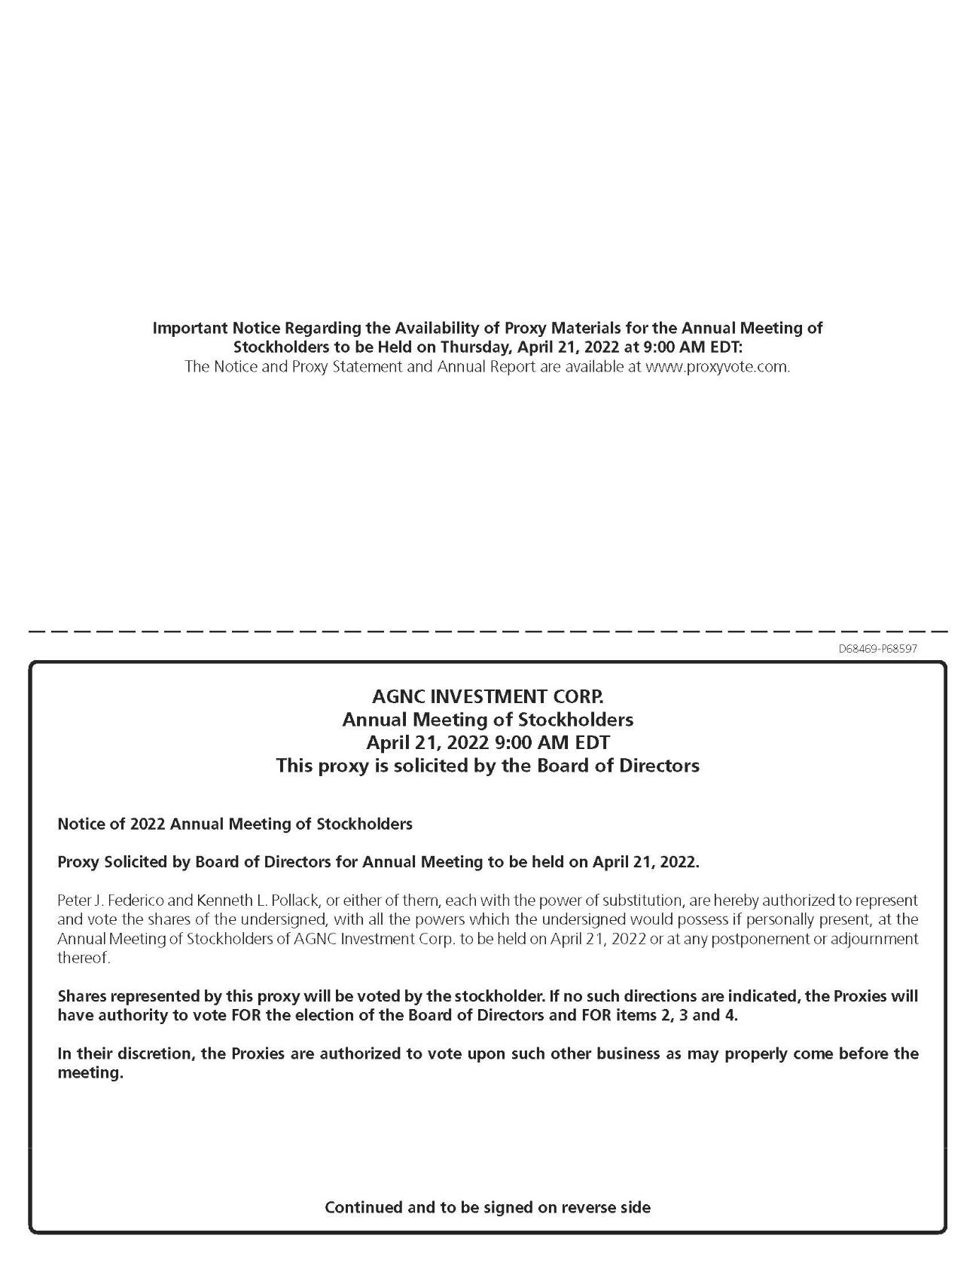

AI-3

