SECURITIES AND EXCHANGE COMMISSION

WASHINGTON, D.C. 20549

SCHEDULE 14A

(Rule 14a-101)

INFORMATION REQUIRED IN PROXY STATEMENT

SCHEDULE 14A INFORMATION

Proxy Statement Pursuant to Section 14(a) of the

Securities Exchange Act of 1934

Filed by the Registrant ☒ Filed by a Party other than the Registrant ☐

Check the appropriate box:

- Preliminary Proxy Statement

- Confidential, for Use of the Commission Only (as permitted by Rule 14a-6(e)(2))

- Definitive Proxy Statement

- Definitive Additional Materials

- Soliciting Material Pursuant to §240.14a-12

American Capital Agency Corp.

(Name of Registrant as Specified in its Charter)

Payment of Filing Fee (Check the appropriate box):

- No fee required

- Fee computed on table below per Exchange Act Rules 14a-6(i)(4) and 0-11.

  - Title of each class of securities to which transaction applies:

  - Aggregate number of securities to which transaction applies:

  - Per unit price or other underlying value of transaction computed pursuant to Exchange Act Rule 0-11 (set forth the amount on which the filing fee is calculated and state how it was determined):

  - Proposed maximum aggregate value of transaction:

  - Total fee paid:

- Fee paid previously with preliminary materials

- Check box if any part of the fee is offset as provided by Exchange Act Rule 0-11(a)(2) and identify the filing for which the offsetting fee was paid previously. Identify the previous filing by registration statement number, or the Form or Schedule and the date of its filing.

  - Amount Previously Paid:

  - Form, Schedule or Registration Statement No.:

  - Filing Party:

  - Date Filed:

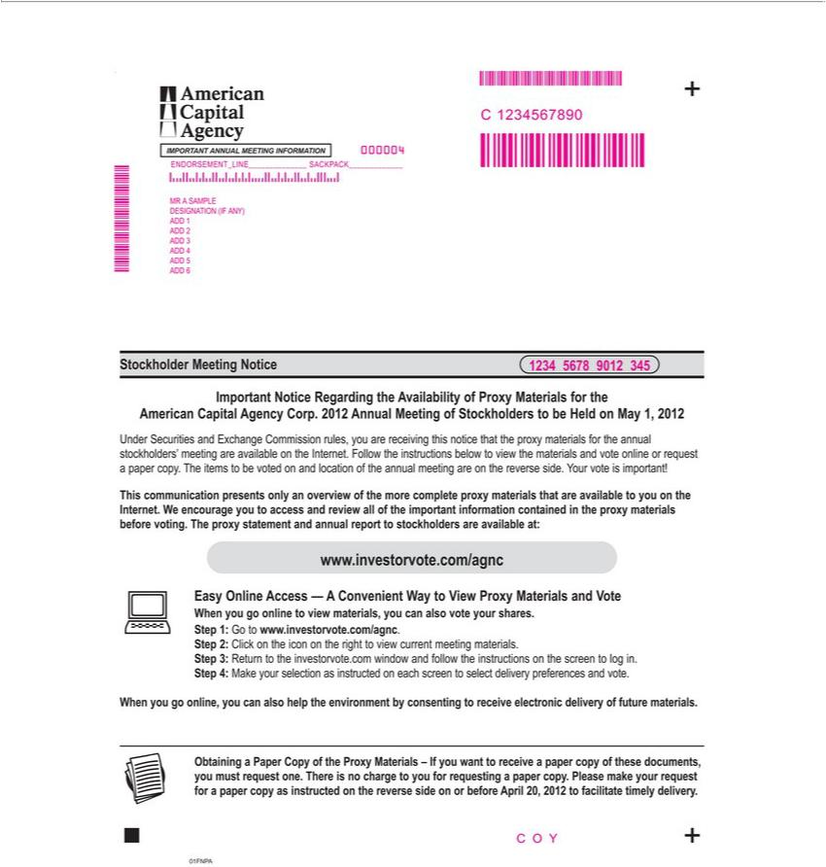

IMPORTANT ANNUAL MEETING INFORMATION
000004
C 1234567890 | SACKPACK
ENDORSEMENT_LINE
MR SAMPLE
DESIGNATION (IF ANY)
1
2
3 ADD 4
5
ADD 6
Stockholder Meeting Notice
1234 5678 9012 345
American Capital Important Agency Notice Corp. Regarding 2012 Annual the Meeting Availability of Stockholders of Proxy Materials to be Held for the on May 1, 2012
Under Securities and | Commission rules, you are receiving this notice that the proxy materials for the annual stockholders’ meeting are available on the Internet. Follow the instructions below to view
the materials and voteExchangeonlior request a paper copy. The items to be voted on and location of the annual meeting are on the |  | side. Your vote is important!
This communication presents only an overview of the more complete proxy materials that are available to you on the Internet.reverseWencourage you to access and review all of the important information contained in the proxy materials before voting. The proxy statement and annual report to stockholders are available at:
www.investorvote.com/agnc
Easy Online Access — A Convenient Way to View Proxy Materials and Vote
When you go online to view materials, you can also vote your shares. Step 1: Go to www.investorvote.com/agnc.
^{Step 3:}2: Click on the icon on the right to view current meeting materials.
When youReturngoonline,tothe investorvote.comyoucanalsohelp windowtheenvironmentandfollowby theconsentinginstructionstoreceiveonthe electronicscreento logdeliveryin.Stepof future4:Makematerials.yourselection as instructed on each screen to select delivery preferences and vote.
Obtaining^{make}Paper Copy of the Proxy Materials – If you want to receive a paper copy of these documents, you must request one. There is no charge to you for requesting a paper copy.
Please your request for a paper copy as instructed on the reverse side on or before April 20, 2012 to facilitate timely delivery.
01FNPACOY

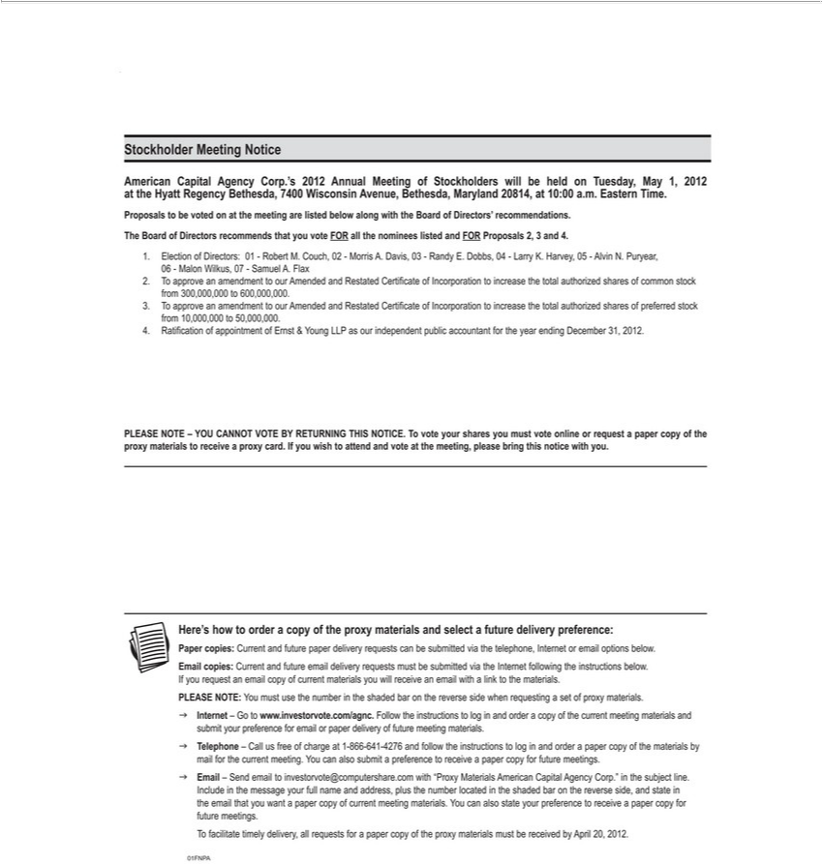

Stockholder Meeting Notice
American Capital Agency Corp.’s 2012 Annual Meeting of Stockholders will be held on Tuesday, May 1, 2012 at the Hyatt Regency Bethesda, 7400 Wisconsin Avenue, Bethesda, Maryland 20814, at 10:00 a.m.
Eastern Time.
Proposals to be voted on at the meeting are listed below along with the Board of Directors’ recommendations. The Board of Directors recommends that you vote FOR all the nominees listed and FOR Proposals
2, 3 and 4.
1. Election of Directors: 01—Robert M. Couch, 02—Morris A. Davis, 03—Randy E. Dobbs, 04—Larry K. Harvey, 05—Alvin N. Puryear,
06—Malon Wilkus, 07—Samuel A. Flax |  | common stock from 300,000,000 to 600,000,000.
2
3 | To approve an amendment to our Amended and Restated Certificate of Incorporation to increase the total authorized shares of preferred stock from 10,000,000 to 50,000,000.
4. | Ratification of appointment of Ernst & Young LLP as our independent public accountant for the year ending December 31, 2012.
PLEASE NOTE – YOU CANNOT VOTE BY RETURNING THIS NOTICE. To vote your shares you must vote online or request a paper copy of the proxy materials to receive a proxy card. If you wish to
attend and vote at the meeting, please bring this notice with you.
Her ’s how to order a copy of the proxy materials and select a future delivery preference:
Paper copies: Current and future paper delivery |  | can be submitted via the telephone, Internet or email options below. Email copies: Current and future email delivery requests must be submitted via the
Internet following the instructions below. If you requests an email copy of current materials you will receive an email with a link to the materials.
PLEASE NOTE: You must use the number in the shaded bar the reverse side when requesting a set of proxy materials.
3 Internet – Go to www.investorvote.com/agnc. Follow the instructions to log in and order a copy of the current meeting materials and submit your preference for email or paper delivery of future meeting
materials.
3 Telephone – Call us free of charge at 1-866-641-4276 and follow the instructions to log in and order a paper copy of the materials by mail for the current meeting. You can also submit a preference to receive a
paper copy for future meetings. |  |  | and address, plus the number
3 Email – Send email to investorvote@computershare.com with “Proxy Materials American Capital Agency Corp.” in the subject line. Include in the message your full
 | in the shaded bar on the reverse side, and state in the email that you want a paper copy of current meeting materials. You can also state your preference to receivenamepaper copy for future meetings.
locatedTfacilitate timely delivery, all requests for a paper copy of the proxy materials must be received by April 20, 2012.
01FNPA

